

The Fish MERLIN-Expo model
V1.2

Author: Artur Radomyskiª, Philippe Ciffroy^{b}
ªCa' Foscari University of Venice, 3246 Dorsoduro, 30123 Venezia, Italy
^{b}EDF R&D, 6 quai Watier, 78400 Chatou, France

artur.radomyski@unive.it
philippe.ciffroy@edf.fr

Reviewers:

Content
Level 1 documentation (basic knowledge on model purpose, applicability and components) 5
1. Model purpose 5
1.1. Goal 5
1.2. Potential decision and regulatory framework(s) 5
2. Model applicability 5
2.1. Spatial scale and resolution 5
2.2. Temporal scale and resolution 5
2.3. Chemical considered 6
2.4. Steady-state vs dynamic processes 6
3. Model components 6
3.1. Media considered 6
3.2. Loadings 7
3.3. Losses 7
3.4. Exchanges between model media 9
3.5. Potential coupled models 9
3.6. Forcing variables 11
3.7. Parameters 13
3.8. Intermediate State variables 17
3.9. Regulatory State variables 22
Level 2 documentation (background science) 26
4. Processes and assumptions 26
4.1. Process n°1: Respiratory uptake of chemicals 26
4.2. Processes n°2 and n°3: Dietary uptake and egestion of chemicals 28
4.3. Process n°4: Respiratory excretion of chemicals 30
4.4. Process n°5: Elimination of chemical through growth 31
4.5. Process n°6: Metabolic biotransformation elimination (only for organics) 32
4.6. Process n°7: Bioaccumulation/Bioconcentration of metals 33
4.7. Process n°8: Ingestion of metals 34
4.8. Process n°9: Excretion and egestion of metals 35
Level 3 documentation (numerical information) 36
5. Numerical default values (deterministic and/or probabilistic) 36
5.1. Initialization of concentrations in Media 36
5.2. Default parameter values 36
5.2.1. Site-specific parameters 36
5.2.1.1. Fish diet preference for food item i (pref_diet_1 to pref_diet_10) 36
5.2.2. Fish physiological parameters 39
5.2.2.1. Fish age at maturity (time_fishlife) 39
5.2.2.2. Fish length at maturity (L_fish) 40
5.2.2.5. Allometric rate exponent (kappa) κ 44
5.2.2.6. Lipid fraction of food item i (p_lipid_1 to p_lipid_10) 45
5.2.2.7. Lipid fraction of fish (p_lipid_fish) 45
5.2.2.8. Fraction of assimilated food (Assimilated_food) 47
5.2.3. Chemical parameters 48
5.2.3.1. Octanol-water partition coefficient (log10_K_ow) 48
5.2.3.2. Food transport coefficient ((gamma) γ _food) 52
5.2.3.3. Lipid layer permeation resistance (ρ_lipid_layer) 53
5.2.3.4. Water layer diffusion resistance for uptake of chemicals from food (ρ_water_layer_food) 53
5.2.3.5. Water layer diffusion resistance for uptake of chemicals from water (ρ_water_layer) 53
5.2.4. Parameters related to partition between phases 55
5.2.4.1. Bioconcentration factor for organics for fish (or fish-water partition coefficient) (log10_BCF organics) 55
5.2.4.2. Intercept of BCF-Concentration relationship (a_BCF) (only for metals) 59
5.2.4.3. Slope of BCF-Concentration relationship (b_BCF) (only for metals) 59
5.2.5. Parameters related to degradation 61
5.2.5.1. Metabolic half-life of chemicals (hl_metabolic_norm) 61
Level 4 documentation (mathematical information) 66
6. Mathematical models for State variables 66
6.1.1. Fish weight at maturity (W_fish) 66
6.1.2. Mean lipid fraction of food (p_lipid_food) (for organics only) 66
6.1.3. Mean concentration of the chemical in ingested diet items (C_diet_mean) 67
6.1.4. Bioconcentration factor of metals (log10_BCF_metal) 67
6.1.5. Respiratory uptake rate constant (k_uptake_resp_organic) (for organics only) 67
6.1.6. Respiratory uptake rate constant (k_uptake_resp_metal) (for metals only) 68
6.1.7. Dietary uptake rate constant (k_ingestion_organic) (for organics only) 68
6.1.8. Dietary uptake rate constant (k_ingestion_metal) (for metals only) 69
6.1.9. Respiratory excretion rate constant (k_excretion) 69
6.1.10. Dietary egestion rate constant (k_egestion_metal) (for metals only) 70
6.1.11. Dietary egestion rate constant (k_egestion_organic) (for organics only) 70
6.1.12. Growth rate constant (k_growth) 71
6.1.13. Metabolic transformation rate constant (λ_metabolism) (for organics only) 71
6.1.14. Mass balance equation for the respiratory system 72
6.1.15. Mass balance equation for the GIT system 72
6.1.16. Concentration in fish 72

Level 1 documentation (basic knowledge on model purpose, applicability and components)

Model purpose

Goal
The goal of the ‘Fish’ model is to dynamically simulate the bioaccumulation of organic contaminants and metals in fish and to calculate the concentration of chemicals accumulated in fish caught for human food.

Potential decision and regulatory framework(s)
Taken alone, the Fish model can provide an estimation of the time-dependent concentration of the targeted contaminant(s) in fish. This/these output(s) can be used for evaluating the risk to exceed a given regulatory threshold for environmental risk (e.g. Environmental Quality Standards (EQS) in fish for individual pollutants).
Coupled with the model dedicated to Human ingestion (Human_ing), the Fish model can provide an estimation of the time-dependent concentration of the targeted contaminant(s) in fish available for food ingestion. This output can be used for evaluating the risk to exceed a given regulatory threshold for human health (e.g. daily Reference Dose) or to provide an input for PBPK models.

Model applicability

Spatial scale and resolution
Spatial scale and resolution are governed by the homogeneity of the water body under investigation, in which Fish is assumed to live. It is then advised to use the Fish model for river zones that show low variations in their geometry. For water bodies showing significant relative variations in their dimensions (e.g. under the effect of tributaries affecting dilution of contaminants in water), it is possible to subdivide these latter in several successive homogeneous zones and to couple them.
The River model assumes that contaminants are homogeneously distributed along the transect of the river (i.e. laterally and vertically). The application of the Fish model just upstream of a lateral point release must then be considered with caution if well-mixing condition is not respected. In such a case, the distribution of Fish among several zones presenting different contamination levels must be defined.
In the MERLIN model, no migration of fish among different zones is assumed. In other words, Fish are assumed to stay in the same water box during their entire lifetime.

Temporal scale and resolution
There is no limitation for temporal scale (i.e. duration of the simulation).
As far as temporal resolution is concerned, several processes included in the model are relevant at daily (or less) resolution for fish submitted to exposure from sediments (e.g. benthic fish, fish ingesting significant quantities of SPM). Physical exchanges at the water column-sediment interface are highly dependent on water velocity and concomitantly on flow rate. This is especially the case for resuspension processes during flood events. As the flow rate can be subject to rapid variations, especially during flood periods, the estimation of particles resuspension is poorly relevant for large temporal resolution (e.g. weekly or monthly). In conclusion, it is highly recommended to run the model for daily (or less) temporal resolution.

Chemical considered
The Fish model can a priori be used for all organic contaminants, like e.g. PAHs, PCBs, pesticides, etc. However, some parameters are estimated from QSAR models and the applicability domain of these latter must be checked before running the Fish model, especially for polar compounds (acids and bases). For such compounds, partition coefficients are theoretically related to pH and the applicability domain of existing QSAR must be checked with cautious.
The Fish model can be used for metals for which Bioconcentration Factors are provided (i.e. As, Cd, Cu, Pb, Zn, Ni, Ag).

Steady-state vs dynamic processes
The Fish model represents all the exchanges processes dynamically. Processes representing exchanges of contaminants between fish and its surrounding environment (i.e. overlying water, sediment porewater, other biota systems representing its food) are dynamically simulated, with uptake and elimination rates. Kinetics representing uptake and elimination processes are first-order.

Model components

Media considered
Definition: A ‘Medium’ is defined as an environmental or human compartment assumed to contain a given quantity of the chemical. The quantity of the chemical in the media is governed by loadings/losses (see 3.2 and 3.3) from/to other media and by transformation processes (e.g. degradation).
The Fish model includes two media that correspond to two input/output pathways for chemical accumulation in Fish, i.e. the Fish respiratory system and the Fish gastro intestinal tract (GIT) system. The media considered is represented in Figure 1.

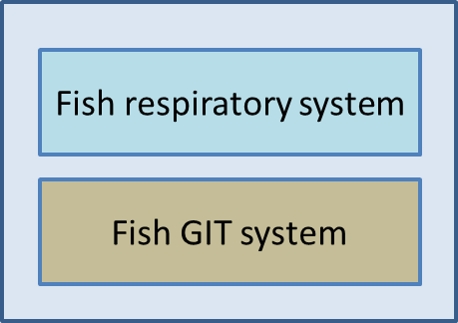
Figure 1 – Media considered in the Fish model

Loadings
Definition: A ‘Loading’ is defined as the rate of release/input of the chemical of interest to the receiving system, here the Fish system.
The inputs of contaminant(s) into the Fish system can have the following origins:
- Contaminant originating from Direct uptake from water through membrane diffusion via the respiratory area (i.e. gills and skin) ;
- Contaminant originating from Uptake from ingestion of food (prey ingestion). By default, in the MERLIN-Expo Fish model, the number of food sources is 10, i.e. Fish can eat 10 different preys according to food availability and preferences.
If the Fish model is used alone (i.e. not coupled to other models available in the MERLIN-Expo library), these loadings are defined by the end-user as time series. If coupled to other models (e.g. the River model able to calculate contamination in water and sediments; and/or Phytoplankton and/or Zooplankton models representing prey for fish), some of these loadings can be calculated by these models (i.e. the outputs of the coupled models are used as loading inputs for the Fish model) (see § 3.5).
The loading inputs are represented in Figure 2.

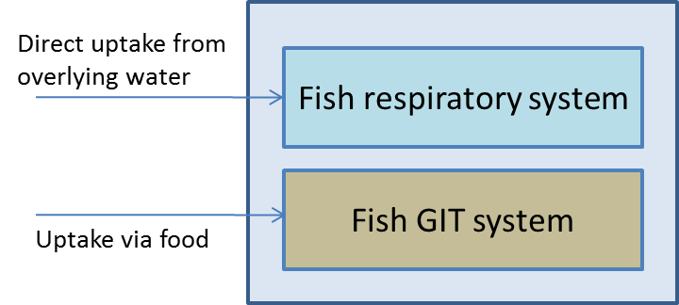
Figure 2 – Media considered + Loading inputs in the Fish model

Losses
Definition: A ‘Loss’ is defined as the rate of output of the chemical of interest from the receiving system, here the Fish system.
The potential losses of contaminant(s) from the Fish system can be:
- Contaminant leaving the Fish system by elimination via the respiratory area (i.e. gills and skin);
- Contaminant leaving the Fish system via elimination into egested feces;
- Contaminant leaving the Fish system via metabolism (i.e. metabolic transformation of the chemical);
- Contaminant concentration decreasing via growth of fish mass (should be regarded as dilution of chemicals and not loss of chemicals).

For metals, some losses are not relevant because these chemicals are assumed not to be subject to metabolism.
The losses of contaminant(s) from the Fish system are represented in Figure 3 and Figure 4.

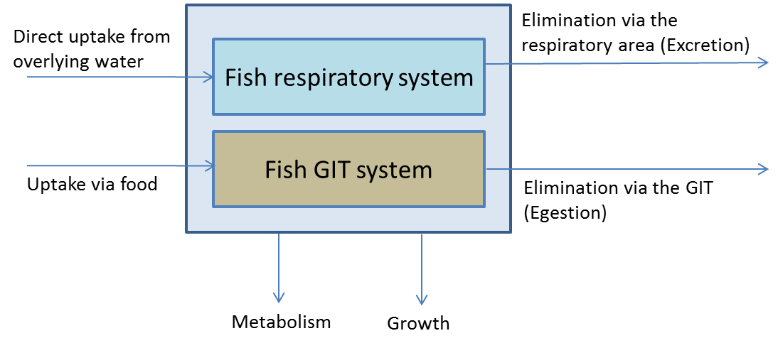
Figure 3 – Media considered + Loading inputs + Losses in the Fish model (for Organics)
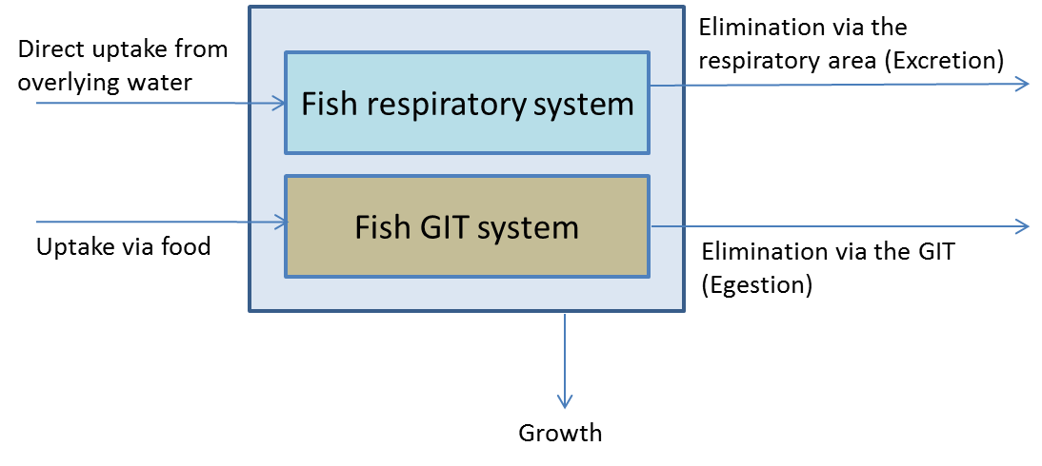
Figure 4 – Media considered + Loading inputs + Losses in the Fish model (for Metals)

Exchanges between model media
Definition: An ‘Exchange’ is defined as the transfer of the chemical of interest between two media of the system, here the Fish system.
As the Fish system is based on one media only, there is no exchange between model media within the investigated system.

Potential coupled models
‘Coupled models’ are defined as models that can generate loadings to the investigated system (here the Fish system) or receive losses from the latter.
The Fish model can be coupled to other models of the MERLIN-Expo library. These latter can provide loading estimates or use losses from the Fish as input data:

Coupled model | Can provide estimates of the following loading(s) | Can use the following losses from the Fish as input data
‘River’ model | Contamination in water used for the estimation of direct uptake from overlying water | - Elimination via the respiratory area  - Egestion
‘Fish’ models | Uptake via food (for carnivorous fish ingesting other fish)
‘Invertebrate’ models | Uptake via food (for herbivorous and carnivorous fish ingesting e.g. invertebrates)
‘Zooplankton’ models | Uptake via food (for herbivorous fish ingesting e.g. invertebrates)
‘Phytoplankton’ models | Uptake via food (for herbivorous fish ingesting phytoplankton)

The potential coupled models are represented in Figure 5 and Figure 6.

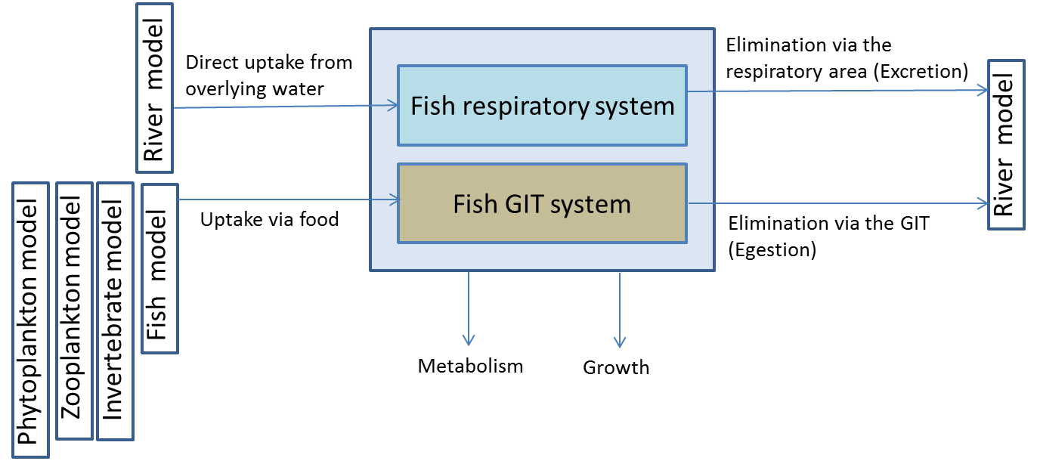
Figure 5 – Media considered + Loading inputs + Losses + Exchanges + Coupled models in the Fish model (for Organics)
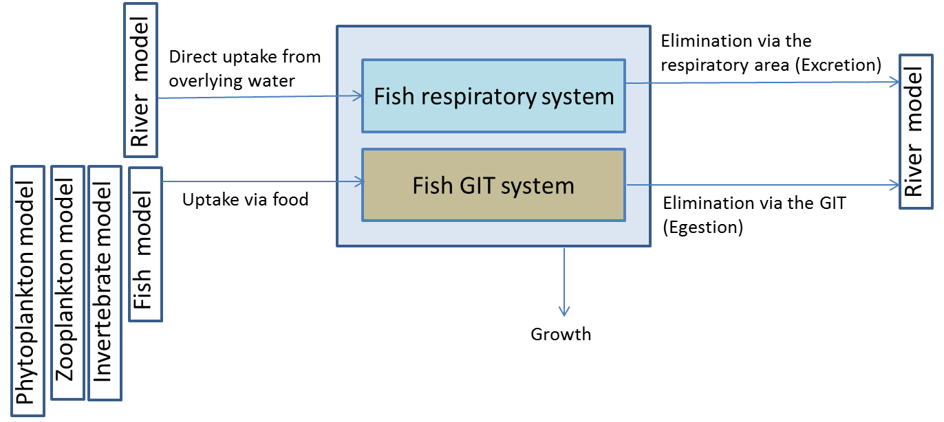
Figure 6 - Media considered + Loading inputs + Losses + Exchanges + Coupled models in the Fish model (for Metals)

Forcing variables
A ‘Forcing variable’ is defined as an external or exogenous (from outside the model framework) factor that influences the state variables calculated within the model. Such variables include, for example, climatic or environmental conditions (temperature, wind flow, etc.).
For running the Fish model, the following forcing variables must be informed for calculating the loading inputs. In the Fish MERLIN model, it is arbitrarily assumed that Fish may have 10 different preys, each of them being contaminated at the concentration C_prey_i (i=1 to 10).

For | Forcing variable | Abbreviation and unit | Purpose | Can be calculated (instead of being defined by the end-user) if the Fish model is coupled to the …
Organics and Metals | Water temperature | T_river (°C) | Temperature affects a fish’s feeding, assimilation, respiration, and excretion
Organics and Metals | Concentration of the chemical in dissolved river water | C_dis_water (mg.m⁻³) | Is used to calculate the input through respiratory uptake. Can be calculated (instead of being defined by the end-user) if the River model is coupled to the Fish model. | River model
Organics and Metals | Concentration of the chemical in prey i, i=1,10 | C_prey_i (mg.kg ⁻¹ fw) | Is used to calculate the input through dietary uptake through other species. Can be calculated (instead of being defined by the end-user) if another Biota model is coupled to the Fish model. | Phytoplankton or Zooplankton or Invertebrate or Fish model

The forcing variables (with indication of the processes they are involved in) are represented in Figure 7 and Figure 8.

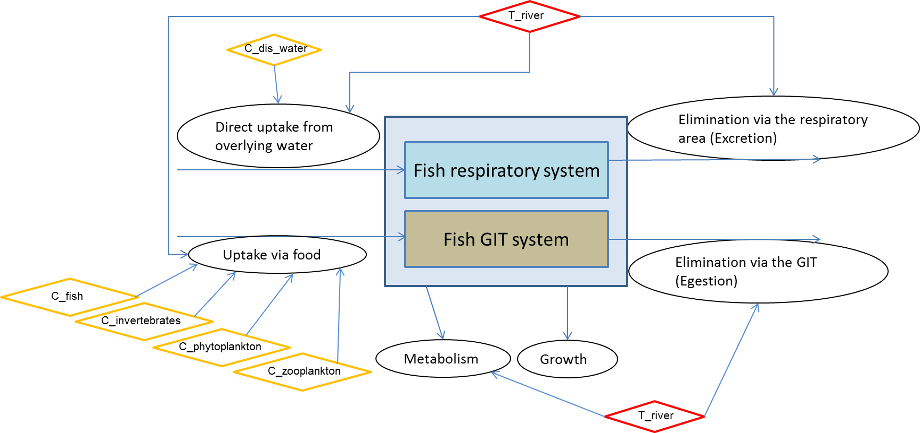
Figure 7 – Media considered + Loading inputs + Losses + Exchanges + Forcing variables in the Fish model (Forcing variables indicated in yellow are those that can be calculated if the Fish model is coupled to other models) (for Organics)

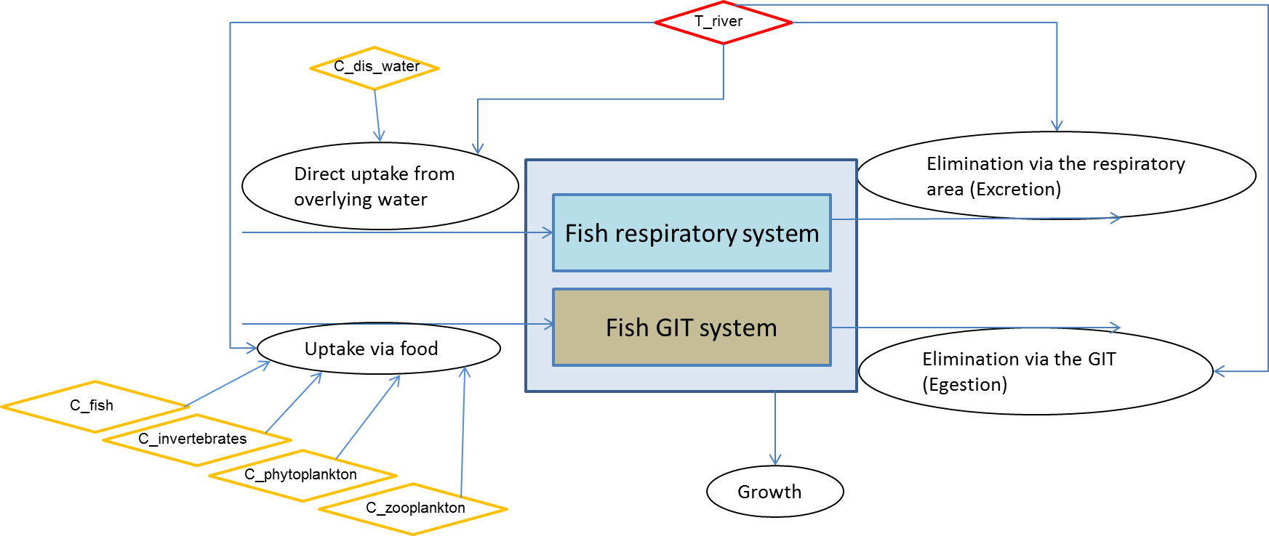
Figure 8 - Media considered + Loading inputs + Losses + Exchanges + Forcing variables in the Fish model (Forcing variables indicated in yellow are those that can be calculated if the Fish model is coupled to other models) (for Metals)

Parameters
A ‘Parameter’ is defined as a term in the model that is fixed during a model run or simulation but can be changed in different runs as a method for conducting sensitivity analysis or to achieve calibration goals.
For running the Fish model, the following parameters must be informed:

- Site-specific parameters
For… | Name | Abbreviation and unit | Purpose | Used for calculating the following state variable(s)
Organics and metal | Fish diet preference for food item i | Pref_diet_i (unitless) (i=1 to 10) | Fish diet preferences for certain foods used to calculate the concentration of the chemical substance that is absorbed with ingested diet. Ten potential diets are arbitrary defined in the MERLIN-Expo model. | - C_fish (mg∙kg⁻¹)  - C_diet_total  - Mean lipid fraction in food p_lipid_food (-)

- Physiological parameters
For | Name | Abbreviation and unit | Purpose | Used for calculating the following state variable(s)
Organics and metal | Fish age at maturity | time_fishlife (d) | It is used for correcting concentration of contaminant in fish body for a given age of fish.  It is also used for calculating growth rate. | - C_fish (mg∙kg⁻¹)  - k_growth (d⁻¹)
Organics and metal | Fish length at maturity | L_fish (cm) | Used in calculating weight of fish at maturity according to an allometric relationship. | - W_fish (kg)
Organics and metal | Intercept of weight-length relationship | a_W_fish (unitless) | The relationship between weight and length is expressed by an allometric formula including intercept a_W_fish. Used in calculating weight of fish at a given age, based on a given fish length. | - W_fish (kg)
Organics and metal | Slope of weight-length relationship | b_W_fish (unitless) | The relationship between weight and length is expressed by an allometric formula including intercept a_W_fish. Used in calculating weight of fish at a given age, based on a given fish length | - W_fish (kg)
Organics and metal | Allometric rate exponent | (kappa) κ (-) | Allometric relationships provide body-size specific parameters instead of values that are arbitrary or taken from a well-known species. Allometric regression exponent κ expresses body size correlation with animals physiological characteristics i.e. rates, transport coefficients. | All rate constants
Organics | Lipid fraction of food item i | p_lipid_i (-) | Lipid fraction of food item i. Used to calculate the fraction of lipid ingested by fish with its diet. It is related to trophic level of the prey. | - Dietary uptake rate constant  k_ingestion (kg·kg ⁻¹·d⁻¹)  - Dietary egestion rate constant  k_egestion (d⁻¹)  - Mean lipid fraction in food p_lipid_food (-)
Organics | Lipid fraction of fish | p_lipid_fish (-) | Lipid fraction of fish. Used to calculate the egestion rate from GIT | - Dietary egestion rate constant  k_egestion_organic (d⁻¹)
Organics and metal | Fraction of assimilated food | Assimilated_food (-) | This parameter represents fraction of ingested food that is absorbed or digested by the organisms in the gastro intestinal tract. Its estimation depends on prey (food) position in the food web. Used in calculating fish’s inflow and outflow rates of chemicals through water/food and feces, respectively. | - Dietary uptake rate constant  k_ingestion (kg·kg ⁻¹·d⁻¹)  - Dietary elimination rate constant  k_egestion (d⁻¹)
Organics | Food transport coefficient | (gamma) γ_food (kg·kg⁻¹·d⁻¹) | Food transport coefficient represents delay in advective transport of chemical substances through organism due to limited supply of new food. | - Dietary uptake rate constant  k_ingestion (kg·kg ⁻¹·d⁻¹)  - Dietary elimination rate constant k_egestion (d⁻¹)

- Parameters related to partition between phases:
For… | Name | Abbreviation and unit | Purpose | Used for calculating the following state variable(s)
Organics only | Bioconcentration Factor for organics (or Fish-water partition coefficient) | Log10_BCF_organic (L∙kg fw⁻¹) | Represents the partitioning at equilibrium of organic chemicals between fish organism and water in absence of diet contribution | - Respiratory elimination rate constant k_excretion (d⁻¹)
Metals only | Intercept of BCF-concentration relationship | a_BCF (-) | BCF for metals is assumed to be related to the metal concentration in water according to an inverse linear relationship in log units. a_BCF represents the regression coefficient (y-intercept) this relationship | - Bioconcentration factor for metals log10_BCF_metal (L∙kg fw⁻¹)
Metals only | Slope of BCF-concentration relationship | b_BCF (-) | BCF for metals is assumed to be related to the metal concentration in water according to an inverse linear relationship in log units. b_BCF represents the regression coefficient (slope) this relationship | - Bioconcentration factor for metals log10_BCF_metal (-)
Organics only | Octanol-water partition coefficient | Log10_K_ow (-) | Kow partition cooefficient is used as a measure of hydrophobicity of the organic substance at equilibrium concentrations between octanol and water phase. | - Respiratory uptake rate constant k_uptake_resp (L·kg⁻¹·d⁻¹)  - Dietary uptake rate constant k_ingestion (kg·kg ⁻¹·d⁻¹)  - Dietary elimination rate constant k_egestion (d⁻¹)
Organics | Water-layer diffusion resistance for uptake of chemicals from food | (rho) ρ _water_layer_food (kg.d.kg⁻¹) | Represents time of diffusion of organic contaminant from ingested food through aqueous layer. | - Dietary uptake rate constant k_ingestion (kg·kg⁻¹·d⁻¹)  - Dietary elimination rate constant k_egestion (d⁻¹)
Organics | Water-layer diffusion resistance for uptake of chemicals from water | (rho) ρ _water_layer(kg.d.kg⁻¹) | Represents time of diffusion of organic contaminant contained in water through aqueous layer. | - Respiratory uptake rate constant k_uptake_resp (L·kg⁻¹·d⁻¹)
Organics | Lipid-layer permeation resistance | (rho) ρ_lipid_layer (kg.d.kg⁻¹) | Represents time of passive diffusion of organic contaminant through lipid membranes. | - Respiratory uptake rate constant k_uptake_resp (L·kg⁻¹·d⁻¹)  - Dietary uptake rate constant k_ingestion (kg·kg⁻¹·d⁻¹)  - Dietary elimination rate constant k_egestion (d⁻¹)

- Parameters related to degradation of chemicals:
For… | Name | Abbreviation and unit | Purpose | Used for calculating the following state variable(s)
Organics | Metabolic half-life of chemicals | hl_metabolic_norm (d⁻¹) | Defines time after which amount of chemical in the organism decreases to half of its starting amount, due to metabolic activity. Half lives are normalised values to 0.01 kg fish and 15°C. | - Biotransformation rate constant λ_metabolism (d⁻¹)

Intermediate State variables
An ‘Intermediate State variable’ is defined as a dependent variable calculated within the model. Some State variables are fixed during a model run or simulation because they are calculated only from parameters. Some others are time-dependent because they are calculated from parameters, but also from time-dependent forcing variables. We distinguish ‘Intermediate State variables’ and ‘Regulatory State variables’. The first ones are generally not used by decision-makers for regulatory purposes but can be used as performance indicators of the model that change over the simulation. The second ones can be used by decision-makers for regulatory purposes.
For running the Fish model, the following state variables are calculated for the following purposes. All the state variables for which no forcing variable is required are constant all over the calculation time. Instead, the state variables for which forcing variable(s) is/are required are time-dependent. In the following tables, the following symbols were adopted:
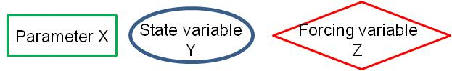

- State variables related to fish physiology:
For… | SV n° | Name | Abbreviation and unit | Purpose | Process followed for calculating the state variable
Organics and metals | 1° | Fish weight at maturity | W_fish (kg fw) | Represents weight of fish at a maturity time of its life. Weight of the fish is estimated from its length. It should be used when user does not have data on weight, but on length instead. | 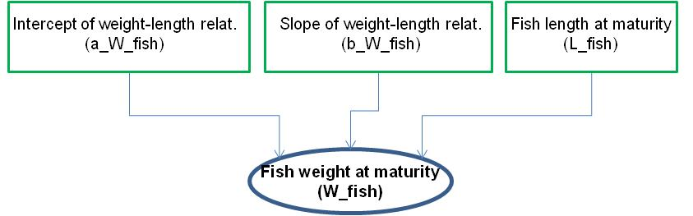

- State variables related to partition between phases
Metals only | 2° | Bioconcentration factor of metals | log10_BCF_metals (log(L.kg fw⁻¹) | Represents the ratio, at equilibrium, of a  chemical concentration in an organism to the concentration in  water | 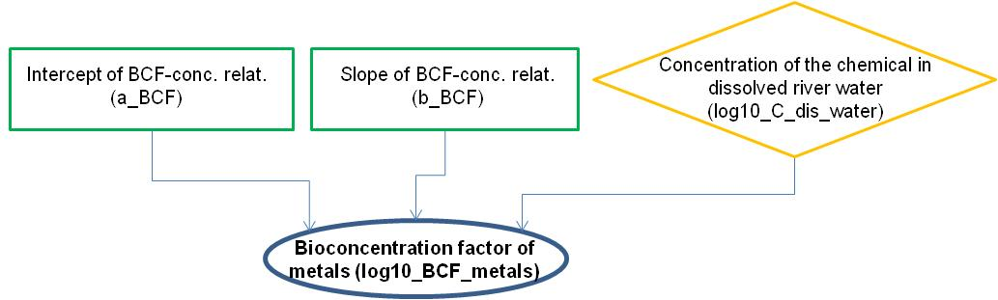

- State variables related to site-specific parameters
Organics only | 3° | Mean lipid fraction of food | p_lipid_food (-) | Defines lipid fraction of food ingested with fish diet | 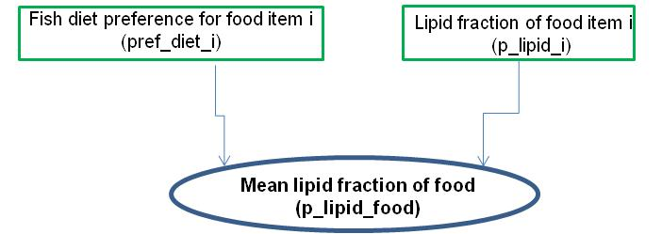
Organics and metals |  | Mean concentration of the chemical in ingested diet items | C_diet_mean | Defines the mean chemical concentration in food ingested with fish diet (weighted by diet preferences) | 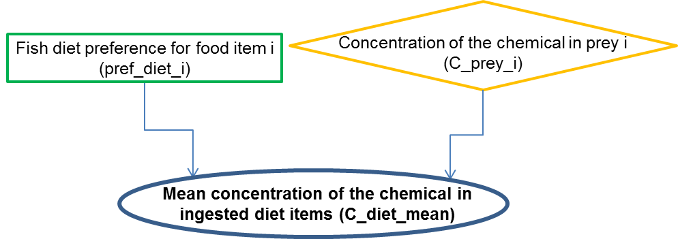

- State variables related to kinetic rate constants:
For… | SV n° | Name | Abbreviation and unit | Purpose | Process followed for calculating the state variable
Organics only | 4° | Respiratory uptake rate constant for organics | k_uptake_resp_organic (L·kg fw⁻¹·d⁻¹) | Defines rate at which chemicals are absorbed via the respiratory surface e.g. gills, skin. | 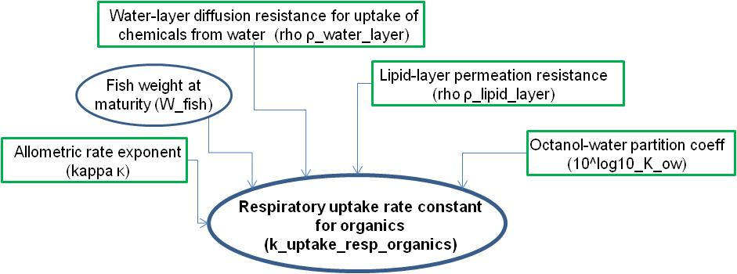
Metals only | 5° | Respiratory uptake rate constant for metals | k_uptake_resp_metal (L·kg fw⁻¹·d⁻¹) | Defines rate at which chemicals are absorbed via the respiratory surface e.g. gills, skin. | 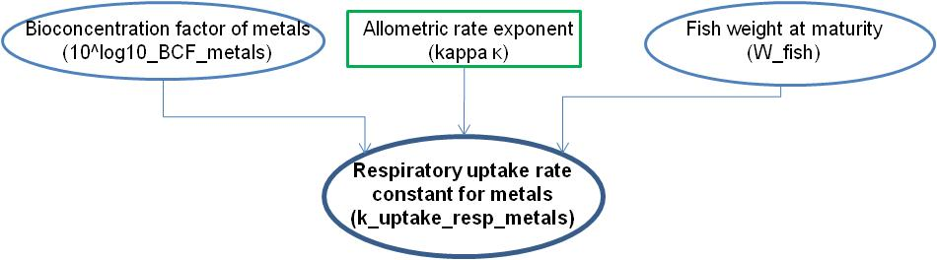
Organics only | 6° | Dietary uptake rate constant for organics | k_ingestion_organic (kg fw·kg fw ⁻¹·d⁻¹) | Defines rate at which organic chemicals are absorbed via ingestion of food. | 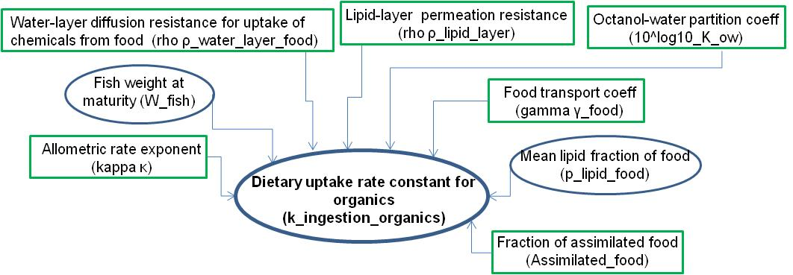
Metals only | 7° | Dietary uptake rate constant for metals | k_ingestion_metal (kg fw·kg fw ⁻¹·d⁻¹) | Defines rate at which metals are absorbed via ingestion of food. | 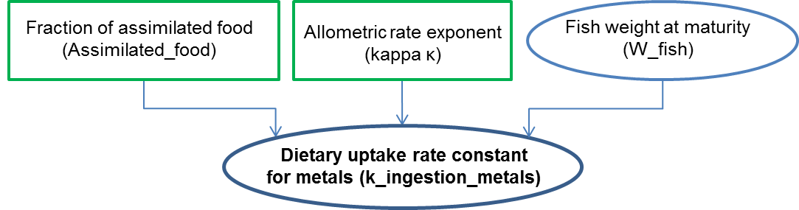
Organics and metals | 8° | Respiratory elimination rate constant | k_excretion (d⁻¹) | Defines rate at which chemicals are eliminated via the respiratory surface. k_uptake_resp used here for calculating k_excretion represents k_uptake_resp_org for organics and k_uptake_resp_metals for metals | 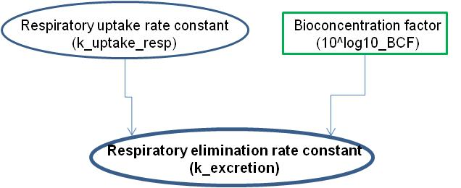
Organics only | 9° | Dietary elimination rate constant | k_egestion_organics (d⁻¹) | Defines rate at which chemicals are eliminated via egestion (undigested food). | 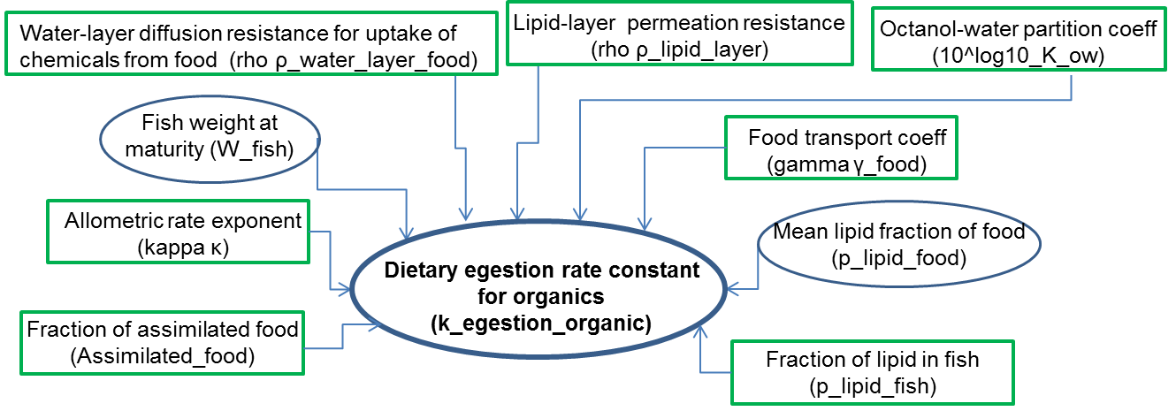
Metals only | 9° | Dietary elimination rate constant | k_egestion_metal (d⁻¹) | Defines rate at which chemicals are eliminated via egestion (undigested food). | 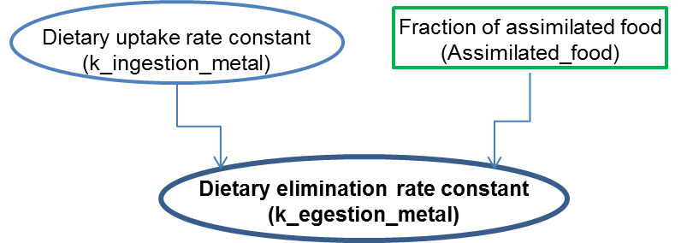
Organic only | 10° | Metabolism rate constant | (lambda) λ_metabolism (d⁻¹) | Defines rate at which chemicals are eliminated via metabolism. | 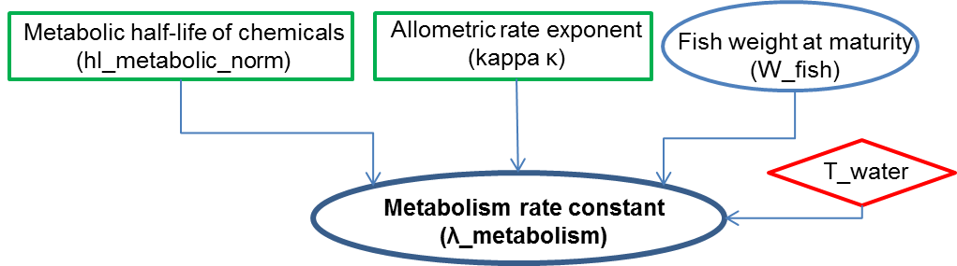
Organics only | 11° | Growth rate constant | k_growth (d⁻¹) | Defines rate at which chemicals are diluted via growth of the organism. | 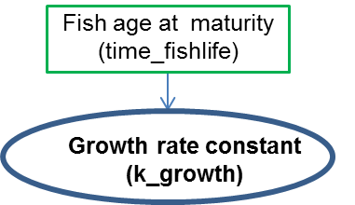

Regulatory State variables
An ‘Regulatory State variable’ is defined as a dependent variable calculated within the model. It is generally time-dependent because it is calculated from parameters, but also from time-dependent forcing variables and loadings. We distinguish ‘Intermediate State variables’ and ‘Regulatory State variables’. The first ones are generally not used by decision-makers for regulatory purposes but can be used as performance indicators of the model that change over the simulation. The second ones can be used by decision-makers for regulatory purposes.

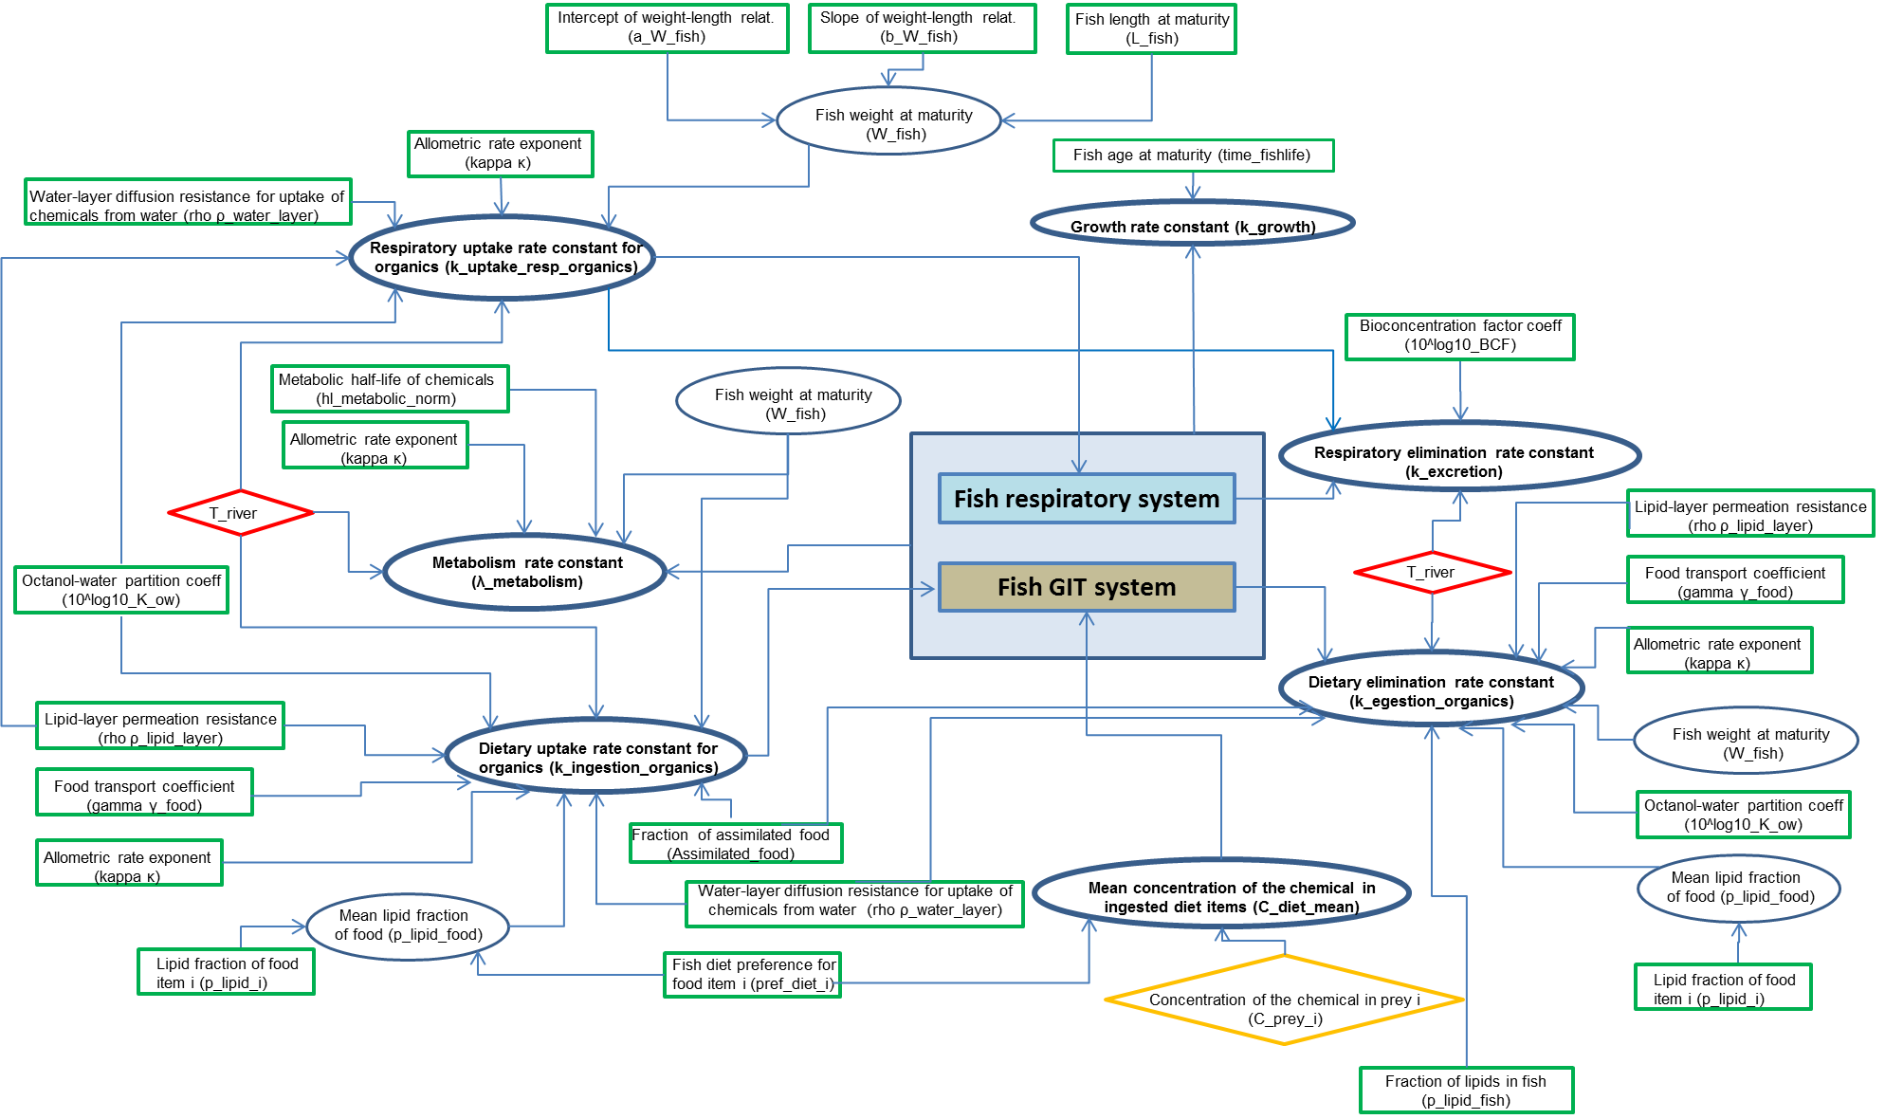
Figure 9 -Flow chart for calculating the ‘regulatory state variables’ (for Organics)
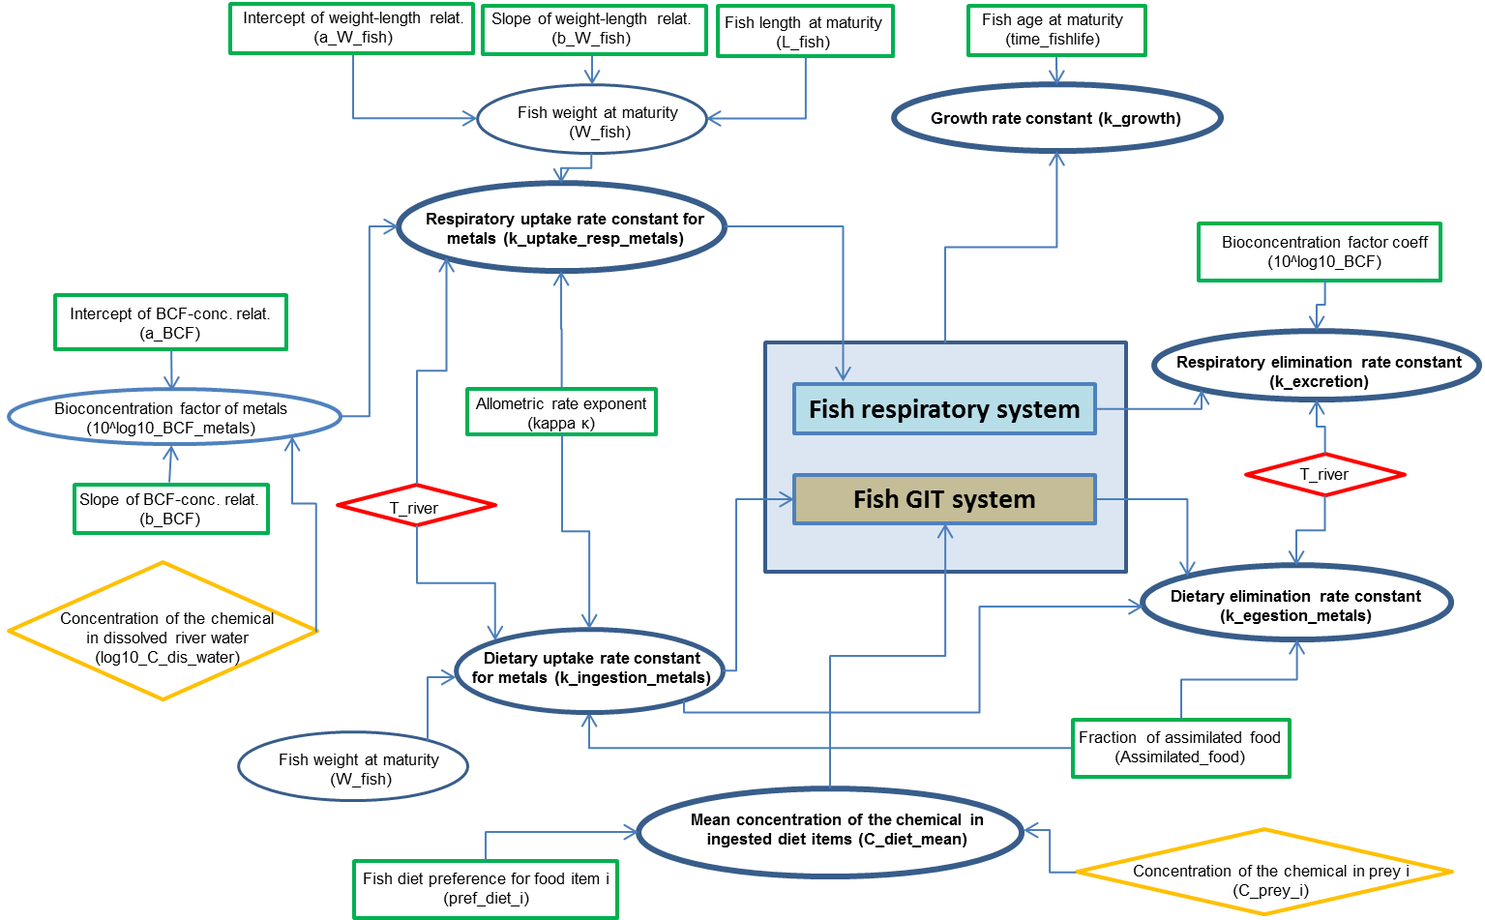
Figure 10 - Flow chart for calculating the ‘regulatory state variables’ (for Metals)

The following ‘regulatory state variables’ are calculated according to the flow charts presented in Figure 9 and Figure 10:

SV n° | Name | Abbreviation and unit
13° | Quantity of chemical in fish | Q_fish (mg)
14° | Concentration of the chemical in an individual fish starting its life at the beginning of the simulation time | C_fish_individual (mg.kg fw⁻¹)
15° | Concentration of the chemical in fish caught for human food | C_fish_human_food (mg.kg fw⁻¹)

End of Level 1 documentation (basic end-user)

Level 2 documentation (background science)

Processes and assumptions

Process n°1: Respiratory uptake of chemicals
Motivation
Bioconcentration in fish partially results from chemical uptake via the respiratory surface (fish’s gill) of the organism. Respiratory uptake together with dietary uptake accounts for bioaccumulation of chemicals in fish. Water assimilation varies between freshwater and marine organism as a result of their distinct requirements for osmoregulatory balance.
Selected model and assumptions
A variety of models addressing uptake of chemicals via respiratory route exist (Arnot and Gobas, 2004, Barber 2003, Hendriks et al, 2001). All these models can be based on different mathematical formulations and parameter names but they actually are consistent and consider common assumptions. In particular, they all assume that ventilation rate depends on organism body weight according to an allometric relationship. They also consider that uptake is governed by an assimilation rate that depends on the chemical substance and its affinity with lipids. The assimilation rate is generally related to the Octanol-Water partition coefficient according to a relationship in the form:
$$Assimilation _efficiency∝\frac{1}{{A+B}/{K_{OW}}}$$
Because of availability of parameter values, the selected MERLIN-Expo model is based on those described in Hendriks et al (2001). This model is based on allometric assumptions and assumes that physicochemical properties of fish’s gill are essential for uptake of chemicals. In the Hendrik’s model, the A and B coefficients allowing calculating assimilation efficiency represent resistances in water and lipids respectively. The resistances for diffusion through water layers can be considered to be the same for different chemicals because molecular weights and volumes are in the same order of magnitude (it derives from this assumption the use of the constant A). The resistance during permeation through lipid layers was considered to decrease with the hydrophobicity of the compound (it derives from this assumption the use of the expression B/K_{OW}). In addition to resistances in lipid and water layers, fluxes can also be limited by delays in the flow of water through organisms. However, the delay imposed by the water flow can be ignored for aquatic species because ventilation and filtration are sufficiently fast in these organisms (Hendriks, 2001). Such model is expected to accurately predict uptake rate and an uncertainty analysis was already performed by Hauck et al (2011).
The model states that the uptake rate of a chemical depends then on the octanol-water partition coefficient of the chemicals (log10_K_ow), body weight, lipid content, and resistances that substances encounter in lipid and water layers of the organism.
Model type
Empirical [ ] vs mechanistic [X]
Steady-state [ ] vs dynamic [X]
Analytical [X] vs numerical [ ]
Alternatives and limits
Similarly to the model we selected, other formulations were proposed for estimating respiratory fish uptake rate of chemicals. They are all based on correlations between uptake rate on one side and ventilation rates and gill assimilation efficiency on the other side. Some of these alternative formulations are described here in more details. In our model, ventilation rate is related to body weight according to an allometric relationship. In some models, ventilation rates of fish (expressed in L.s⁻¹) are assumed to be directly associated to its needs in oxygen. It is then estimated by the three variables that governs oxygen uptake, i.e. the fish rate of oxygen consumption (expressed in mgO₂.s⁻¹), the fish oxygen assimilation efficiency and the dissolved oxygen concentration of the ambient water (in mgO₂.L⁻¹). This alternative requires however more information on fish physiology.
Assimilation efficiency determines amount of chemicals that fish extracts from the volume of water flowing across the gill membrane. Assimilation Efficiency (AE_gill) of the chemical depends on biological attributes of the fish, but also on chemical structure of the investigated substance and its affinity with lipid stores. Several relationships were proposed to predict the chemical assimilation efficiency from octanol-water partition coefficient K_{OW}:
- Some authors (Barber et al 2008) observed a positive correlation with K_{OW} for hydrophilic and moderately hydrophobic chemicals and a negative correlation with K_{OW} for extremely hydrophobic chemicals. The decreasing of Assimilation Efficiency can be caused by the increasing water phase resistance. Thus Barber et al (2008) propose a piecewise function for representing assimilation efficiency:
$$AE_gill=\left\{\begin{aligned}0,577 logKow-2,81 log Kow≤4,70 \\ \log{0,8} 4,70≤log Kow≤6,75 \\ -0,731 logKow+4,84 log Kow>6,75\end{aligned}\right.$$

- Aquatox (Barber et al 2008) estimates Assimilation Efficiency on the basis of its correlation with the following ranges of logK_{OW} values: log K_{OW}≤1,5, 1,5<log K_{OW}≤3,0, 3,0<log K_{OW}≤6,0, 6,0<log K_{OW}≤8,0, log K_{OW}>8,0, using the piecewise function;
$$AE_gill=\left\{\begin{aligned}0,1 log Kow≤1,5 \\ 0,3 logKow-0,35 1.5<log Kow≤3,0 \\ 0,55 3.0<\log{Kow}≤6,0 \\ 1,90-0,225 logKow 6.0<\log{Kow}≤8,0 \\ 0,1 log Kow>8,0\end{aligned}\right.$$

- Gobas et al, (1988) suggests the following relationship between the Assimilation Efficiency of chemicals and octanol-water partition coefficient, based on observation of correlation between experimentally derived assimilation efficiencies and octanol-water partition coefficients for 36 chemicals;
AE_gill = (A.logK_{ow}+B)⁻¹
With A = 5,3 (+/-1,5).10⁻⁸
B = 2,3 (+/-0,3)

- Fisk et al characterized this relationship for juvenile rainbow trout using the quadratic equation:
AE_gill = -1,8 + 1,0 logKow – 0,08.(logKow) ²

- Arnot et al (2004) proposes calculating of Assimilation efficiencies as a function of octanol-water partition coefficient based on observation in fish, in agreement with the formulation chosen in the MERLIN-Expo model. The Arnot’s function shows a plateau for high Kow values:
$$AE_gill={\left(1,85+\left({155}/{{logK}_{OW}}\right)\right)}^{-1}$$
Solution proposed by Gobas et al 1988 is based on reliable data (i.e. number of observations, confidence intervals), what makes it a good alternative for use in MERLIN-expo fish model. However, in Gobas database, only chemicals with logK_{OW}>4 were studied. Instead, the original publication on which piecewise functions were based (i.e. Thomann et al, 1992) showed extreme uncertainties for some K_{ow} values and the reliability for low K_{OW} is disputable.
Quantitative structure-activity relationship uptake models are another alternative to estimating uptake across gill. Although such empirical models can provide useful conceptual insight, their utility for actual prediction must be carefully evaluated due to limited databases from which they were calculated and also their implicit assumption that biological determinants of uptake are either insignificant or constant across species or body size.

Processes n°2 and n°3: Dietary uptake and egestion of chemicals
Motivation
The rate at which chemicals are assimilated from the diet via the gastro intestinal tract (GIT) is expressed by the dietary uptake rate constant k_ingestion (kg.kg⁻¹.d⁻¹), and the rate at which chemicals are eliminated from the organism body via the gastro intestinal tract (GIT) is expressed by the egestion rate constant k_egestion (kg.kg⁻¹.d⁻¹). Although direct aqueous uptake is the dominant route of accumulation for moderately hydrophobic chemicals, dietary uptake can be the dominant pathway for extremely hydrophobic chemicals (Barber 2008). Due to the fact that water is not a significant contributor to the storage capacity of highly hydrophobic organic chemicals, its value has a negligible impact on the mechanism of biomagnification for these chemicals. Once the dietary exposure pathway becomes dominant, an actual concentration of accumulated chemical can exceed those predicted by thermodynamic partitioning. This is because of fish’s decreasing ability to excrete highly hydrophobic chemicals across its gills, and also due to its ability to maintain high dietary diffusion gradients (Barber, 2008). The high diffusion gradient makes assimilation of digestion products more rapid than hydrophobic chemicals, leading to increase concentration of these chemicals in guts.
Selected model and assumptions
MERLIN-Expo fish model applies Hendriks’ formulations to model uptake and egestion of chemicals via ingestion.

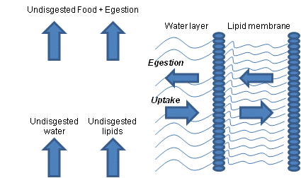
Figure 11 – Exchange processes taking place across gastro intestinal tract (GIT)
It is assumed that chemical exchanges across the gastro intestinal tract (GIT) are driven by diffusion gradients i.e. the concentration differences between phases within the fish and its food/feces. These exchanges are assumed to be mainly simple molecular diffusions. Although alternative diffusion mechanisms were proposed (e.g. lipid micelle-mediated diffusion model), their role in controlling dietary exchanges of fish is not well established (Barber 2008).
In our model ingestion rate constant of chemicals is related to:
- the distribution of food between digested and undigested fractions respectively, represented by an assimilation fraction Assimilated_food. Assimilated food may be allocated to production of somatic or gonadal biomass. Dietary assimilation efficiencies reflect dietary matrix (e.g. organic matter quality and quantity), and digestive physiology of the organism e.g., feeding rates and gut retention time.
- the assimilation fraction of the chemical. For this purpose, food is assumed to be composed of lipids and water only, in respective proportions p_lipid_food and (1- p_lipid_food). The assimilation fraction of the chemical contained in water is directly related to the assimilation fraction of food; the assimilation fraction of the chemical contained in lipids is related to the assimilation fraction of food but also to the octanol-water partition coefficient K_{OW};
- partial resistance from water layer. As for respiratory uptake, the resistance for diffusion through water layer is considered to be the same for different chemicals because molecular weights and volumes are in the same order of magnitude;
- partial resistance from lipid layer (encountered to and from food), assumed to be inversely proportional to octanol-water partition coefficient K_{OW};
- a flow delay of food and feces, depending on the fraction of undigested chemical contained in lipids;
- an allometric rate exponent describing the effect of species weight on ingestion and egestion rate constants. In the MERLIN-Expo model, the weight of each species is assumed to be those at adult age.
Besides, the ingestion and egestion rate constants are related: their ratio represents indeed the ratio between the food assimilated and non-assimilated fractions, i.e. Assimilated_food/(1-Assimilated_food).
Model type
Empirical [ ] vs mechanistic [X]
Steady-state [ ] vs dynamic [X]
Analytical [X] vs numerical [ ]
Alternatives and limits
Alternatively, bioaccumulation models employ dietary uptake formulations based on assimilation efficiencies at equilibrium.
Models applying assimilation implicitly assume that chemical equilibrium assimilation efficiencies describe the net chemical exchange between fish and their food. These models describe a fish’s chemical elimination either as a single, lumped parameter process that is independent of the fish’s egestion rate or as a process that does not require an explicit fecal egestion term.
Chemical assimilation efficiencies via food often have been considered only as functions of K_{OW}, similarly to what is established for respiratory uptake. Moreover, as far as the fish’s dietary assimilation efficiencies are concerned, Thomann et al, 1992 concluded that a fish’s dietary and gill assimilation efficiencies could be estimated with the same empirical function of K_{OW}. As presented in 4.1, these relations are presented often as hyperbolic functions (i.e. AE_diet = (a₀ + a₁K_{OW})⁻¹)). One example of this approach is described by Gobas et al, 1988 (see paragraph ‘Alternatives and limits’ in ‘Process n°1: Respiratory uptake of chemicals’).
Another relationship for deriving assimilation efficiency based on the same modeling framework is proposed by Clark et al, 1990:

$$AE_diet=\left\{\begin{aligned}2,25+1,67∙ {10}^{-8} Kow for guppies \\ 1,83+1,02∙ {10}^{-7}Kow for goldfish \\ 1,32+1,39 ∙ {10}^{-9}Kow for rainbow trout \end{aligned}\right.$$
Some other models used as parameter the Partition coefficient of the chemical between the GIT (gastrointestinal tract) and the organism that expresses the change in phase partitioning properties that occurs as a result of digestion of the diet.

Process n°4: Respiratory excretion of chemicals
Motivation
Excretion can be seen as a release of chemicals from fish’s water compartment via respiratory route. Chemical uptake via the respiratory surface (fish’s gill) of the organism (as described in 2.1) is associated to chemical excretion associated to the outflux of water via the respiratory surface. Both processes are influenced by the same factors connected with respiration.
Selected model and assumptions
Many experiments were conducted under controlled laboratory conditions where dietary uptake is considered negligible. Under such conditions, equilibrium between concentration of the chemical in fish tissues and surrounding water can be reached. The bioconcentration factor (BCF), defined as the ratio at equilibrium of biota concentration of the substance to water concentration, can then be defined. As equilibrium condition is assumed to be reached, BCF also represents the ratio between respiratory uptake rate and excretion rate. In the MERLIN-Expo model, we then use the bioconcentration factor (BCF) to estimate the excretion rate (k_excretion) and to reflect affinity of the substance for staying in the lipid compartment of the organism (Mackay&Fraser, 2000).
The BCF concept was originally developed for hydrophobic organic substances and several quantitative structure-activity relationship (QSAR) techniques were proposed to predict BCF from chemical descriptors of hydrophobicity like octanol-water partition coefficients (see 3.2.4.1).

Model type
Empirical [ ] vs mechanistic [X]
Steady-state [ ] vs dynamic [X]
Analytical [X] vs numerical [ ]
Alternatives and limits
Hendricks (2001) also considered that the ratio between the respiratory uptake rate and the excretion rate is constant, but did not explicitly used a BCF for representing this ratio. He assumed that the ratio depends on the lipid fraction of fish tissues and on octanol-water partition coefficient (K_ow). Assumptions behind this formulation are identical to those used in QSAR models to predict BCF from chemical descriptors of hydrophobicity (like K_{OW}) (Gobas et al 1986, Schüürmann et al 2007).
Other proposed alternative approach is based on a concept that a fish’s whole body is as series of homogenous phases (i.e. lipid, non-lipid organic matter, and water), and that thermodynamic partitioning coefficient describes distribution of chemicals between these phases. Body composition and K_{OW} determine organism-water partition coefficient. Partitioning between non lipid organic matter and water can be related to K_{OW} by applying proportionality constant (Arnot et al 2004).
Another alternative to model the distribution of chemicals between different internal phases of a fish is the physiologically based toxicokinetic modeling approach. In this approach, the chemicals in aqueous phase carried by fish’s blood, when pass through organs equilibrate with different lipid/organic phases within these organs. The internal aqueous concentrations are dynamic functions of organ-specific partition coefficients, perfusion rates and blood paths (Barber 2003, Nichols et al. 1990).
Non-physiologically based multicompartmental models have also been used to describe the uptake and internal deposition of chemicals by fish (Barber 2003, Koenemann et al. 1980).

Process n°5: Elimination of chemical through growth
Motivation
Part of the energy ingested by the organism is spent on production of new biomass. Production of biomass, and as a consequence dilution of chemicals in fish is expressed as biomass production rate constant k_growth (resulting in a decrease of chemical concentration in fish tissues because of dilution in an increasing volume). The k_growth is related to mass and life time of the organism.
Selected model and assumptions
As fish weight and time life are used for other parameters in the MERLIN-Expo model, and for guaranteeing consistency, the growth rate of a given species is calculated by dividing the weight at adult age and the time needed for reaching maturity. The model then assumes a linear growth during juvenile period of time.
Two kinds of elimination via biomass production have to be taken into account. First occurs only due to weight increase, and second is achieved by somatic and gonadal growth, replacement of tissues as well as birth and death of individuals in the population. Actually, both kinds of elimination by biomass are taken into account in the MERLIN-Expo model. The first one (weight increase of each individual fish) is explicitly taken into account by calculating growth rate of each fish individual. The second one is implicitly taken into account by introducing the average lifetime of each individual that leads to a continuous renewal of fish population (i.e. death of old potentially contaminated individuals replaced by newborn non contaminated individuals). Chemical elimination pathways are considered as parallel, the overall removal of chemicals will be largely determined by the fastest route. Therefore, production of biomass account for elimination of extremely hydrophobic chemicals that are highly retained in fish lipid tissues.
Model type
Empirical [ ] vs mechanistic [X]
Steady-state [ ] vs dynamic [X]
Analytical [X] vs numerical [ ]
Alternatives and limits
In other models, the rate for biomass production is considered as a function of species weight and production coefficient. Dilution via biomass production takes into account the addition and repulsion of tissues from organism (shedding of biomass) in the form of coefficient (γ_biomass). Although biomass production rate varies considerably among species as a function of size, temperature, prey availability and quality, and other factors, general correlation of biomass production rate to species size provides reasonable approximation (Arnot et al 2004).
Additional feature that can be considered for applying to calculating biomass production rate is a temperature correction factor, which according to Hendriks 2001, equals to 1 for cold-blooded and 10 for warm-blooded organisms.

Process n°6: Metabolic biotransformation elimination (only for organics)
Motivation
One of the routes of chemical elimination in fish is metabolic transformation. Negligible biotransformation rates are often assumed for screening level hazard and risk assessment, thus resulting in overestimates of bioaccumulation, exposure, and risk for chemicals that undergo biotransformation processes. Biotransformation can lead to reduction in bioconcentration of some non-ionic substances due to reactions associated with certain functional groups. Schüürmann et al. (2007) states that for predictive BCF assessment, factors such as biotransformation should be taken into account.
In MERLIN-Expo, we apply a quantitative structure-activity relationship (QSAR) model to predict biotransformation half-lives and rate constants (λ_metabolism) for organic chemicals in fish.
Selected model and assumptions
In our model biotransformation is defined as a change of the parent substance to another molecule or a conjugated form of the parent substance. The model assumes first-order processes and cannot estimate biotransformation rates that may occur under non-first-order conditions e.g. enzyme saturation.
Metabolic biotransformation has a larger influence on bioaccumulation factor for more hydrophobic chemicals. This is because the rates of chemical elimination by gill respiration become slower with increasing hydrophobicity of contaminants. When metabolic biotransformation rate (λ_metabolic) is negligible, total elimination (i.e. sum of respiratory, excretion, growth, and metabolic eliminations) of chemicals from fish organism is determined by slow rates of growth and egestion. Meaning that even low values of λ_metabolic has a significant effect on total elimination of chemicals from animal body, thus also on reducing bioaccumulation (Arnot et al, 2009).
QSAR predictions of metabolic biotransformation are functions of structural properties, additionally the predictions derived from the QSAR model used in the MERLIN-Expo tool are presented as normalised values to 0.01 kg fish and 15°C. Therefore, for comparison of models’ estimates and use in mass balance models, it is recommended to convert QSAR predicted values to body weight and temperature specific values.
Model type
Empirical [ ] vs mechanistic [X]
Steady-state [ ] vs dynamic [X]
Analytical [X] vs numerical [ ]
Alternatives and limits
Biotransformation rate constant alternatively can be calculated as the difference between two quantities, a measured bioconcentration factor or elimination rate constant, and a model-derived bioconcentration factor or elimination rate constant estimated assuming no biotransformation.
Selected model does not provide predictions for the formation of specific biotransformation products nor does it inform about characteristic pathways for the biotransformation processes.
The model cannot differentiate between stereoisomers and does not provide estimates for rates of potential bioisomerisation (Arnot et al, 2009).

Process n°7: Bioaccumulation/Bioconcentration of metals
Motivation
Bioaccumulation of metals via the respiratory pathway can occur across body surfaces such as gill and is generally described by the bioconcentration factor (BCF), defined as the ratio at equilibrium of the substance concentration in fish tissue to water concentration in water. The BCF concept was originally developed for hydrophobic organic substances. Simple passive diffusion across the lipid biomembranes is believed to be the key process for the accumulation of neutral hydrophobic substances in biota, which ensures BCF is independent of exposure concentrations (McGeer et al. 2003). In the case of metal, however, the assumption of BCF being independent of exposure concentrations is controversial. As a result of complex physiological processes such as sequestration, detoxification, storage, branchial elimination, biota is often actively able to regulate metal bioconcentration via dynamic reaction systems that respond to environmental loading and maintain homeostasis (Chapman et al. 1996; Hamilton et al. 1986). In addition, Deforest et al. (2007) hypothesized the trend in which metal uptake increases at lower exposure concentrations, according to the basis that organisms actively uptake essential metals at low concentrations to satisfy metabolic requirements. Non essential metals would also be regulated because the mechanisms for regulating essential metals are not metal-specific (Phillips and Rainbow 1989).
Selected model and assumptions
Based on the factors influencing metal uptake and accumulation described above, it was assumed BCF values for metals are not independent of exposure. In the MERLIN model, the BCF is then assumed to be related to the metal concentration in water. Several authors observed an inverse linear relationship between BCF and the total metal concentration in water in log units, i.e. (Hendriks 2001, McGeer et al. 2003, Deforest et al., 2007, Tanaka et al, 2010). However, this relationship being parameterized for some metals only, the parameter b_{BCF} will be set at zero for metals with poor datasets.
Model type
Empirical [X] vs mechanistic [ ]
Steady-state [ ] vs dynamic [X]
Analytical [X] vs numerical [ ]

Process n°8: Ingestion of metals
Motivation
Aquatic organism can also accumulate metals through ingested food. After ingestion, some of the metals can be released from the ingested food (generally under particulate forms) into the gastrointestinal tract fluids of the animal and become available for assimilation into the tissue of the animal.
Selected model and assumptions
Ingestion of metals (k_ingestion) in the MERLIN model is directly related to assimilation efficiency and ingestion rate (Ingestion_rate). Food assimilation efficiencies can vary significantly with environmental and physiological conditions for any given animal. It depends also on animals’ position in the food web and different feeding and digestion strategies, and also on food quality. Way in which metals are processed during digestion can play significant role in different assimilation efficiencies among aquatic species.
Efficiencies for assimilation of metals can be highly variable. Hendriks reports that confidence intervals for assimilation efficiencies for metals are large, indicating that experiments were difficult and yielded inconsistent results. This variability can be attributed to food quantity, and quality. Differences between elements were associated with their affinity for digestible and nondigestible food components such as polar cytosol, and nonpolar membrane respectively.
Considering these large uncertainties, it seems conservative to consider that metal assimilation efficiency is assimilated to food assimilation efficiency.
Model type
Empirical [X] vs mechanistic [ ]
Steady-state [ ] vs dynamic [X]
Analytical [X] vs numerical [ ]
Alternatives and limits
Calculation of assimilated fraction of metals from food can be done by correlating to affinities for body components, resistances in lipid and layers, transport coefficients, and metals exposure concentration in water and food (Hendriks et al 2001).

Process n°9: Excretion and egestion of metals
Motivation
When exposed to elevated metal concentrations, aquatic organisms can control bioaccumulation by moderating uptake and elimination processes. Moreover, concentrations of essential metals (Zn, Cu) tend to be highly regulated compared to nonessential elements (Cd). The mechanisms for reducing metal accumulation and toxicity vary with organism and include uptake inhibition, detoxification, storage (binding to metallothioneins, and other proteins) and increased elimination. These are natural mechanisms developed to deal with accumulation of metals.

Selected model and assumptions
In MERLIN-Expo model, elimination of metals consists of two depuration processes i.e. excretion and egestion. Both rate constants are inversely proportional to the weight of the organism according to the relationship proposed by Hendriks et al 2001; results yielded by Hendrik’s model show k_elimination and organism weight are inversely related, taking respectively for cold-blooded organisms 0.002·W^{-κ}, and warm-blooded organisms 0.01·W^{-κ}. Additionally, depuration rate constants show no metal-specific character (Veltman et al 2008), and high variability among metals for higher animals like fish (McGeer et al 2004).
Model type
Empirical [X] vs mechanistic [ ]
Steady-state [ ] vs dynamic [X]
Analytical [X] vs numerical [ ]

End of Level 2 documentation (end-user with expertise in process)

Level 3 documentation (numerical information)

Numerical default values (deterministic and/or probabilistic)

Initialization of concentrations in Media
The ‘regulatory state variable’, i.e. the concentrations of the chemical in fish (i.e. C_fish (mg.kg⁻¹)) must be initialized (i.e. value for time=0). By default, no contamination is assumed at the beginning of the simulation, i.e. the concentration in fish is put at zero, but end-user must adapt these values according to their specific case studies.

Default parameter values

Site-specific parameters

Fish diet preference for food item i (pref_diet_1 to pref_diet_10)
Physical/chemical/biological/empirical meaning
The sum of the specific fractions of diet constituents of preying aquatic species (here a fish species) adds up to 1. According to the fish species, the diversity of food items is highly variable and can target either phytoplankton, zooplankton, benthos and/or other fish species.
Role in the model
Organisms’ preferences for certain foods are used to calculate the concentration of the chemical substance that is absorbed with ingested diet. We distinguish preference parameters that are associated to each of the ten potential diets that were (arbitrary) defined in the MERLIN-Expo model. The sum of these 10 dietary preferences must be unity (i.e. $\sum_{i=1}^{i=10}{Pref_{diet_{i}}=1}$).
Database used for parameter estimation
Diet preferences are specific to the fish species that are investigated in the scenario and to the site; they must then be informed case by case by end-user.
We give however below some examples of dietary preferences identified in several aquatic systems for fish species. Campfens and Mackay (1997) give some examples of diet preferences for several fish species and applied these data for studying the bioaccumulation of PCBs in aquatic food webs (Table 1). Gandhi et al (2006) identified diet preferences for fish species found in a Norwegian lake (Table 2). Nfon and Cousins (2007) proposed dietary preferences relevant for Baltic food webs (Table 3). Lim and Lastoskie (2011) designed a food web for the Erie lake (Figure 12).

Fish species/Diet preference | Mysid 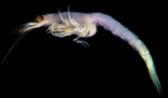 | Pontoporeia  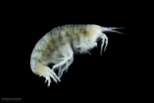 | Alewife  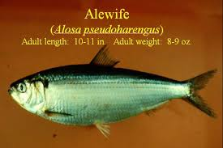 | Sculpin   | Smelt  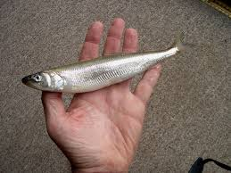
Sculpin | 0.18 | 0.82
Alewife | 0.60 | 0.40
Smelt | 0.54 | 0.21 | 0.25
Salmonids  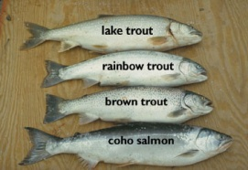 |  |  | 0.5 | 0.1 | 0.4
Table 1 – Diet preferences for different fish species (from Campfens and Mackay, 1997)

Fish species/Diet preference | Zooplankton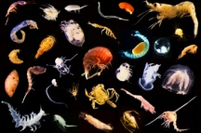 | Chironomid  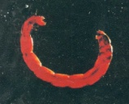 | Caddishfly  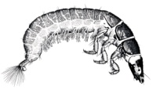 | Small char  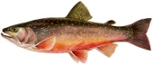
Small char  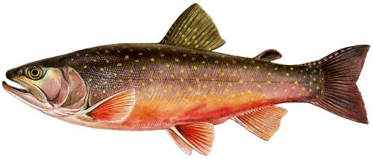 | 0.30 | 0.60 | 0.10
Large char   | 0.10 | 0.70 | 0.10 | 0.10
Table 2 – Diet preferences for different fish species (from Gandhi et al, 2006)

Fish species/Diet preference | Mesozooplankton | Pelagic macrofauna | Benthic macrofauna | Sprat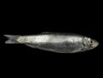 | Herring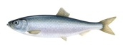
Sprat (juvenile or adult)  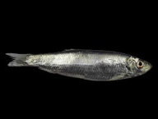 | 1
Juvenile herring  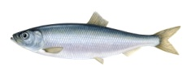 | 0.9 | 0.06 | 0.03 | 0.14
Adult herring | 0.87 | 0.1 | 0.03 | 0.102
Juvenile cod  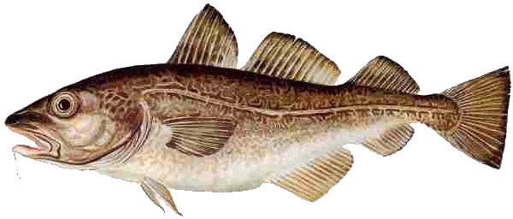 |  |  | 0.47 | 0.14 | 0.25
Adult cod |  |  | 0.22 | 0.31 | 0.37
Salmon  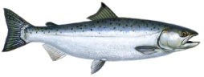 |  |  |  | 0.72 | 0.28
Table 3– Diet preferences for different fish species (from Nfon and Cousins, 2007)

Figure 12 - Diet preferences for different fish species (from Lim and Lastoskie, 2011)

Parameter estimation type
Statistical analysis of large database [ ]
Calibration [ ]
Extrapolation [ ]
Expert elicitation [ ]
Bayesian approach [ ], eventually
QSAR or read-across [ ]
Mechanistic model [ ]
Perfect information [x] to be informed by the end user case by case
Parameter estimation description
The examples provided above demonstrate that end-users have to inform these parameters for their own case study. As default values and for simplification, we estimated only one source of diet in the MERLIN-Expo model, but the software offers the opportunity to build more complex food webs.
Parameter default value and PDF

pref_diet_1 = 1 (unitless)
pref_diet_i = 0 (unitless) for i=2 to 10

Fish physiological parameters

Fish age at maturity (time_fishlife)
Physical/chemical/biological/empirical meaning
Fish body length and weight change over organism’s lifetime, what is expressed as a growth of an organism. Fish lifetime also governs the renewal of fish population, with the death of old potentially contaminated fish and the renewal by neonates that are not contaminated.
In the MERLIN-Expo model, the fish lifetime is defined as the time needed for reaching maturity rather than maximum reported age. Time to reach maturity corresponds indeed to the growth period of the fish where fish body length and weight change, and it also generally corresponds to the time when fish can be caught for human food.
Role in the model
We recognize that fish grows in time and suffers from natural mortality. Therefore we include time_fishlife parameter for correcting concentration of chemicals in fish body for a given maximum attainable age of the fish. time_fishlife is used in calculating fish growth rate (k_growth).
Database used for parameter estimation
Fishbase.org database (http://www.fishbase.org) can be used as a reference for specific fish age as well as other measurements. We provide here some examples to illustrate that such information can be found in the reported database, but end-user have to consult the freely available database for each specific fish species.

Species | Lifetime (maturity) (in years)
European Seabass Dicentrarchus labrax | Mediterranean sea: 2-4  Atlantic-Males: 4-7  Atlantic-Females: 5-8
Trout Salmo trutta | 3-4
Yellow Perch Perca flavescens | 2-4
Table 4 – Age at maturity for different fish species (from www.fishbase.org)
Parameter estimation type
Statistical analysis of large database [ ]
Calibration [ ]
Extrapolation [ ]
Expert elicitation [X]
Bayesian approach [ ], eventually
QSAR or read-across [ ]
Mechanistic model [ ]
Perfect information [ ] to be informed by the end user case by case
Parameter estimation description
Age of the fish should be specified according to user’s case study. For taking growth of fish into account age at maturity is recommended as an input parameter.
Parameter default value and PDF
As an example, trout (Salmo trutta) was chosen as default values and PDFs proposed in the MERLIN-Expo model. These values must however be adapted according to the targeted fish species.

Best estimate (time_fishlife) = 1280 (days)
PDF (time_fishlife) = U (min=730 ; max=1460)

Fish length at maturity (L_fish)
Physical/chemical/biological/empirical meaning
We refer to the body length (cm) of a fish at maturity and a given time of its life, without specifying whether it was measured as total length, standard length or fork length. Different measurements of fish length are depicted below:

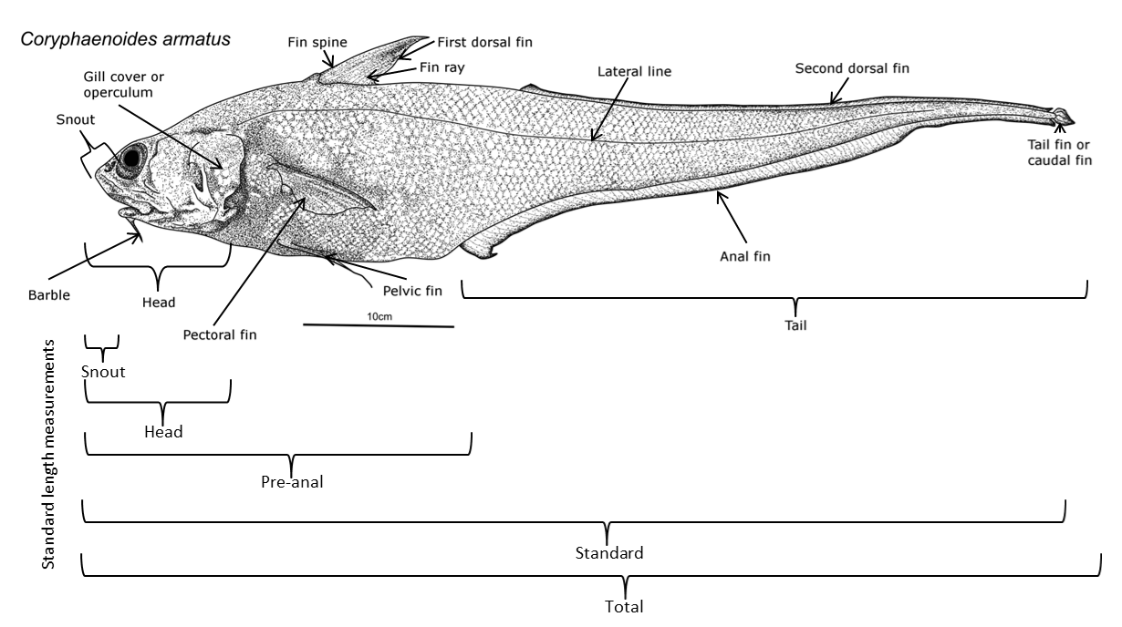
Figure 13 - Fish length measurements (http://en.wikipedia.org/wiki/Fish_measurement)
Factors influencing parameter value
Length of fish changes with animal’s age.
Role in the model
The body length at maturity is used for calculating the fish weight at fish maturity W_fish (see 3.2.2.3 and 3.2.2.4).
Database used for parameter estimation
End user informs fish length L_fish for individual species. FishBase.org database may support choice of lengths of various species. Other data can be found in http://animaldiversity.ummz.umich.edu. We provide here some examples to illustrate that such information can be found in the reported database, but end-user have to consult the freely available database for each specific fish species.

Species | Body length (at maturity) (in cm)
European Seabass Dicentrarchus labrax | 23-100
Trout Salmo trutta | 18-56
Yellow Perch Perca flavescens | 10-25
Table 5 – Age at maturity for different fish species (from www.fishbase.org or animaldiversity.ummz.umich.edu)
Parameter estimation type
Statistical analysis of large database [ ]
Calibration [ ]
Extrapolation [ ]
Expert elicitation [X]
Bayesian approach [ ], eventually
QSAR or read-across [ ]
Mechanistic model [ ]
Perfect information [ ] to be informed by the end user case by case
Parameter estimation description
Length of fish (L_fish) should be specified according to user’s case study. For taking growth of fish into account Length of fish at maturity is recommended as an input parameter.
Parameter default value and PDF

Best estimate (L_fish) = 37 (cm)
PDF (L_fish) = U (min=18 ; max=56)
As an example, trout (Salmo trutta) was chosen as default values and PDFs proposed in the MERLIN-Expo model. These values must however be adapted according to the targeted fish species.

      - Intercept of weight-length relationship (a_W_fish)
and
      - Slope of weight-length relationship (b_W_fish)
Physical/chemical/biological/empirical meaning
Fish body mass can be described as a function of age. Age data can be obtained by counting of year rings on fish scales or otoliths. These rings result from fluctuation in environmental conditions between summer and winter periods. While age reading from rings on scales or otoliths is relatively simple for fish from temperate waters, tropical fish species do not show clear year-rings on their scales/otoliths because of the lack of strong seasonality in environmental conditions. For these species numerical methods involving length-age relationship become particularly useful.
One of the most commonly used models for determining mass of individual species was developed by von Bertalanffy (1934), and is based on assumption that body length is a function of age. Size of fishes is often measured in body length. However, for regulation of catches and estimation of biomass the information about body weight is required.
As fish grows in length, it increases in weight. The relationship between weight and length is not linear. The relationship between length (L_fish) and weight (W_fish) is expressed by formula including allometric exponent b_W_fish and y-intercept a_W_fish.
Factors influencing parameter value
Fish weight is dependent on length.
Role in the model
Coefficient a_W_fish and exponent b_W_fish are used for calculating weight of fish based on given animal’s length. For simplicity end user may assume exponent b_W_fish to be equal 3.0 if detailed information is lacking (Introduction to Tropical Fish Stock Assessment - Part 1: Manual).
Database used for parameter estimation
Length-weight parameters for fish species can be found at: http://www.fishbase.org/Topic/List.php?group=12. The length-weight tables present the a_W_fish and b_W_fish values of over 5,000 length-weight relationships of the form W_fish = (a_W_fish∙L_fish^{b_W_fish})/1000 (or, after transformed to linear regression lnW_fish=lna_W_fish+b_W_fish∙lnL_fish), pertaining to about over 2,000 fish species. Users can enter and plot their own estimate for comparisons in FishBase.
We provide here some examples to illustrate that such information can be found in the reported database, but end-user have to consult the freely available database for each specific fish species.

Species | Number of data | a_W_fish  (geometric mean) | GSD a_W_fish | b_W_fish (arithmetic mean) | SD  b_W_fish
European Seabass Dicentrarchus labrax | 18 | 0,0098 | 1.5 | 3,05 | 0,12
Trout Salmo trutta | 62 | 0.01 | 1.78 | 3.03 | 0.16
Yellow Perch Perca flavescens | 9 | 0.0141 | 1.91 | 3.02 | 0.19
Table 6– Length-weight relationship for two fish species

Parameter estimation type
Statistical analysis of large database [X]
Calibration [ ]
Extrapolation [ ]
Expert elicitation [ ]
Bayesian approach [ ], eventually
QSAR or read-across [ ]
Mechanistic model [ ]
Perfect information [X] to be informed by the end user case by case
Parameter estimation description
The range of specie-specific parameters a_W_fish and b_W_fish values together with means and standard deviations of these parameters can found in http://www.fishbase.org/Topic/List.php?group=12.
Parameter default value and PDF
Best estimates can be chosen from FishBase database. Log-normal distributions can be attributed to a_W_fish and normal distributions can be attributed to b_W_fish parameters. As an example, trout (Salmo trutta) was chosen as default values and PDFs proposed in the MERLIN-Expo model. These values must however be adapted according to the targeted fish species.

Best estimate (a_W_fish) = 0.01 (unitless)
PDF (a_W_fish) = LN (GM=0.01 ; GSD=1.78)

Best estimate (b_W_fish) = 3.03 (unitless)
PDF (b_W_fish) = N (AM=3.03 ; SD=0.16)

Allometric rate exponent (kappa) κ
Physical/chemical/biological/empirical meaning
Allometric relationships provide body-size specific parameters instead of values that are arbitrary or taken from a well-known species. Allometry, or the biology of scaling, is the study of size and its consequences. It has become a useful tool for comparative physiology. There are several empirical allometric equations that relate body size to many parameters, including ingestion rate, lifespan, inhalation rate, mortality, age at maturity, maximum density, territory size, rate constants, etc. Even if these relationships were originally derived from empirical observations, there is a growing body of evidence that these relationships have their origins in the dynamics of energy transport mechanisms. From a meta-analysis based on 230 relationships, slopes of allometric regressions were shown to be mutually consistent with rate constants, and generally decrease with organism mass at a constant exponent (Hendriks 2007).
Factors influencing parameter value
Differences in allometric regressions can be observed according to temperature, trophic position and evolutionary history (for example between plants, invertebrates, cold-blooded vertebrates and warm-blooded vertebrates). Cold-blooded species have generally lower rate constants but reach higher ages and densities than equally sized warm-blooded organisms. Intercepts of body size distributions tend to decrease with trophic position (Hendriks 2007).
Role in the model
Slope of allometric regression κ is a component of each rate constant used in fish bioaccumulation model. Moreover, allometric rate exponent affects the values and uncertainties of the transport coefficients γ, because it is used in the allometric relations from which the transport coefficients are derived.
Database used for parameter estimation
Hendriks et al (2007) conducted a meta-analysis on 230 allometric regressions derived from over 100 publications. The relationships were shown to be consistent and rate constants generally decrease with organism mass at an exponent of -0,25.
The range of the slope of allometric regression is derived from reviews of empirical studies that have shown that the exponent is usually within the range of 0,25 to 0,33, theoretically explained by food-web networks and surface-volume relationships (Hendriks, 2001).
Parameter estimation type
Statistical analysis of large database [X]
Calibration [ ]
Extrapolation [ ]
Expert elicitation [ ]
Bayesian approach [ ], eventually
QSAR or read-across [ ]
Mechanistic model [ ]
Perfect information [ ] to be informed by the end user case by case
Parameter estimation description
The parameter estimation was based on the range observed by Hendriks et al (2007) in their meta-analysis, and reported by Hauck et al (2011).
Parameter default value and PDF

Best estimate (κ) = 0,25 (unitless)
PDF (κ) = N (µ=0,25 ; SD=0,11)

Lipid fraction of food item i (p_lipid_1 to p_lipid_10)
And

Lipid fraction of fish (p_lipid_fish)
Physical/chemical/biological/empirical meaning
The lipid fraction in food represents the fraction of lipid ingested by fish with diet. It is related to the trophic level of each specific prey. The lipid fraction of fish is related to fish species.
Factors influencing parameter value
The parameter p_lipid_i depends on the prey that is considered and on its trophic level.
Role in the model
p_lipid_i/fish affects the estimation of the partial resistances (ρ). It is used in calculating fish’s inflow and outflow rates of chemicals through water/food and feces respectively.
Database used for parameter estimation
If the prey is another fish species (for carnivorous fish species), the values proposed in 3.2.2.7 can be used. Some examples of lipid fractions in aquatic organisms other than fish are reported in Table 7 .

Species | Lipid fraction | Reference
Chironomids | 0.03 | Gandhi et al, 2006
Caddishfly | 0.03
Plankton | 0.015 | Campfens et al, 1997
Mysid | 0.04
Pontoporeia | 0.03
Oligochaete | 0.01
Plankton | 0.015 | Lim et al, 2001
Diporeia | 0.03
Mysid | 0.04
Phytoplankton/Phytobenthos | 0.005 | Ciavatta et al, 2009
Zooplankton | 0.05
Macrobenthos | 0.012 – 0.05
Plankton | Mean=0.012  SD=0.0024 | Morrisson, 1997
Zebra mussels | Mean=0.013  SD=0.0034
Caddishfly larvae | Mean=0.017
Gammarus | Mean=0.021  SD=0.0104
Amphipod | 0.018 | Watanabe, 2004
Aquatic vegetation | 0.016
Aquatic insect | 0.05
Grass shrimp | 0.022
Phytoplankton | 0.023 | Webster, 2012
Zooplankton | 0.018
Bay scallop/Clam | 0.053
Whelk (gastropod mollusc) | 0.062
Shrimp/Crab | 0.066
Table 7 – Lipid fraction in several species reported in different literature sources
For carnivorous fish, one or several food items can be based on other fish species. Lipid content of fish species can be derived using data from literature. Some examples of fish lipid fractions are reported in Table 8

Species | Lipid fraction | Reference
Sprat | 0.04 | Nfon and Cousins, 2007
Juvenile Herring | 0.04
Adult Herring | 0.044
Juvenile Cod | 0.05
Adult Cod | 0.055
Salmon | 0.16
Large Char | 0.05 | Gandhi et al, 2006
Small Char | 0.0314
Sculpin | 0.08 | Campfens et al, 1997
Alewife | 0.07
Smelt | 0.04
Salmonid | 0.16
Golden shiner | 0.0265 | Lim et al, 2001
Bluntnose minnow | 0.0435
Yellow perch | 0.0179
Smallmouse bass | 0.0141
Lake trout | 0.2
Chelon labrosus | 0.068 | Ciavatta et al, 2009
Atherina boyeri | 0.096
Zosterisessor ophiocephalus | 0.11
Sparus aurata | 0.097
Dicentrarcus labrax | 0.13
Crayfish | Mean=0.017  SD=0.0011 | Morrisson, 1997
Mullet | 0.044 | Webster, 2012
Wolffish/Flathead/Catfish | 0.037
Weever | 0.046
Table 8 – Lipid fraction in several fish species reported in different literature sources
Parameter estimation type
Statistical analysis of large database [X]
Calibration [ ]
Extrapolation [ ]
Expert elicitation [ ]
Bayesian approach [ ], eventually
QSAR or read-across [ ]
Mechanistic model [ ]
Perfect information [ ] to be informed by the end user case by case
Parameter estimation description
Data reported in Table 7 give a good overview of extreme values that can be found for the lipid fraction in different preys that can be involved in fish diet. Data reported in Table 8 give a good overview of extreme values that can be found for the lipid fraction in different fish species. In the MERLIN-Expo model, we considered a generic prey species and we proposed then a PDF covering all the range of potential lipid fraction values. However, if the end-user specifically studies a given species with its associated preys, it is recommended to adapt the value of this parameter to better fit with the actual physiology of the investigated prey. In the MERLIN-Expo model, we used as default value those defined for trophic level 2.
Parameter default value and PDF
If the prey belongs to trophic level 1 (phytoplankton)
Best estimate (p_lipid_i) = 0,02 (unitless)
PDF (p_lipid_i) = U (min=0,01 ; max=0,03)

If the prey belongs to trophic level 2 (invertebrates)
Best estimate (p_lipid_i) = 0,04 (unitless)
PDF (p_lipid_i) = U (min=0,01 ; max=0,07)

If the prey belongs to trophic level 3 (fish)
Best estimate (p_lipid_i) = 0,05 (unitless)
PDF (p_lipid_i) = LU (min=0,01 ; max=0,2)

Fraction of assimilated food (Assimilated_food)
Physical/chemical/biological/empirical meaning
The fraction of food assimilated by fish, noted Assimilated_food represents the fraction of ingested food that is absorbed or digested by the organisms and spent on production and respiration.
Factors influencing parameter value
The fraction of food assimilated by fish depends on fish species, prey species (position in the trophic chain) as well as energetic budget in fish driven by physico-chemical conditions and health status.
Role in the model
Assimlilated_food affects the estimation of the partial resistances for chemical uptake (ρ) and is used in calculating fish’s inflow and outflow rates of chemicals through water/food and feces respectively.
Database used for parameter estimation
In the MERLIN-Expo model, we considered the uncertainty ranges proposed by Hauck et al, 2011, based on previous publications which reviewed assimilation fractions for several organisms.
Parameter estimation type
Statistical analysis of large database [X]
Calibration [ ]
Extrapolation [ ]
Expert elicitation [ ]
Bayesian approach [ ], eventually
QSAR or read-across [ ]
Mechanistic model [ ]
Perfect information [ ] to be informed by the end user case by case
Parameter estimation description
Hauck et al (2011) proposed a logit distribution to describe the uncertainty of assimilation fraction for organisms belonging to trophic level 3 (i.e. fish in our case). The logit distribution is however difficult to manage and it was here preferred to use an equivalent type of distribution, i.e. the beta distribution. The logit-normal distribution proposed by Hauck et al (2011) were then numerically analysed to derive the moments (percentiles 5 and 95%) and an equivalent Beta PDF was fitted from this analysis.
Parameter default value and PDF
Best estimate (Assimilated_food) = 0,73 (unitless)
PDF (Assimilated _food) = beta (α=50 ; β = 18.5)

Chemical parameters

Octanol-water partition coefficient (log10_K_ow)
Physical/chemical/biological/empirical meaning
The partition coefficient of a substance between water and a lipophilic solvent (n-octanol) characterizes the equilibrium distribution of the chemical between the two phases. The partition coefficient between water and n-octanol (K_{ow}) is defined as the ratio of the equilibrium concentrations of a chemical in octanol saturated with water and water saturated with octanol. The parameter characterizes the equilibrium distribution of the chemical between the two phases and hence represents the degree to which a chemical prefers organic material to water.
Factors influencing parameter value
In accordance with Nernst’s law, K_ow is independent from compound absolute concentration in n-octanol and water. K_ow is usually weakly dependent on temperature, and experiments to measure K_ow values are set to standard conditions i.e. 25°C and 1 atm (OECD protocol). Large organic compounds or highly nonpolar compounds exhibit a high degree of hydrophobicity. Such hydrophobic substances tend to partition to octanol rather than to water and hence have large values of K_{ow}. In contrast, smaller or polar substances are less hydrophobic and have smaller values of K_{ow}. The range of K_{ow} is many orders of magnitude for variety of organic compounds. Literature value with log K_ow > 6 may contain significant error and thus should be carefully checked. Application of K_ow implies that the solute under consideration has identical speciation in both phases. Processes such as complex formation, dissociation and protonation in at least one of the two phases lead to more complex distribution phenomena. K_{ow} is not an accurate determinant of lipophilicity for ionizable compounds because it only correctly describes the partition coefficient of neutral (uncharged) molecules. For example, the parameter is not a good predictor of drug behaviors in the changing pH environments of the body because the majority of them are ionizable.
Role in the model
Hydrophobicity of chemicals moderate resistance they encounter while passing through organic membranes i.e. the resistance. The resistance processes are governed by the lipid content of the fish organs. Octanol-water partition coefficient is used as a surrogate for Lipid-water partition.
Database used for parameter estimation
Experimental protocols to measure K_{ow} are well established and standardised, for example, in OECD guidelines (OECD, 2006; OECD, 2004; OECD 1995). When the parameter is measured following such well-established experimental protocols, it can be assumed that the obtained values of K_{ow} are not likely to be very variable. The measurement values of K_{ow} are available for many of well-recognized toxic substances. Therefore, in this document, measurement data were selected for the determination of default K_{ow} values.
The measurement data were obtained from OECD (2004) and from the software called EPI-Suite developed by US-EPA (http://www.epa.gov/opptintr/exposure/pubs/episuite.htm). The measurement data in EPI-Suite were initially entered by junior and senior scientists using many sources for which the data had already been carefully evaluated, and then were checked by senior scientists.
Parameter estimation type
Statistical analysis of large database [X]
Calibration [ ]
Extrapolation [ ]
Expert elicitation [ ]
Bayesian approach [ ], eventually
QSAR or read-across [X]
Mechanistic model [ ]
Perfect information [ ] to be informed by the end user case by case
Parameter estimation description
The QSAR approach used in the EPI-Suite (i.e. “KOWWIN”) was applied to estimate K_{ow} in the case where no measurement was available. The approach uses a "fragment constant" methodology to predict K_{ow}. In the "fragment constant" method, a structure is divided into fragments (atom or larger functional groups) and coefficient values of each fragment or group are summed together to yield the log K_{ow} estimate. KOWWIN’s methodology is known as an Atom/Fragment Contribution (AFC) method. Coefficients for individual fragments and groups were derived by multiple regression. Meylan and Howard (1995) present a more complete description of KOWWIN’s methodology. Analysis of applicability domain of KOWWIN model (Nikolova and Jaworska, 2005) was based on training set of 2434 compounds (r² = 0,981 and RMSE (root mean squared error) = 0,22) revealed 186 different fragments and 322 different correction factors, resulting in a 508-dimensional descriptor space. The validation set consisted of 10 910 substances, in which the log K_{ow} values vary between -4.99 and 11.71.
Assuming identical, independent and normally distributed errors, the uncertainty in a QSAR prediction log K_{ow} can be defined as the predictive distribution by the predictive mean log K_{ow} and standard error of predictions$\overline{ K_ow}$:

${log K_ow}_{p}\sim \overline{log {K_ow}_{p}}+t_{n-k-1}.SE ({\overline{log K_ow}}_{p})$

Where is the student t-distribution with n-k-1 degrees of freedom, n is the number of data in the training set, k is the number of descriptors in the model (and k+1 is the intercept plus the number of descriptors).
The QSAR model used here provides an estimation of the standard error of predictions $SE ({\overline{log K_ow}}_{p})$ by the Mean Squared error (MSE).
Parameter default value and PDF
Table 9 presents the values of K_{ow} for well-recognized toxic substances with experimental data (when available), simulated data generated by KOWWIN and uncertainty derived from the approach presented above. Experimental references sited by EPI-Suite are all documented in the software (freely downloadable from the link shown above).

Chemical class | Substance | Log Kow experimental estimate (ref in appendix 1) | Log Kow KOWWIN estimate | Residual | 5th-95th percentile  (KOWWIN)
PAH | Anthracene | 4,45 | 4,35 | -0,10 | 3,99 – 4,71
PAH | Benzo(a)pyrene | 6,13 | 6,11 | -0,02 | 5,75 – 6,47
PAH | Benzo(b)fluoranthene | 5,78 | 6,11 | 0,33 | 5,75 – 6,47
PAH | Benzo(k)fluoranthene | 6,11 | 6,11 | 0,00 | 5,75 – 6,47
PAH | Fluoranthene | 5,16 | 4,93 | -0,23 | 4,57 – 5,29
PAH | Naphthalene | 3,30 | 3,17 | -0,13 | 2,81 – 3,53
PCB | PCB28 | 5,62 | 5,69 | 0,07 | 5,33 – 6,05
PCB | PCB 52 | 6,09 | 6,34 | 0,25 | 5,98 – 6,70
PCB | PCB101 | 6,80 | 6,98 | 0,18 | 6,62 – 7,34
PCB | PCB118 | 7,12 | 6,98 | -0,14 | 6,62 – 7,34
PCB | PCB138 | 7,44 | 7,62 | 0,18 | 7,26 – 7,98
PCB | PCB153 | 7,75 | 7,62 | -0,13 | 7,26 – 7,98
PCB | PCB180 | - | 8,27 | - | 7,91 – 8,63
Pesticides | Alachlor | 3,37 | 3,52 | -0,15 | 3,01 – 3,73
Pesticides | Atrazine | 2,61 | 2,82 | 0,21 | 2,46 – 3,18
Pesticides | Chlordane | 6,16 | 6,26 | 0,10 | 5,90 – 6,62
Pesticides | Chlorpyrifos | 4,96 | 4,66 | -0,30 | 4,30 – 5,02
Pesticides | DDT | 6,91 | 6,79 | -0,12 | 6,43 – 7,15
Pesticides | Dieldrin | 5,40 | 5,45 | 0,05 | 5,09 – 5,81
Pesticides | Diuron | 2,68 | 2,67 | -0,01 | 2,31 – 3,03
Pesticides | Endosulfan | 3,83 | 3,50 | -0,33 | 3,14 – 3,86
Pesticides | Hexachlorocyclohexane (lindane) | 3,72 | 4,26 | 0,54 | 3,90 – 4,62
Pesticides | Isoproturon | 2,87 | 2,84 | -0,03 | 2,48 – 3,20
Pesticides | Malathion | 2,36 | 2,29 | -0,07 | 1,93 – 2,65
Pesticides | Parathion | 3,83 | 3,73 | -0,10 | 3,37 – 4,09
Pesticides | Pentachlorophenol | 5,12 | 4,74 | -0,38 | 4,38 – 5,10
Brominated flame retardants | Pentabromo diphenylether | - | 7.66 | - | 7,30 – 8,02
Brominated flame retardants | Hexabromobiphenyl | - | 9.10 | - | 8,74 – 9,46
VOCs | Benzene | 2,13 | 1,99 | -0,14 | 1,63 – 2,35
VOCs | 1,2-Dichloroethane | 1,48 | 1,83 | 0,35 | 1,47 – 2,19
VOCs | Dichloromethane | 1,25 | 1,34 | 0,09 | 0,98 – 1,70
VOCs | Hexachlorobenzene (HCB) | 5,73 | 5,86 | 0,13 | 5,50 – 6,22
VOCs | Hexachlorobutadiene | 4,78 | 4,72 | -0,06 | 4,36 – 5,08
VOCs | Pentachlorobenzene | 5,17 | 5,22 | 0,05 | 4,86 – 5,58
VOCs | Trichlorobenzene | 4,05 | 3,93 | -0,12 | 3,57 – 4,29
VOCs | Trichloromethane (chloroform) | 1,97 | 1,52 | -0,45 | 1,16 – 1,88
Phthalate | Dibutylphthalate (DBP) | 5,53 | 4,61 | -0,92 | 4,25 – 4,97
Phthalate | Di(2-ethylhexyl)phthalate (DEHP) | 7,60 | 8,39 | 0,79 | 8,03 – 8,75
Dioxins | 2,3,7,8-TCDD | 6,80 | 6,92 | 0,12 | 6,56 – 7,28
Dioxins | 1,2,3,7,8-PeCDD | 6,64 | 7,56 | 0,92 | 7,20 – 7,92
Dioxins | 1,2,3,6,8-HxCDD | 7,80 | 8,21 | 0,41 | 7,85 – 8,57
Phenols - Alkylphenols | 2,4,6-tri-tert-butylphenol | 6,06 | 6,39 | 0,33 | 6,03 – 6,75
Phenols - Alkylphenols | Nonylphenol | 5,76 | 5,99 | 0,23 | 5,63 – 6,35
Phenols - Alkylphenols | 2-Octylphenol | - | 5,50 | - | 5,14 – 5,86
Table 9– Log K_ow values for selected substances. For the full list of chemicals and their log K_ow values see APPENDIX 1: KOWWIN log K_ow values

Food transport coefficient ((gamma) γ _food)
Physical/chemical/biological/empirical meaning
The food transport coefficient through organism γ_food expresses transport delay of food through organism.
As assumed by Hauck et al (2011), physiological rate constants (here ingestion and egestion rate constants) are not only limited by resistances in water or membranes but also on delay taken by food to be transported in organism.
Role in the model
The food transport coefficient is used to represent delays in advective transport of chemical substances through organism. This delay occurs due to limited supply of new food. Delay is expressed as the inversion of the transport coefficient.
Database used for parameter estimation
Data are used as they are presented in Hauck et al 2011. Allometric data that relate the physiological flows to species size were used to derive the transport coefficient. Allometric data to derive the food transport coefficient were collected from the literature to represent several levels of the aquatic food chain (invertebrates, fish, amphibians, reptiles) and aggregated. In total, 178 pairs of masses and corresponding rate constants for all the trophic levels were included. Food transport coefficient was first fitted assuming an allometric rate exponent equal to 0.25. The total uncertainty of γ_food was then calculated by taking into account the variance in γ_food due to the uncertainty in allometric rate exponent κ and in γ_food itself. The approach summarized above is described in more detail in Hauck et al 2011.
Parameter estimation type
Statistical analysis of large database [ ]
Calibration [X]
Extrapolation [ ]
Expert elicitation [ ]
Bayesian approach [ ]
QSAR or read-across [ ]
Mechanistic model [ ]
Perfect information [ ] to be informed by the end user case by case
Parameter estimation description
Transport coefficients are calculated from allometric relationship. Hauck et al (2011) obtained the mean values of the transport coefficients for food flows. We adopt this assumption in MERLIN-expo Fish model.
Parameter default value and PDF
For food transport coefficient, log-normal distribution was used. Best estimate is expressed here as maximum likelihood estimates (MLE).
Best estimate (γ_food) = 3,0·10⁻² (kg·kg⁻¹·d⁻¹)
PDF (γ_food) = N (perc 5 = 2,2∙10⁻² – perc 95 = 4,1∙10⁻²)

Lipid layer permeation resistance (ρ_lipid_layer)
and

Water layer diffusion resistance for uptake of chemicals from food (ρ_water_layer_food)
and

Water layer diffusion resistance for uptake of chemicals from water (ρ_water_layer)

Physical/chemical/biological/empirical meaning
Uptake and elimination rate constants of chemicals are expressed in terms of parameters that are separately specific to the fish and to the chemical. Resistances we use in model are specific to fish, and are believed to vary with fish size. Water/lipid resistances can be viewed as the time (d) required to achieve a certain degree of chemical transfer, hence long resistance time means slow transfer of contaminant (Clark et al, 1990).
Measured fraction of the substance assimilated from food is often used for calibrating partial resistances ρ (Hauck et al, 2011).
Factors influencing parameter value
It is assumed that water and lipid resistances apply to all chemicals involved in passive diffusion across membranes, and that the water layer diffusion resistances for contaminant uptake through water and food are the same for different xenobiotics. Additionally, the lipid layers permeation changes with K_ow of chemical.
Role in the model
Partial resistance in water and lipid layers are used in calculating the following rate constants: k_ingestion, k_excretion, and k_egestion. They are expressed as a reciprocal sum of water and lipid resistances.
Database used for parameter estimation
Water resistance parameters, as well as Lipid resistance parameter, were obtained by Hendriks et al (2001) and Hauck et al (2011) by fitting rate constants on data collected from literature. Published measured data related to chemical rate constants for intake from water and assimilated fractions from food were collected. Data are related to substances with K_ow values between 10³ and 10⁹ and to algae, invertebrates, and fish. These values were compared to calculated values for the rate constants of chemical intake from water and the fractions of substance assimilated from food to estimate the most likely values for the resistances. Resistances were calibrated simultaneously. The calibration of resistances was performed using constant values (best estimates) for allometric rate constant, lipid fractions and fraction of food assimilated. The total uncertainty of resistances was then calculated by taking into account the variance in resistance due to the uncertainty in other parameters and in resistance itself. The approach summarized above is described in more detail in Hauck et al 2011.
Parameter estimation type
Statistical analysis of large database [ ]
Calibration [X]
Extrapolation [ ]
Expert elicitation [ ]
Bayesian approach [ ], eventually
QSAR or read-across [ ]
Mechanistic model [ ]
Perfect information [ ] to be informed by the end user case by case
Parameter estimation description
Measured and estimated chemical rate constants for intake from water and fraction of substance assimilated from food were compared to calculate the most likely values for the partial resistances (ρ_lipid_layer, ρ_water_layer_food, ρ_water_layer) (Hauck et al, 2011).
Parameter default value and PDF
Best estimates were derived based on maximum likelihood estimation.

Best estimate (ρ_lipid_layer) = 97 (kg∙d∙kg⁻¹)
PDF (ρ_lipid_layer) = LN (perc 5 = 32 – perc 95 = 298)

Best estimate (ρ_water_layer_food) = 2,0∙10⁻⁴ (kg∙d∙kg⁻¹)
PDF (ρ_water_layer_food) = LN (perc 5 = 3,6∙10⁻⁶ – perc 95 = 1,1∙10⁻²)

Best estimate (ρ_water_layer) = 6,8∙10⁻³ (kg∙d∙kg⁻¹)
PDF (ρ_water_layer) = LN (perc 5 = 3,7∙10⁻³ – perc 95=1,3∙10⁻²)

Parameters related to partition between phases

Bioconcentration factor for organics for fish (or fish-water partition coefficient) (log10_BCF organics)
Physical/chemical/biological/empirical meaning
The Bioconcentration Factor BCF is defined as the ratio of the compound concentration in the organism to the concentration in water at equilibrium and reflects chemical exposure from the water only. It can be described as a process of transferring compound between aqueous phase and organism phase.
Factors influencing parameter value
Bioconcentration Factor is dependent on metabolism, in addition to respiratory elimination, and typically reduces the BCF of metabolically active compound. Hydrophobicity of chemicals is another factor relevant to the changes in BCF values.
Role in the model
It is used in calculation of respiratory elimination rate (k_excretion)
Database used for parameter estimation
Several QSAR models were proposed in the literature for estimating BCF in fish (Shüürmann et al 2007). Many of these QSAR models were implemented in QSAR software like ChemProp (UFZ Department of Ecological Chemistry), EPI-Suite (US EPA. 2012. Estimation Programs Interface Suite™ for Microsoft® Windows, v 4.11. United States Environmental Protection Agency, Washington, DC, USA) or VEGA (http://www.vega-qsar.eu/). For the purpose of the MERLIN-Expo model, several QSAR models were tested, but end-users can compare case by case the consistency of these predictions with other QSAR models. The QSAR models we applied are based on hydrophobicity (K_{OW}) of chemicals, and do not address molecular size, lipid solubility, and bioavailability. Two of the QSAR models presented below are designed to predict ‘maximum BCFs’ and are then theoretically suitable for worst-case scenarios; for predicting maximum BCF (BCF_{max}) mitigating factors were not taken into account in such models:
- QSAR model developed by Dimitrov et al is a BCF non-linear model based on observed BCFmax values. The number of data included in the training set is 81 and the standard deviation is 0,20. A set of compounds with upper borderline BCF were selected, for each interval of 0,5 log units, compounds with BCF values within 0,5 log units from the maximum BCF observed for the respective log K_ow interval were included in the training set.

- An alternative QSAR model for calculating BCFmax values is originated from Nendza (1991). This model is represented by bilinear equation, constructed without regression, therefore it does not include calibration statistics. The number of data included in the training set is 132.

- BCF values for several compounds were calculated by BCFBAF program (EPI-Suite). The estimation methodology used in BCFBAF is described in Meylan et al, 1999. The source of the experimental data for training and validation set is Arnot and Gobas, 2006. Training set for non-ionic compounds includes 466 non-ionic compounds and 61 ionic compounds (carboxylic acids, sulfonic acids, quaternary ammonium cations). Methodology for non-ionic compounds was to separate them into three divisions by logK_{OW} value as follows: logK_{OW} < 1.0; logK_{OW} 1.0 to 7.0; logK_{OW} > 7.0. For each division, a best-fit straight line was derived by common statistical regression methodology, including derivation of correction factors based on specific structural features.
For logK_{OW} 1.0 to 7.0 the derived BCF QSAR equation is:
log BCF = 0.6598 logK_{OW} - 0.333 + Σ correction factors
(n = 396, r² = 0.792, SD = 0.511)
For logK_{OW} > 7.0 the derived BCF QSAR equation is:
log BCF = -0.49 logK_{OW} + 7.554 + Σ correction factors
(n = 35, r² = 0.634, SD = 0.538)
Parameter estimation type
Statistical analysis of large database [ ]
Calibration [ ]
Extrapolation [ ]
Expert elicitation [ ]
Bayesian approach [ ], eventually
QSAR or read-across [X]
Mechanistic model [ ]
Perfect information [ ] to be informed by the end user case by case
Parameter estimation description
We conducted estimation of bioconcentration factors (BCF) through application of QSAR models. Such QSAR models are based on correlations between molecular properties, and tend to be developed for specific groups or classes of chemicals. Therefore QSAR models can be adapted for some classes of chemicals only.
A compilation of QSAR models based on relationships with K_ow was proposed in Schüürmann et al (2007) and implemented in the ChemProp tool (http://www.ufz.de/index.php?en=6738). The ChemProp software selects the most reliable QSAR model from the following ones: (i) the Mackay’s model (1982), based on a linear relationship between log(BCF) and log(K_ow); (ii) the Veith’s model (1979), also based on a linear relationship and providing applicability domains; (iii) the Bintein’s model (1993), based on a non-linear dependence of fish bioconcentration on K_ow; (iv) the Dimitrov’s non linear model (2002).
log BCF_{max} are also estimated as a worst case scenario estimate, using formulation proposed by Dimitrov-(2002) et al or Nendza et al (1991). If Dimitrov’s BCF_{max} value was lower than one calculated from non conservative QSAR model, then result obtained from Nendza et al equation was used. However, due to lack of statistics on Nendza et al model, Dimitrov et al QSAR model was preferred.
The ChemProp software also provides uncertainty factors for the four methods presented above (Mackay’s, Veith’s, Bintein’s and Dimitrov’s models). For estimating these uncertainty factors, the model has been run with an independent data set and the model uncertainty was estimated from the errors of the next neighbor chemicals, employing ACF (atom-centered fragment) similarity. The MERLIN-Expo model selected the QSAR model for which the uncertainty factor was the lowest one.
For maximum models estimates by Dimitrov (2002) or Nendza et al (1991), we assume identical, independent and normally distributed errors; in this case the uncertainty in a QSAR prediction log BCF_{max} can be defined as the predictive distribution by the predictive mean log BCF and standard error of predictions$\overline{BCF}$:

${log BCF}_{p}\sim \overline{log {BCF}_{p}}+t_{n-k-1}.SE ({\overline{log BCF}}_{p})$

Where is the student t-distribution with n-k-1 degrees of freedom, n is the number of data in the training set, k is the number of descriptors in the model (and k+1 is the intercept plus the number of descriptors).The QSAR models used here provide an estimation of the standard error of predictions $SE ({\overline{log BCF}}_{p})$ by the Mean Squared error MSE.
Parameter default value and PDF
Substance | Model | Best estimate logBCF/logBCFmax | 5th - 95th
Anthracene | Dimitrov | 2,44 | 2,09 – 2,79
Anthracene | Dimitrov max | 3,24 | 2,91 – 3,57
Benzo(a)pyrene | Dimitrov | 3,65 | 2,65 – 4,65
Benzo(a)pyrene | Dimitrov max | 4,66 | 4,33 – 4,99
Benzo(b)fluoranthene | Dimitrov | 3,58 | 3,13 – 4,03
Benzo(b)fluoranthene | Dimitrov max | 4,57 | 4,24 – 4,90
Benzo(k)fluoranthene | Dimitrov | 3,58 | 3,13 – 4,03
Benzo(k)fluoranthene | Dimitrov max | 4,56 | 4,23 – 4,89
Fluoranthene | Dimitrov | 2,83 | 2,33 – 3,33
Fluoranthene | Dimitrov max | 3,67 | 3,34 – 4,00
Naphthalene | Bintein | 4,23 | 3,93 – 4,53
Naphthalene | Dimitrov max | 4,79 | 4,46 – 5,12
PCB28 | Mackay | 4,15 | 4,00 – 4,30
PCB28 | Dimitrov max | 4,46 | 4,13 – 4,79
PCB 52 | Bintein | 4,23 | 3,93 – 4,53
PCB 52 | Dimitrov max | 4,79 | 4,46 – 5,12
PCB101 | Veith | 5,08 | 4,58 – 5,58
PCB101 | Nendza max | 6,54
PCB118 | Veith | 5,08 | 4,58 – 5,58
PCB118 | Nendza max | 6,54
PCB138 | Veith | 5,64 | 5,14 – 6,14
PCB138 | Nendza max | 6,8
PCB153 | Veith | 5,64 | 5,14 – 6,14
PCB153 | Dimitrov max | 6,8
PCB180 | Veith | 6,2 | 5,7 – 6,7
PCB180 | Nendza max | 6,73
Alachlor | Mackay | 1,98 | 1,56 – 2,40
Alachlor | Dimitrov max | 2,50 | 2,17 – 2,83
Atrazine | Mackay | 1,09 | 0,67 – 1,51
Atrazine | Dimitrov max | 1,82 | 1,49 – 2,15
Chlordane | Dimitrov | 3,82 | 3,52 – 4,12
Chlordane | Dimitrov max | 4,21 | 3,88 – 4,54
Chlorpyrifos | Mackay | 3,84 | 3,42 – 4,26
Chlorpyrifos | Dimitrov | 4,22 | 3,89 – 4,55
DDT | Dimitrov | 3,73 | 3,23 – 4,23
DDT | Dimitrov max | 4,86 | 4,53 – 5,19
Dieldrin | Bintein | 2,90 | 2,60 – 3,20
Dieldrin | Dimitrov max | 3,20 | 2,87 – 3,53
Diuron | Dimitrov | 1,22 | 0,87 – 1,57
Diuron | Dimitrov max | 1,91 | 1,58 – 2,24
Endosulfan | Veith | 1,89 | 1,69 – 2,09
Endosulfan | Dimitrov max | 2,28 | 1,95 – 2,61
Hexachlorocyclohexane (lindane) | Bintein | 2,77 | 2,74 – 2,8
Hexachlorocyclohexane (lindane) | Dimitrov max | 3,07 | 2,74 – 3,40
Isoproturon | Mackay | 1,12 | 0,70 – 1,54
Isoproturon | Dimitrov max | 1,84 | 1,51 – 2,17
Malathion | Mackay | 1,00 | 0,58 – 1,42
Malathion | Dimitrov max | 1,77 | 1,44 – 2,10
Parathion | Dimitrov | 1,52 | 1,42 – 1 ,62
Parathion | Dimitrov max | 2,24 | 1,91 – 2,57
Pentachlorophenol | Mackay | 3,53 | 3,03 – 4,03
Pentachlorophenol | Dimitrov max | 3,96 | 3,63 – 4,29
Pentabromo diphenylether | BCFBAF | 4,18 | 3,34 – 5,02
Hexabromobiphenyl | BCFBAF | 3,68 | 2,77 – 4,59
Benzene | Mackay | 0,49 | 0,09 - 0,89
Benzene | Dimitrov max | 1,50 | 1,17 – 1,83
1,2-Dichloroethane | Mackay | 0,15 | -0,35 – 0,65
1,2-Dichloroethane | Dimitrov max | 1,36 | 1,03 – 1,69
Dichloromethane | Dimitrov | 0,68 | 0,18 – 1,18
Dichloromethane | Dimitrov max | 1,29 | 0,96 – 1,62
Hexachlorobenzene (HCB) | BCFBAF | 3,45 | 2,61 – 4,29
Hexachlorobutadiene | BCFBAF | 2,82 | 1,98 – 3,66
Pentachlorobenzene | Veith | 3,71 | 3,56 – 3,86
Pentachlorobenzene | Dimitrov max | 4,25 | 3,92 – 4,58
Trichlorobenzene | Bintein | 2,70 | 2,55 – 2,85
Trichlorobenzene | Dimitrov max | 2,99 | 2,66 – 3,32
Trichloromethane (chloroform) | Dimitrov | 0,87 | 0,83 – 0,91
Trichloromethane (chloroform) | Dimitrov max | 1,51 | 1,18 – 1,84
Dibutylphthalate (DBP) | Dimitrov | 2,34 | 0,84 – 3,84
Dibutylphthalate (DBP) | Dimitrov max | 3,13 | 2,80 – 3,46
Di(2-ethylhexyl)phthalate (DEHP) | Dimitrov | 3,55 | 2,05 – 5,05
Di(2-ethylhexyl)phthalate (DEHP) | Dimitrov max | 4,78 | 4,45 – 5,11
2,3,7,8-TCDD | Dimitrov | 3,54 | 3,29 – 3,79
2,3,7,8-TCDD | Dimitrov max | 4,51 | 4,18 – 4,84
1,2,3,7,8-PeCDD | Dimitrov | 3,74 | 3,49 – 3,99
1,2,3,7,8-PeCDD | Dimitrov max | 4,82 | 4,49 – 5,15
1,2,3,6,8-HxCDD | Dimitrov | 3,64 | 3,39 – 3,89
1,2,3,6,8-HxCDD | Dimitrov max | 4,83 | 4,50 – 5,16
2,4,6-tri-tert-butylphenol | Dimitrov | 3,74 | 3,49 – 3,99
2,4,6-tri-tert-butylphenol | Dimitrov max | 4,85 | 4,52 – 5,18
Nonylphenol | Dimitrov | 3,44 | 2,94 – 3,94
Nonylphenol | Dimitrov max | 4,38 | 4,05 – 4,71
2-Octylphenol | Dimitrov | 3,14 | 2,64 – 3,64
2-Octylphenol | Dimitrov max | 4,03 | 3,70 – 4,36
Table 10– log BCF for selected substances

Intercept of BCF-Concentration relationship (a_BCF) (only for metals)
and

Slope of BCF-Concentration relationship (b_BCF) (only for metals)
Physical/chemical/biological/empirical meaning
In the MERLIN model, the BCF for metals is assumed to be related to the metal concentration in water according to an inverse linear relationship in log units, i.e. . The parameters a_BCF and b_BCF are the intercept and slope of this BCF-Concentration relationship.
Factors influencing parameter value
The BCF-Concentration relationship can depend on fish species (Tanaka et al, 2010). However, given the scarcity of data, generic values for all fish species are proposed here.
Role in the model
a_BCF and b_BCF are used for calculating the Bioconcentration factor for metals (BCF)
Database used for parameter estimation
Tanaka et al (2010) built a database containing BCF, as well as concentrations in water, for five metals (Cd, Cu, Zn, Pb and As). Data were extracted from ECETOX and US EPA databases, as well as from data available in McGeer et al (2003) or other more recent papers. Only chronic exposure conditions (> 28 days) were considered for deriving BCFs because they are assumed to be relevant for equilibrium situations. As a result of the data selection, Tanaka et al (2010) collected 110, 74, 110, 31 and 25 data for Cd, Cu, Zn, Pb, et As respectively.
Parameter estimation type
Statistical analysis of large database [X]
Calibration [ ]
Extrapolation [ ]
Expert elicitation [ ]
Bayesian approach [ ], eventually
QSAR or read-across [X]
Mechanistic model [ ]
Perfect information [ ] to be informed by the end user case by case
Parameter estimation description
Tanaka et al (2010) conducted a regression analysis to test the correlation between BCFs and metal concentrations in exposure waters. The model was tested through a cross-validation design: 90% of available data was used as a training set, i.e. for calibrating the model, and 10% was used for validating the model; this process was repeated 1000 times for generating different training and validation sets. An estimation of the a_BCF and b_BCF parameters was thus obtained with confidence intervals.
McGeer et al (2003) fitted also BCF-Concentration relationships for Ag and Ni and their results are reported in the MERLIN-Expo model (after modification of the units for fitting with the MERLIN-Expo ones).
Parameter default value and PDF
According to the approach described above, the default best estimates and PDF for the a_BCF and b_BCF parameters are presented in Table 11 and Table 12.
Metal | Best estimate | Distribution type | Percentile 5% | Percentile 95% | Source
As | 2.97 | Log-normal | 2.03 | 3.9 | Tanaka et al, 2010
Cd | 2.03 |  | 1.89 | 2.18
Cu | 2.91 |  | 2.7 | 3.12
Pb | 2.26 |  | 1.99 | 2.53
Zn | 4.35 |  | 4.02 | 4.68
Ni | 2.52 |  | 2.42 | 2.64 | McGeer et al, 2003
Ag | 2.82 |  | 2.74 | 2.95
Table 11 – Best estimates and PDFs of the intercept a_BCF of the BCF-Concentration relationship
Metal | Best estimate | Distribution type | SD | Percentile 5% | Percentile 95% | Source
As | -0.96 | Normal | 0.26 | -1.38 | -0.54 | Tanaka et al, 2010
Cd | -0.57 |  | 0.055 | -0.66 | -0.48
Cu | -0.81 |  | 0.1 | -0.97 | -0.65
Pb | -0.85 |  | 0.08 | -0.98 | -0.73
Zn | -1.04 |  | 0.092 | -1.19 | -0.89
Ni | -0.4 |  | 0.08 | -0.53 | -0.27 | McGeer et al, 2003
Ag | -0.54 |  | 0.07 | -0.66 | -0.42
Table 12 – Best estimates and PDFs of the slope b_BCF of the BCF-Concentration relationship

Parameters related to degradation

Metabolic half-life of chemicals (hl_metabolic_norm)
Physical/chemical/biological/empirical meaning
Arnot’s QSAR model (Arnot et al, 2009) uses metabolic half-lives (hl_metabolic_norm) of chemicals as a dependant variable of the model, reasoning that half-lives are more intuitive than rate constants. Transformation of results expressed in normalised half-lives (hl_metabolic_norm) (in day units) to specific metabolic rate constant (in days⁻¹ units) is required, as described in chapter 4.1.6.
Biotransformation results in formation of a more hydrophilic compound which is more easily excreted that a parent compound. The organ that is most commonly involved in the biotransformation of xenobiotics is the liver.
The main processes involved in metabolisation of chemical in fish body are categorised in three phases (van der Oost et al, 2003):
- Phase I of metabolism involves such process as oxidation, reduction, or hydrolysis to unmask or add reactive functional groups to xenobiotic compound.
- Phase II of metabolism involves enzymes catalyzing conjugation of the xenobiotic or its metabolite with an endogenous ligand (e.g. glutathione, glucuronic acid), thus facilitating the excretion of chemical
- Phase III involves enzymes (i.e. peptidases, hydrolases, and β-lyase) that catalyse metabolites to form products easily removable from the organism body.
Factors influencing parameter value
Biotransformation half-lives depend on the metabolic capacity of the organism of interest. It is also assumed to depend on the organism weight and on surrounding environment temperature. That is why QSAR predictions of metabolic biotransformation proposed by Arnot et al (2009) are normalised values assumed to be valid for 0.01 kg fish and 15°C. QSAR predicted values have then to be converted to account for targeted organism body weight and temperature.
Role in the model
The MERLIN-Expo model requires metabolic biotransformation information to improve estimates for chemicals that are subjected to biotransformation.
Database used for parameter estimation
Arnot and al (2009) built a database for this parameter based upon published and online databases (e.g. http://cfpub.epa.gov/ecotox/) and the peer-reviewed literature.
The data set comprises diverse chemicals such as halogenated organics (polychlorinated biphenyls, dioxins, and furans), aliphatic and aromatic hydrocarbons, amines, imides, alcohols, phenols, ethers, ketones, and esters, including various pesticides, herbicides, and fungicides.
Database of a total of 634 chemicals was created and subdivided in 6 confidence categories: (i) 93 chemicals from categories 1 and 2 corresponding to very high and high confidence respectively ; (ii) and 541 chemicals from confidence categories 3 (good), 4 (moderate), 5 (low), and 6 (uncertain).
Based on collected data, Arnot et al (2009) defined the linear QSAR model for predicting biological half-lives:
$Log hl_metabolic_norm = a_{0}+\sum_{n}{{a_{n}f}_{n}+a_{MW}MW+a_{Kow}logKow}+e_{j}$
Where: a_{n} regression coefficient for the molecular descriptor n, f_{n} is the number of nth molecular structural descriptor in the chemical, a_{MW} is the regression coefficient for molecular weight (MW), a_{Kow} is the regression coefficient for logK_{OW}, and e_{j} is the error term.
Descriptors for model development include 57 fragment (substructure) descriptors, the octanol-water partition coefficient, and molar mass.

Applicability domain of the model contains a large set of unique structural fragments so that it can be applied broadly to diverse chemicals. However, this approach does not reflect the entire domain of possible structural fragments for organic chemistry. The model is not expected to provide accurate results for all chemicals in all fish species, thus making it difficult to define precisely the domain of applicability
Parameter estimation type
Statistical analysis of large database [ ]
Calibration [ ]
Extrapolation [ ]
Expert elicitation [ ]
Bayesian approach [ ], eventually
QSAR or read-across [X]
Mechanistic model [ ]
Perfect information [ ] to be informed by the end user case by case
Parameter estimation description
The QSAR model for calculating half-life of biotransformation in fish is described in Arnot et al, 2009, it calculates the biotransformation half-lives based on multiple linear regressions of datasets against of 57 molecular substructures, K_{ow}, and molar mass.
Assuming identical, independent and normally distributed errors, the uncertainty in a QSAR prediction log (hl_metabolic_norm) can be defined as the predictive distribution by the predictive mean log hl_metabolic_norm and standard error of predictions $\overline{log hl_metabolic_norm}$:

${log hl_metabolic_norm}_{p}\sim \overline{log {hl_metabolic_norm}_{p}}+t_{n-k-1}.SE ({\overline{log hl_metabolic_norm}}_{p})$

Where $t_{n-k-1}$ is the student t-distribution with n-k-1 degrees of freedom, n is the number of data in the training set, k is the number of descriptors in the model (and k+1 is the intercept plus the number of descriptors).
The Arnot’s QSAR model used here provides an estimation of the standard error of predictions $SE ({\overline{log hl_metabolic_norm}}_{p})$ by the Mean Squared error MSE (here MSE = 0.45).
Parameter default value and PDF
According to the approach described above, the default best estimates and PDF for the half life biotransformation factor are given for several key substances in table 11. All the calculations were computed on the ChemProp software that is freely available on request (http://www.ufz.de/index.php?en=6738). We use approach described by Arnot et al (2009) for estimating applicability domain for calculated half-lives of chemicals’ in fish. ChemProp does not provide alternative methods for calculating half-lives of biotransformation.

Chemical class | Substance | Applicability domain | Best estimate | 5th-95th percentile
PAH | Anthracene | in | 27,9 | 5,1 - 154,4
PAH | Benzo(a)pyrene | in | 38,5 | 7,0 - 212,8
PAH | Benzo(b)fluoranthene | border out | 129,5 | 23,4 - 715,7
PAH | Benzo(k)fluoranthene | in | 129,1 | 23,4 - 713,6
PAH | Fluoranthene | in | 23,4 | 4,2 - 129,2
PAH | Naphthalene | border ins | 149,2 | 27,0- 824,4
PCB | PCB28 | in | 88,4 | 16,0 - 488,7
PCB | PCB 52 | border ins | 149,2 | 27,0 - 824,4
PCB | PCB101 | in | 251,6 | 45,5 - 1390,9
PCB | PCB118 | in | 251,6 | 45,5 - 1390,9
PCB | PCB138 | in | 424,5 | 76,8 - 2346,5
PCB | PCB153 | in | 424,5 | 76,8 - 2346,5
PCB | PCB180 | in | 716,2 | 129,6 - 3958,6
Pesticides | Alachlor | in | 0,23 | 0,04 - 1,27
Pesticides | Atrazine | in | 0,10 | 0,02 - 0,56
Pesticides | Chlordane | in | 268,2 | 48,5 - 1482,2
Pesticides | Chlorpyrifos | in | 2,4 | 0,4 - 13,3
Pesticides | DDT | in | 81,9 | 14,8 - 452,4
Pesticides | Dieldrin | in | 10,4 | 1,9 - 57,5
Pesticides | Diuron | in | 0,017 | 0,003 - 0,092
Pesticides | Endosulfan | out | 13,8 | 2,5 - 76,3
Pesticides | Hexachlorocyclohexane (lindane) | in | 14,6 | 2,6 - 80,6
Pesticides | Isoproturon | in | 0,010 | 0,002 - 0,053
Pesticides | Malathion | in | 0,008 | 0,001 - 0,041
Pesticides | Parathion | in | 1,0 | 0,2 - 5,4
Pesticides | Pentachlorophenol | in | 1,8 | 0,3 - 10,0
Brominated flame retardants | Pentabromo diphenylether | - | - | -
Brominated flame retardants | Hexabromobiphenyl | - | - | -
VOCs | Benzene | border ins | 1,2 | 0,2 - 6,5
VOCs | 1,2-Dichloroethane | border out | 0,27 | 0,05 - 1,49
VOCs | Dichloromethane | in | 0,24 | 0,04 - 1,32
VOCs | Hexachlorobenzene (HCB) | - | - | -
VOCs | Hexachlorobutadiene | - | - | -
VOCs | Pentachlorobenzene | in | 13,9 | 2,5 - 76,9
VOCs | Trichlorobenzene | in | 4,8 | 0,9 - 26,5
VOCs | Trichloromethane (chloroform) | In | 0,4 | 0,1 - 2,3
Phthalate | Dibutylphthalate (DBP) | in | 0,06 | 0,01 - 0,34
Phthalate | Di(2-ethylhexyl)phthalate (DEHP) | in | 0,5 | 0,1 - 2,6
Dioxins | 2,3,7,8-TCDD | in | 16 | 3 - 88
Dioxins | 1,2,3,7,8-PeCDD | in | 27,3 | 4,9 - 150,8
Dioxins | 1,2,3,6,8-HxCDD | in | 46,5 | 8,4 - 257,1
Phenols Alkylphenols | 2,4,6-tri-tert-butylphenol | in | 17 | 3 - 94
Phenols Alkylphenols | Nonylphenol | border ins | 1,0 | 0,2 - 5,5
Phenols Alkylphenols | 2-Octylphenol | border ins | 0,7 | 0,1 - 4,1
Table 13– Table Chemical half-lives in fish based on QSAR biotransformation model by Arnot et al (2009)
End of Level 3 documentation (end-user with expertise in parameterization)

Level 4 documentation (mathematical information)

Mathematical models for State variables
The objective of Chapter 4 is to present the mathematical models used for calculating each of the State variables conceptually listed in 1.8. The understanding of these models is a prerequisite for understanding the mass balance equations presented in Chapter 4.1.7. In the following tables, the following symbols were adopted:

Fish weight at maturity (W_fish)

The data process for calculating the State variable W_fish is reminded here:

The ‘W_fish’ State variable is calculated as follows:
(1) $W_fish=(a_W_fish∙L_fish^b_W_fish$ )/1000

Mean lipid fraction of food (p_lipid_food) (for organics only)
The data process for calculating the State variable p_lipid_food is reminded here:

The ‘p_lipid_food’ State variable is calculated as follows:
(2) $p_lipid_food=\sum_{i=1}^{10}{Pref_diet_i ·p_lipid_i}$

Mean concentration of the chemical in ingested diet items (C_diet_mean)
The data process for calculating the State variable C_diet_mean is reminded here:

The ‘C_diet_mean’ State variable is calculated as follows:
(3) $C_diet_mean=\sum_{i=1}^{10}{Pref_diet_i ·C_prey_i}$

Bioconcentration factor of metals (log10_BCF_metal)

The data process for calculating the State variable log10_BCF_metals is reminded here:

The ‘log10_BCF_metals’ State variable is calculated as follows:
(4) $log10_BCF_metal=a_BCF+b_BCF∙log10(C_diss_water)$

Respiratory uptake rate constant (k_uptake_resp_organic) (for organics only)

The data process for calculating the State variable k_uptake_resp_organics is reminded here:
The ‘k_uptake_resp_organics’ State variable is calculated as follows:
(5) $k_uptake_resp_organic=\frac{W_fish^(-к)}{ρ_water_layer+ \frac{ρ_lipid_layer}{10^log10_K_ow }}$

Respiratory uptake rate constant (k_uptake_resp_metal) (for metals only)

The data process for calculating the State variable k_uptake_resp_metals is reminded here:

The ‘k_uptake_resp_metals’ State variable is calculated as follows:
(6) $k_uptake_resp_metal=10^log10_BCF_metals∙0.002∙W_fish^(-κ)$

Dietary uptake rate constant (k_ingestion_organic) (for organics only)

The data process for calculating the State variable k_ingestion_organics is reminded here:

The ‘k_ingestion_organics’ State variable is calculated as follows:
(7)
$k_ingestion_organic=\frac{Assimilated_food}{1-Assimilated_food}.\frac{1}{\left(p_lipid_food∙\left(10^log10_K_ow-1\right)+1\right)}.\frac{w_fish^-κ}{ρ_water_layer_food+\frac{ρ_lipid_layer}{10^log10_K_ow}+\frac{1}{(p_lipid_food∙10^log10_K_ow∙(1-Assimilated_food)∙γ_food)}}$

Dietary uptake rate constant (k_ingestion_metal) (for metals only)

The data process for calculating the State variable k_ingestion_metals is reminded here:

The ‘k_ingestion_metals’ State variable is calculated as follows:

(8) $k_ingestion_metal=\frac{Assimilated_food}{1-Assimilated_food}∙0.002∙W_fish^(-κ)$

Respiratory excretion rate constant (k_excretion)

The data process for calculating the State variable k_excretion is reminded here:

The ‘k_excretion’ State variable is calculated as follows:

(9) $k_excretion=\frac{k_uptake_resp}{10^log10_BCF}$

Dietary egestion rate constant (k_egestion_metal) (for metals only)
The data process for calculating the State variable k_egestion_metal is reminded here:
The ‘k_ingestion_metal’ State variable is calculated as follows:
(10)

$$k_egestion_metal=\frac{1-Assimilated_food}{Assimilated_food}.k_ingestion_metal$$

Dietary egestion rate constant (k_egestion_organic) (for organics only)

The data process for calculating the State variable k_egestion_organic is reminded here:

The ‘k_ingestion_organic’ State variable is calculated as follows:
(11)

$k_egestion_organic=\frac{1}{\left(p_lipid_fish∙\left(10^log10_K_ow-1\right)+1\right)}.\frac{w_fish^-κ}{ρ_water_layer_food+\frac{ρ_lipid_layer}{10^log10_K_ow}+\frac{1}{(p_lipid_food∙10^log10_K_ow∙(1-Assimilated_food)∙γ_food)}}$

Growth rate constant (k_growth)

The data process for calculating the State variable k_growth is reminded here:

The ‘k_growth’ State variable is calculated as follows:
(11) $k_growth=\frac{1}{time_fishlife}$

Metabolic transformation rate constant (λ_metabolism) (for organics only)
The data process for calculating the State variable λ_metabolism is reminded here:

The ‘λ_metabolism’ State variable is calculated as follows:

(12) $λ_metabolism=\frac{ln2}{hl_metabolic_norm }.\frac{W_fish}{0.01}.exp(0.01\left(T-15\right))$

Mass balance equation for the respiratory system
The mass balance equation for simulating the quantity of chemical in fish due to the respiratory system Q_{fish_respiratory_system} (in mg) is given by:

(13a) $\frac{dQ_fish_respiratory_system}{dt}=W_fish∙k_uptake_resp∙C_diss_water /1000-(k_excretion+k_growth+λ_metabolism)∙Q_fish_respiratory_system$

Mass balance equation for the GIT system
The mass balance equation for simulating the quantity of chemical in fish due to the GIT system Q_{fish_GIT_system} (in mg) is given by:

(13b) $\frac{dQ_fish_GIT_system}{dt}=W_fish∙k_ingestion∙C_diet_mean-(k_egestion+k_growth+λ_metabolism)∙Q_fish_GIT_system$

Concentration in fish
The instantaneous concentration of an individual fish starting to live at the beginning of the simulation time period is given by:

(14) $C_fish_individual=\frac{Q_fish_respiratory_system+Q_fish_GIT_system}{W_fish}$

The concentration in fish caught for human food at time corresponding to mature age, taking into account continuous renewal of fish population (i.e. death of old potentially contaminated individuals replaces by newborn non contaminated individuals), is given by:

$C_fish_human_food[t]=max(0;\frac{(Q_fish_respiratory_system\left[t\right]+Q_fish_GIT_system\left[t\right])]}{W_fish}-\frac{Q_fish_respiratory_system\left[t-time_fishlife\right]+Q_fish_GIT_system\left[t-time_fishlife\right]}{W_fish}∙exp(-\left(k_excretion+k_egestion+k_growth+λ_metabolism\right)∙(time_fishlife)$
References:
Arnot J.A. and Gobas F.A.P.C., A food web bioaccumulation model for organic chemicals in aquatic ecosystems, Environ. Toxicol. Chem. 23, 2004

Arnot J.A., Meylan W., Tunkel J., Howard P.H., MacKay D., Bonnell M., Boethling R.S., A quantitative structure–activity relationship for predicting metabolic biotransformation rates for organic chemicals in fish, Environ. Toxicol. Chem. 28, 2009

Barber M.C., A review and comparison of models for predicting dynamic chemical bioconcentration in fish, Toxicol. Chem. 22, 2003

Barber M. C., Dietary uptake models used for modeling the bioaccumulation of organic contaminants in fish, Environ. Toxicol. Chem. 27, 2008

Bintein S, Devillers J, Karcher W. Nonlinear dependence of fish bioconcentration on n-octanol/water partition coefficient. SAR QSAR Environ. Res. 1: 29-39. 1993

Campfens J, MacKay D., Fugacity-based model of PCB bioaccumulation in complex aquatic food webs, Environ Sci Technol 31, 1997
Ciavatta S., Lovato T., Ratto M., Pastres R., Global uncertainty and sensitivity analysis of a food-web bioaccumulation model, Environ. Toxicol. Chem. 28, 2009

Clark K.E., Gobas F.A.P.C., MacKay D., Model of organic chemical uptake and clearance by fish from food and water, Environ. Sci. Technol. 24, 1990

De Laender F., Van Oevelen D., Middelburg J.J., Soetaert K., Uncertainties in ecological, chemical and physiological parameters of a bioaccumulation model: Implications for internal concentrations and tissue based risk quotients, Ecotoxicology and Environmental Safety 73 (2010) 240–246

Fisk A.T., Norstrom R.J., Cymbalisty C.D., Muir D.C.G., Dietary accumulation and depuration of hydrophobic organochlorines: bioaccumulation parameters and their relationship with the octanol/water partition coefficient, Environ. Toxicol. Chem. 17, 1998

Froese, R. and D. Pauly. Editors. 2014. FishBase. World Wide Web electronic publication. www.fishbase.org, version (08/2014).

Gandhi N., Bhasvar S.P., Gewurtz S.B., Diamond M.L., Evenset A., Christensen G.N., Gregor D., Development of a Multichemical Food Web Model: Application to PBDEs in Lake Ellasjøen, Bear
Island, Norway, Environ. Sci. Technol. 40, 2006

Gobas F.A.P.C., Opperhuizen A., Hutzinger O., Bioconcentration of hydrophobic chemicals in fish: relationship with membrane permeation, Environ. Toxicol. Chem. 5, 1986

Gobas F.A.P.C., Muir D.C.G., MacKay D., Dynamics of dietary bioaccumulation and faecal elimination of hydrophobic organic chemicals in fish, Chemosphere 17, 1988

Hauck M., Hendriks H.W.M., Huijbregts M.A.J., Ragas A.M.J., Van de Meent D.,
Hendriks A.J., Parameter uncertainty in modeling bioaccumulation factors of fish, Environ. Toxicol. Chem. 30, 2011

Hendriks A.J., The power of size: A meta-analysis reveals consistency of allometric regressions, ecological modeling 205, 2007

Hendriks A.J., Allometric scaling of rate, age and density parameters in ecological models, OIKOS 86, 1999

Hendriks A. J., Van der Linde A., Cornelissen G., Sijm D.T.H.M., The power of size. 1. rate constants and equilibrium ratios for accumulation of organic substances related to octanol–water partition ratio and species weight, Environ. Toxicol. Chem. 20, 2001

Koenemann H., van Leeuwen K., Toxicokinetics in fish: accumulation and elimination of six chlorobenzenes by guppies, Chemosphere 9, 1980

Lim D-H., Lastoskie C.M., A dynamic multimedia environmental and bioaccumulation model for
brominated flame retardants in lake huron and lake erie, USA, Environ. Toxicol. Chem. 30, 2011

Loizeau V., Abarnou A., Ménesguen A., A Steady-State Model of PCB Bioaccumulation in the Sea Bass (Dicentrarchus labrax) Food Web from the Seine Estuary, France, Estuaries 24, 2001

Mackay D., Fraser A., Bioaccumulation of persistent organic chemicals: mechanisms
and models, Environmental Pollution 110, 2000

McGeer J.C., Brix K.V., Skeaff J.M., Deforest D.K., Brigham S.I.,
Adams W.J., Green A., Inverse Relationship Between Bioconcentration Factor and Exposure Concentration for Metals: Implications for Hazard Assessment of
Metals in the Aquatic Environment, Environ. Toxicol. Chem. 22, 2003

Nfon E., Cousins I. T., Modelling PCB bioaccumulation in a Baltic food web, Environmental Pollution 148, 2007
Nichols J.W., Fitzsimmons P.N., Whiteman F. W., Kuehl D.W., Butterworth B.C., Jenson C.T., Dietary uptake kinetics of 2,2’,5,5’-tetrachlorobiphenyl in rainbow trout, Drug Metabolism and Disposition 29, 2001

Nikolova-Jeliazkova N., Jaworska J., An Approach to Determining Applicability Domains for
QSAR Group Contribution Models: An Analysis of SRC KOWWIN, ATLA 33, 2005

Park R.A., Clough J.S., AQUATOX (release 3.1) Volume 2: Technical Documentation, U.S. Environmental Protection Agency Office of Water and Office of Science and Technology, August 2012

Schüürmann G., Ebert R.-U., Nendza M., Dearden J.C., Paschke A., Kühne R., Predicting fate-related physicochemical properties in van Leeuwen C.J., T.G. Vermeire Risk assessment of chemicals: An introduction 2nd edition, 2007

Tetko, I. V., Tanchuk, V. Y., Application of associative neural networks for prediction of lipophilicity in ALOGPS 2.1 program, J. Chem. Inf. Comput. Sci. 42, 2002

Tetko, I. V., Tanchuk, V. Y., Kasheva, T. N., Villa, A. E., Internet software for the calculation of the lipophilicity and aqueous solubility of chemical compounds, J. Chem. Inf. Comput. Sci. 41, 2001

Thomann R.V., Bioaccumulation model of organic chemicals distribution in aquatic food chains, Environ. Sci. Technol. 23, 1989

Veith GD, de Foe DL, Bergstaedt BV. Measuring and estimating the bioconcentration factor of chemicals in fish. J. Fish Res. Board Can. 36: 1040-1048, 1979.

http://en.wikipedia.org/wiki/Fish_measurement

ChemProp, UFZ Department of Ecological Chemistry

EPI-Suite, US EPA. 2012. Estimation Programs Interface Suite™ for Microsoft® Windows,
v4.11. United States Environmental Protection Agency, Washington, DC, USA

VEGA, http://www.vega-qsar.eu/.
APPENDIX 1 KOWWIN references to experimental log K_ow values. SMILES, and CAS number provided for identification of MERLIN substances
Substance | CAS number | SMILES | Reference (KOW experimental)
Anthracene | 120-12-7 | C1=CC=C2C=C3C=CC=CC3=CC2=C1 | Hansch,C et al. (1995)
Benzo(a)pyrene | 192-97-2 | C1=CC=C2C3=C4C(=CC2=C1)C=CC5=C4C(=CC=C5)C=C3 | De Voogt,P et al. (1990)
Benzo(b)fluoranthene | 205-99-2 | C1=CC=C2C3=C4C(=CC=C3)C5=CC=CC=C5C4=CC2=C1 | Wang,L et al. (1986)
Benzo(k)fluoranthene | 207-08-9 | C1=CC=C2C=C3C4=CC=CC5=C4C(=CC=C5)C3=CC2=C1 | De Maagd,PG et al. (1998)
Fluoranthene | 206-44-0 | C1=CC=C2C(=C1)C3=CC=CC4=C3C2=CC=C4 | Hansch,C et al. (1995)
Naphthalene | 91-20-3 | C1=CC=C2C=CC=CC2=C1 | Hansch,C et al. (1995)
PCB28 | 7012-37-5 | C1=CC(=CC=C1C2=C(C=C(C=C2)Cl)Cl)Cl | Hansch,C & Leo,A (1985)
PCB 52 | 35693-99-3 | C1=CC(=C(C=C1Cl)C2=C(C=CC(=C2)Cl)Cl)Cl | Hansch,C et al. (1995)
PCB101 | 37680-73-2 | C1=CC(=C(C=C1Cl)C2=CC(=C(C=C2Cl)Cl)Cl)Cl | Hansch,C et al. (1995)
PCB118 | 31508-00-6 | C1=CC(=C(C=C1C2=CC(=C(C=C2Cl)Cl)Cl)Cl)Cl | Hansch,C et al. (1995)
PCB138 | 35065-28-2 | C1=CC(=C(C(=C1C2=CC(=C(C=C2Cl)Cl)Cl)Cl)Cl)Cl | Rapaport,RA & Eisenreich,SJ (1984)
PCB153 | 35065-27-1 | C1=C(C(=CC(=C1Cl)Cl)Cl)C2=CC(=C(C=C2Cl)Cl)Cl | Hansch,C et al. (1995)
PCB180 | 35065-29-3 | C1=C(C(=CC(=C1Cl)Cl)Cl)C2=CC(=C(C(=C2Cl)Cl)Cl)Cl | -
Alachlor | 15972-60-8 | CCC1=C(C(=CC=C1)CC)N(COC)C(=O)CCl | Hansch,C et al. (1995)
Atrazine | 1912-24-9 | CCNC1=NC(=NC(=N1)Cl)NC(C)C | Hansch,C et al. (1995)
Chlordane | 57-74-9 | C1C2C(C(C1Cl)Cl)C3(C(=C(C2(C3(Cl)Cl)Cl)Cl)Cl)Cl | Simpson,CD et al. (1995)
Chlorpyrifos | 2921-88-2 | CCOP(=S)(OCC)OC1=NC(=C(C=C1Cl)Cl)Cl | Sangster (1994)
DDT | 50-29-3 | C1=CC(=CC=C1C(C2=CC=C(C=C2)Cl)C(Cl)(Cl)Cl)Cl | Hansch,C et al. (1995)
Dieldrin | 60-57-1 | C1[C@@H]2[C@H]3[C@@H]([C@H]1[C@H]4[C@@H]2O4)[C@]5(C(=C([C@@]3(C5(Cl)Cl)Cl)Cl)Cl)Cl | DeBruijn,J et al. (1989)
Diuron | 330-54-1 | CN(C)C(=O)NC1=CC(=C(C=C1)Cl)Cl | Hansch,C et al. (1995)
Endosulfan | 959-98-8 | C1C2C(COS(=O)O1)C3(C(=C(C2(C3(Cl)Cl)Cl)Cl)Cl)Cl | Hansch,C et al. (1995)
Hexachlorocyclohexane (lindane) | 58-89-9 | [C@@H]1([C@@H]([C@@H]([C@H]([C@@H]([C@@H]1Cl)Cl)Cl)Cl)Cl)Cl | Hansch,C et al. (1995)
Isoproturon | 34123-59-6 | CC(C)C1=CC=C(C=C1)NC(=O)N(C)C | Hansch,C et al. (1995)
Malathion | 121-75-5 | CCOC(=O)CC(C(=O)OCC)SP(=S)(OC)OC | Hansch,C et al. (1995)
Parathion | 56-38-2 | CCOP(=S)(OCC)OC1=CC=C(C=C1)[N+](=O)[O-] | Hansch,C et al. (1995)
Pentachlorophenol | 87-86-5 | C1(=C(C(=C(C(=C1Cl)Cl)Cl)Cl)Cl)O | Hansch,C et al. (1995)
Pentabromo diphenylether | 32534-81-9 | C1=CC(=C(C=C1Br)Br)OC2=CC(=C(C=C2Br)Br)Br | -
Hexabromobiphenyl | 36355-01-8 | Brc2ccc(c1ccc(Br)c(Br)c1Br)c(Br)c2Br | -
Benzene | 71-43-2 | C1=CC=CC=C1 | Hansch,C et al. (1995)
1,2-Dichloroethane | 107-06-2 | C(CCl)Cl | Hansch,C et al. (1995)
Dichloromethane | 75-09-02 | C(Cl)Cl | Hansch,C et al. (1995)
Hexachlorobenzene (HCB) | 118-74-1 | C1(=C(C(=C(C(=C1Cl)Cl)Cl)Cl)Cl)Cl | DeBruijn,J et al. (1989)
Hexachlorobutadiene | 87-68-3 | C(=C(Cl)Cl)(C(=C(Cl)Cl)Cl)Cl | Hansch,C et al. (1995)
Pentachlorobenzene | 608-93-5 | C1=C(C(=C(C(=C1Cl)Cl)Cl)Cl)Cl | Hansch,C et al. (1995)
Trichlorobenzene | 87-61-6 | C1=CC(=C(C(=C1)Cl)Cl)Cl | Sangster (1994)
Trichloromethane (chloroform) | 67-66-3 | C(Cl)(Cl)Cl | Hansch,C et al. (1995)
Dibutylphthalate (DBP) | 1962-75-0 | [O-]C(=O)c1ccc(CCCC)c(CCCC)c1C([O-])=O | Hansch,C et al. (1995)
Di(2-ethylhexyl)phthalate (DEHP) | 117-81-7 | CCCCC(CC)COC(=O)C1=CC=CC=C1C(=O)OCC(CC)CCCC | DeBruijn,J et al. (1989)
2,3,7,8-TCDD | 1746-01-6 | C1=C2C(=CC(=C1Cl)Cl)OC3=CC(=C(C=C3O2)Cl)Cl | Shiu,WY et al. (1988)
1,2,3,7,8-PeCDD | 40321-76-4 | C1=C2C(=CC(=C1Cl)Cl)OC3=C(C(=C(C=C3O2)Cl)Cl)Cl | BioByte (1995)
1,2,3,6,8-HxCDD | 39227-28-6 | C1=C2C(=C(C(=C1Cl)Cl)Cl)OC3=CC(=C(C(=C3O2)Cl)Cl)Cl | Shiu,WY et al. (1988)
2,4,6-tri-tert-butylphenol | 732-26-3 | CC(C)(C)C1=CC(=C(C(=C1)C(C)(C)C)O)C(C)(C)C | Chem Inspect Test Inst (1992)
Nonylphenol | 104-40-5 | CCCCCCCCCC1=CC=CC=C1O | Itokawa,H et al. (1989)
2-Octylphenol | 27193-28-8 | CCCCCCCCC1=CC=CC=C1O | -

Data provided in http://www.fishbase.org/Topic/List.php?group=12 are given in SD(log10) and must be converted to obtain GSD
Relationships proposed by Tanaka et al (2010) used natural logarithms and were converted to be consistent with log10.

