

The Phytoplankton MERLIN-Expo model
V1.0

Author: Artur Radomyskiª, Philippe Ciffroy^{b}
ªCa' Foscari University of Venice, 3246 Dorsoduro, 30123 Venezia, Italy
^{b}EDF R&D, 6 quai Watier, 78400 Chatou, France

artur.radomyski@unive.it
philippe.ciffroy@edf.fr

Reviewers:

Content
Level 1 documentation (basic knowledge on model purpose, applicability and components) 4
1. Model purpose 4
1.1. Goal 4
1.2. Potential decision and regulatory framework(s) 4
2. Model applicability 4
2.1. Spatial scale and resolution 4
2.2. Temporal scale and resolution 5
2.3. Chemical considered 5
2.4. Steady-state vs dynamic processes 5
3. Model components 5
3.1. Media considered 5
3.2. Loadings 6
3.3. Losses 6
3.4. Exchanges between model media 7
3.5. Potential coupled models 7
3.6. Forcing variables 9
3.7. Parameters 10
3.8. Intermediate State variables 12
3.9. Regulatory State variables 14
Level 2 documentation (background science) 16
4. Processes and assumptions 16
4.1. Process n°1: Uptake of chemicals (organics) 16
4.2. Process n°2: Uptake of chemicals (metals) 17
4.3. Process n°3: Elimination of chemicals through excretion (organics) 19
4.4. Process n°4: Elimination of chemicals through excretion (metals) 19
4.5. Process n°5: Elimination of chemicals through growth (organics) 20
Level 3 documentation (numerical information) 22
5. Numerical default values (deterministic and/or probabilistic) 22
5.1. Initialization of concentrations in Media 22
5.2. Default parameter values 22
5.2.1. Phytoplankton physiological parameters 22
5.2.1.1. Phytoplankton cell volume (V_cell) (µm³) 22
5.2.1.2. Volume to weight conversion factor (volume_to_weight) (µg. µm⁻³) 26
5.2.1.3. Intercept of phytoplankton growth rate (a_growth) 27
5.2.1.4. Slope of phytoplankton growth rate (b_growth) 27
5.2.1.5. Allometric rate exponent (kappa) κ 28
5.2.2. Parameters related to partition between phases 29
5.2.2.1. Carbon fraction of phytoplankton (p_carbon_phytoplankton) 29
5.2.2.2. Lipid layer permeation resistance (ρ_lipid_layer) (d·kg) 32
5.2.2.3. Water layer diffusion resistance for uptake of chemicals from water (ρ_water_layer) (d·kg) 32
5.2.2.4. Lipid layer resistance exponent (b_lipid_layer_resistance) (only for metals) 33
5.2.2.5. Water-organic carbon partition coefficient (log10_K_oc) (for organics only) 34
5.2.2.6. Octanol-water partition coefficient (log10_K_ow) (for organics only) 40
5.2.2.7. Water-Dissolved Organic Carbon partition coefficient (log10_Kd_doc) (for metals only) 44
Level 4 documentation (mathematical information) 48
6. Mathematical models for State variables 48
6.1.1. Phytoplankton weight 48
6.1.2. Uptake rate constant of organics (k_uptake_organics) 48
6.1.3. Uptake rate constant of metals (k_uptake_metals) 49
6.1.4. Elimination rate constant of organics (k_excretion_organics) 49
6.1.5. Elimination rate constant of metals (k_excretion_metals) 49
6.1.6. Growth rate constant (k_growth_phytoplankton) 50
6.1.7. Mass balance equation for organic chemicals accumulation in the cell matrix 50
6.1.8. Mass balance equation for metals accumulation in the cell matrix 51
6.1.9. Concentration of chemicals organics/metals in phytoplankton 51

Level 1 documentation (basic knowledge on model purpose, applicability and components)

Model purpose

Goal
Phytoplankton are microscopic autotrophic aquatic organisms that derive their nutrition from photosynthesis. Groups of freshwater phytoplankton include algae (green, yellow-green and golden-brown), cyanobacteria (blue-green algae), diatoms and dinoflagellates. Phytoplankton can be unicellular, colonial, or filamentous. These organisms have limited mobility that is based on water movements; however, some are able to move via flagella. An aquatic habitat will generally contain an assemblage of phytoplanktonic species that vary in proportion over time and space. As the base of the food webs, phytoplankton plays a significant role in the bioaccumulation of contaminants. The goal of the ‘Phytoplankton’ model is to dynamically simulate the bioaccumulation of organic contaminants and metals in phytoplankton.

Potential decision and regulatory framework(s)
Taken alone, the Phytoplankton model can provide an estimation of the time-dependent concentration of the targeted contaminant(s) in phytoplankton.
Coupled with Fish model and Invertebrates models, the Phytoplankton model can provide an estimation of the time-dependent concentration of the targeted contaminant(s) in phytoplankton available for food ingestion by other aquatic organisms. Together with Invertebrates and Fish models, it can be used to represent an aquatic food chain where trophic transfer of contaminants is simulated. The output(s) of coupled models can be used for evaluating the risk to exceed a given regulatory threshold for environmental risk (e.g. Environmental Quality Standards (EQS) in specific aquatic organisms for individual pollutants). The EU WFD requires that at least good ecological status be achieved in coastal and transitional waters. According to the WFD definition, good ecological status for phytoplankton implies that the composition and abundance of phytoplankton taxa display only slight signs of disturbance.

Model applicability

Spatial scale and resolution
Spatial scale and resolution are governed by the homogeneity of the water body under investigation, in which phytoplankton is assumed to live. It is then advised to use the Phytoplankton model for water bodies that show low variations in their geometry. For water bodies showing significant relative variations in their dimensions (e.g. under the effect of tributaries affecting dilution of contaminants in water), it is possible to subdivide these latter in several successive homogeneous zones and to couple them.
The River model assumes that contaminants are homogeneously distributed along the transect of the river (i.e. laterally and vertically). The application of the Phytoplankton model just upstream of a lateral point release must then be considered with caution if well-mixing condition is not respected. In such a case, the distribution of phytoplankton among several zones presenting different contamination levels must be defined. Phytoplankton are present in the water column of the aquatic ecosystem where photosynthesis can occur, it is assumed that phytoplankton do not reside in benthic sediment and do not respire pore water.
In the MERLIN model, no migration of phytoplankton among different zones is assumed. In other words, phytoplankton is assumed to stay in the same water box during their entire lifetime.

Temporal scale and resolution
There is no limitation for temporal scale (i.e. duration of the simulation).

Chemical considered
The Phytoplankton model can a priori be used for all organic contaminants, like e.g. PAHs, PCBs, pesticides, etc. However, some parameters are estimated from QSAR models and the applicability domain of these latter must be checked before running the Phytoplankton model, especially for polar compounds (acids and bases). For such compounds, partition coefficients are theoretically related to pH and the applicability domain of existing QSAR must be checked with cautious. The Phytoplankton model can be used for metals for which rate constants have been fitted (i.e. Cr, Co, Cu, Zn, Cd, Pb Hg, Sn, Ag, Am, Mn).

Steady-state vs dynamic processes
Processes representing exchanges of contaminants between phytoplankton and its surrounding environment are dynamically simulated, with uptake and elimination rates. Kinetics representing uptake and elimination processes are first-order.

Model components

Media considered
Definition: A ‘Medium’ is defined as an environmental or human compartment assumed to contain a given quantity of the chemical. The quantity of the chemical in the media is governed by loadings/losses (see 3.2 and 3.3) from/to other media and by transformation processes (e.g. degradation).
The Phytoplankton model includes one medium, i.e. phytoplankton. The medium considered is represented in Figure 1.
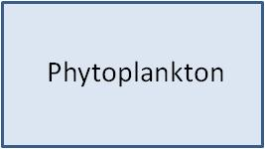
Figure 1 – Medium considered in the Phytoplankton model

Loadings
Definition: A ‘Loading’ is defined as the rate of release/input of the chemical of interest to the receiving system, here the Phytoplankton system.
The inputs of contaminant(s) into the Phytoplankton system can have one origin:
- Contaminant originating from Direct uptake from water and through membrane diffusion.
If the Phytoplankton model is used alone (i.e. not coupled to other models available in the MERLIN-Expo library), these loadings are defined by the end-user as time series. If coupled to other models (e.g. River model able to calculate contamination in water and sediments), some of these loadings can be calculated by these models (i.e. the outputs of the coupled models are used as loading inputs for the Phytoplankton model) (see § ).
The loading inputs are represented in Figure 2.

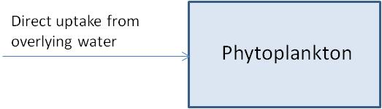
Figure 2 – Medium considered + Loading inputs in the Phytoplankton model

Losses
Definition: A ‘Loss’ is defined as the rate of output of the chemical of interest from the receiving system, here the Phytoplankton system.
The potential losses of contaminant(s) from the Phytoplankton system can be:
- Contaminant leaving the Phytoplankton system via elimination;
- Contaminant concentration decreasing via growth of phytoplankton (should be regarded as dilution of chemicals and not loss of chemicals).

The losses of contaminant(s) from the Phytoplankton system are represented in Figure 3 and Figure 4.

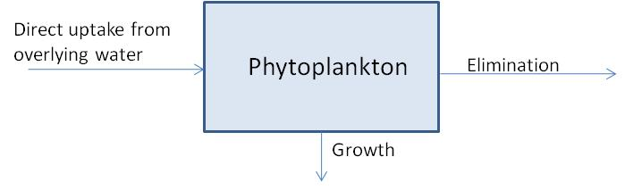
Figure 3 – Media considered + Loading inputs + Losses in the Phytoplankton model (for Organics)
Figure 4 – Media considered + Loading inputs + Losses in the Phytoplankton model (for Metals)

Exchanges between model media
Definition: An ‘Exchange’ is defined as the transfer of the chemical of interest between two media of the system, here the Phytoplankton system.
As the Phytoplankton system is based on one media only, there is no exchange between model media within the investigated system.

Potential coupled models
‘Coupled models’ are defined as models that can generate loadings to the investigated system (here the Phytoplankton system) or receive losses from the latter.
The Phytoplankton model can be coupled to other models of the MERLIN-Expo library. These latter can provide loading estimates or use losses from the phytoplankton as input data:

Coupled model | Can provide estimates of the following loading(s) | Can use the following losses from the Phytoplankton model as input data
‘River’ model | Contamination in water used for the estimation of direct uptake from overlying water | Elimination

The potential coupled models are represented in Figure 5 and Figure 6.

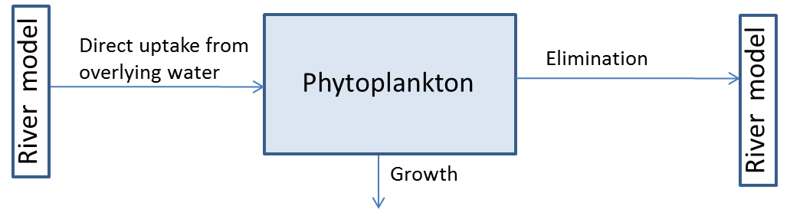
Figure 5 – Media considered + Loading inputs + Losses + Exchanges + Coupled models in the Fish model (for Organics)

Figure 6 - Media considered + Loading inputs + Losses + Exchanges + Coupled models in the Fish model (for Metals)

Forcing variables
A ‘Forcing variable’ is defined as an external or exogenous (from outside the model framework) factor that influences the state variables calculated within the model. Such variables include, for example, climatic or environmental conditions (temperature, wind flow, etc.).
For running the Phytoplankton model, the following forcing variables must be informed for calculating the loading inputs.

For… | Forcing variable | Abbreviation and unit | Purpose | Can be calculated (instead of being defined by the end-user) if the Fish model is coupled to the …
Organics and Metals | Water temperature | T_water (°C) | Temperature affects phytoplankton uptake of chemicals.
Organics and Metals | Concentration of the chemical in dissolved river water | C_dis_water  (mg∙m⁻³) | Is used to calculate the input through diffusion uptake | River model

The forcing variables (with indication of the processes they are involved in) are represented in Figure 7 and Figure 8.

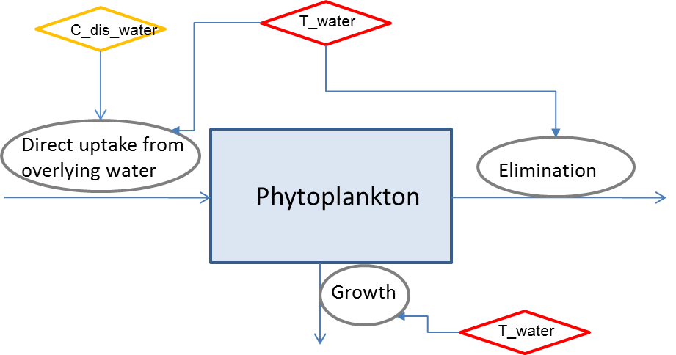
Figure 7 – Media considered + Loading inputs + Losses + Exchanges + Forcing variables in the Fish model (Forcing variables indicated in yellow are those that can be calculated if the Fish model is coupled to other models) (for Organics)

Figure 8 - Media considered + Loading inputs + Losses + Exchanges + Forcing variables in the Fish model (Forcing variables indicated in yellow are those that can be calculated if the Fish model is coupled to other models) (for Metals)

Parameters
A ‘Parameter’ is defined as a term in the model that is fixed during a model run or simulation but can be changed in different runs as a method for conducting sensitivity analysis or to achieve calibration goals.
For running the Phytoplankton model, the following parameters must be informed:

- Physiological parameters
For… | Name | Abbreviation and unit | Purpose | Used for calculating the following state variable(s)
Organics and metals | Phytoplankton cell volume | V_cell (μm³) | Volume of the phytoplankton cell subjected to chemicals accumulation | - All rate constants
Organics and metals | Allometric rate exponent | (kappa) κ (-) | Expresses body size correlation with animals physiological characteristics i.e. rates, transport coefficients. | - Uptake rate constant  k_uptake (L·kg⁻¹·d⁻¹)  - Elimination rate constant k_excretion (d⁻¹)
Organics and metals | Volume to weight conversion factor | volume_to_weight (-) | Used to obtain phytoplankton cell weight from phytoplankton cell volume. | - Uptake rate constant  k_uptake (L·kg⁻¹·d⁻¹)  - Elimination rate constant k_excretion (d⁻¹)
Organics and metals | Intercept of phytoplankton growth rate | a_growth (-) | Coefficient of phytoplankton growth-volume relationship. | - Uptake rate constant  k_uptake (L·kg⁻¹·d⁻¹)  - Elimination rate constant k_excretion (d⁻¹)
Organics and metals | Slope of phytoplankton growth rate | b_growth (-) | Coefficient of phytoplankton growth-volume relationship. | - Uptake rate constant  k_uptake (L·kg⁻¹·d⁻¹)  - Elimination rate constant k_excretion (d⁻¹)

- Parameters related to partition between phases:
For… | Name | Abbreviation and unit | Purpose | Used for calculating the following state variable(s)
Organics and metals | Organic carbon fraction of phytoplankton | p_carbon_phytoplankton (-) | Indicates organic carbon fraction in phytoplankton. | - Elimination rate constant k_excretion (d⁻¹)
Organics and metals | Lipid-layer permeation resistance | (rho) ρ_lipid_layer(d·kg) | Represents time of passive diffusion of organic contaminant through lipid membranes. | - Uptake rate constant k_uptake (L·kg⁻¹·d⁻¹)
Organics and metals | Water-layer diffusion resistance for uptake of chemicals from water | (rho) ρ _water_layer (d·kg) | Represents time of diffusion of organic contaminant from water through aqueous layer. | - Uptake rate constant k_uptake (L·kg⁻¹·d⁻¹)
Metals only | Water-Dissolved Organic Carbon partition coefficient | log10_K_doc (-) | Represents the ratio of sorbed metal concentration to the dissolved metal concentration at equilibrium. | - Elimination rate constant k_excretion (d⁻¹)
Organics only | Octanol-water partition coefficient | log10_K_ow (-) | Represents ratio of concentrations of a compound in a mixture of two immiscible phases at equilibrium | - Uptake rate constant k_uptake (L·kg-1·d-1)
Organics only | Organic carbon-water partition coefficient | log10_K_oc (-) | Represents sorption of compound to organic carbon. | - Uptake rate constant k_uptake (L·kg-1·d-1)

Intermediate State variables
An ‘Intermediate State variable’ is defined as a dependent variable calculated within the model. Some State variables are fixed during a model run or simulation because they are calculated only from parameters. Some others are time-dependent because they are calculated from parameters, but also from time-dependent forcing variables. We distinguish ‘Intermediate State variables’ and ‘Regulatory State variables’. The first ones are generally not used by decision-makers for regulatory purposes but can be used as performance indicators of the model that change over the simulation. The second ones can be used by decision-makers for regulatory purposes.
For running the Fish model, the following state variables are calculated for the following purposes. All the state variables for which no forcing variable is required are constant all over the calculation time. Instead, the state variables for which forcing variable(s) is/are required are time-dependent. In the following tables, the following symbols were adopted:
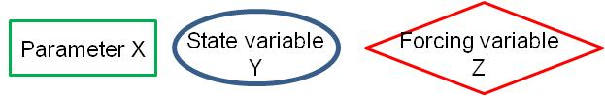

- State variables related to kinetic rate constants:
For… | SV n° | Name | Abbreviation and unit | Purpose | Process followed for calculating the state variable
Organics and metals | 1° | Phytoplankton weight | W_Phytoplankton (μg) | Estimates phytoplankton cell weight based on conversion from cell volume. | 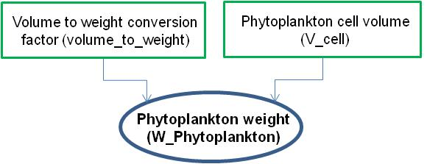
Organics only | 2° | Uptake rate constant | k_uptake_organics (L·kg⁻¹·d⁻¹) | Defines rate at which chemicals are absorbed. Used for calculating elimination rate constant (k_elimination) | 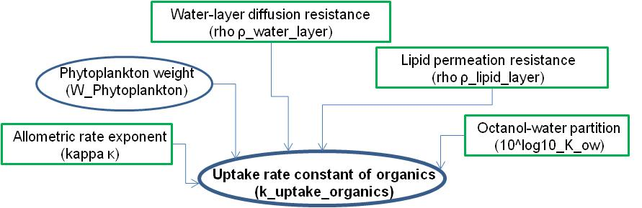
Metals only | 3° | Uptake rate constant | k_uptake_metals (L·kg⁻¹·d⁻¹) | Defines rate at which chemicals are absorbed. Used for calculating elimination rate constant (k_elimination) | 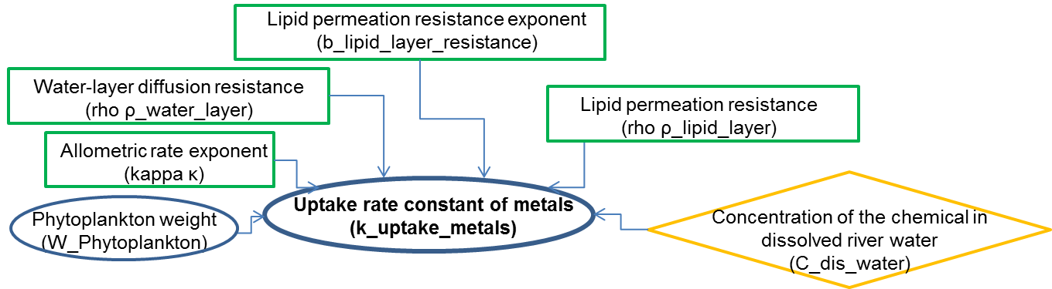
Organics only | 4° | Elimination rate constant | k_excretion_organics (d⁻¹) | Defines rate at which chemicals are eliminated. Used for calculating chemical concentration in phytoplankton (C_Phytoplankton) | 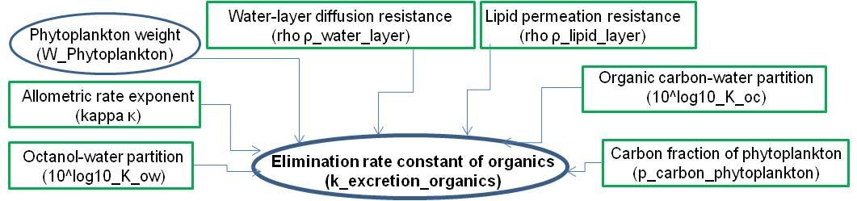
Metals only | 5° | Elimination rate constant | k_excretion_metals (d⁻¹) | Defines rate at which chemicals are eliminated. Used for calculating chemical concentration in phytoplankton (C_Phytoplankton) | 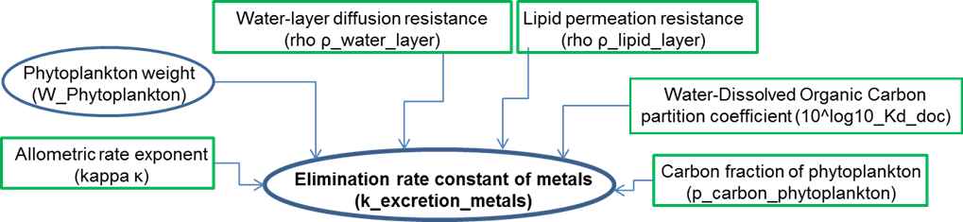
Organics and metals | 6° | Growth rate constant | k_growth (d⁻¹) | Defines rate of growth of phytoplankton. Used for calculating (C_Phytoplankton) | 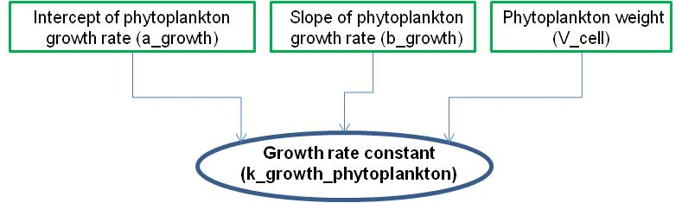

Regulatory State variables
An ‘Regulatory State variable’ is defined as a dependent variable calculated within the model. It is generally time-dependent because it is calculated from parameters, but also from time-dependent forcing variables and loadings. We distinguish ‘Intermediate State variables’ and ‘Regulatory State variables’. The first ones are generally not used by decision-makers for regulatory purposes but can be used as performance indicators of the model that change over the simulation. The second ones can be used by decision-makers for regulatory purposes.

Figure 9 - Flow chart for calculating the ‘regulatory state variables’ (for Organics)
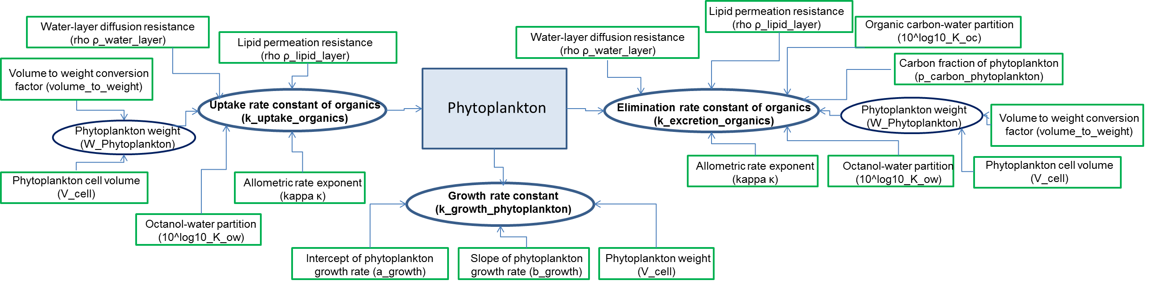

Figure 10 - Flow chart for calculating the ‘regulatory state variables’ (for Metals)

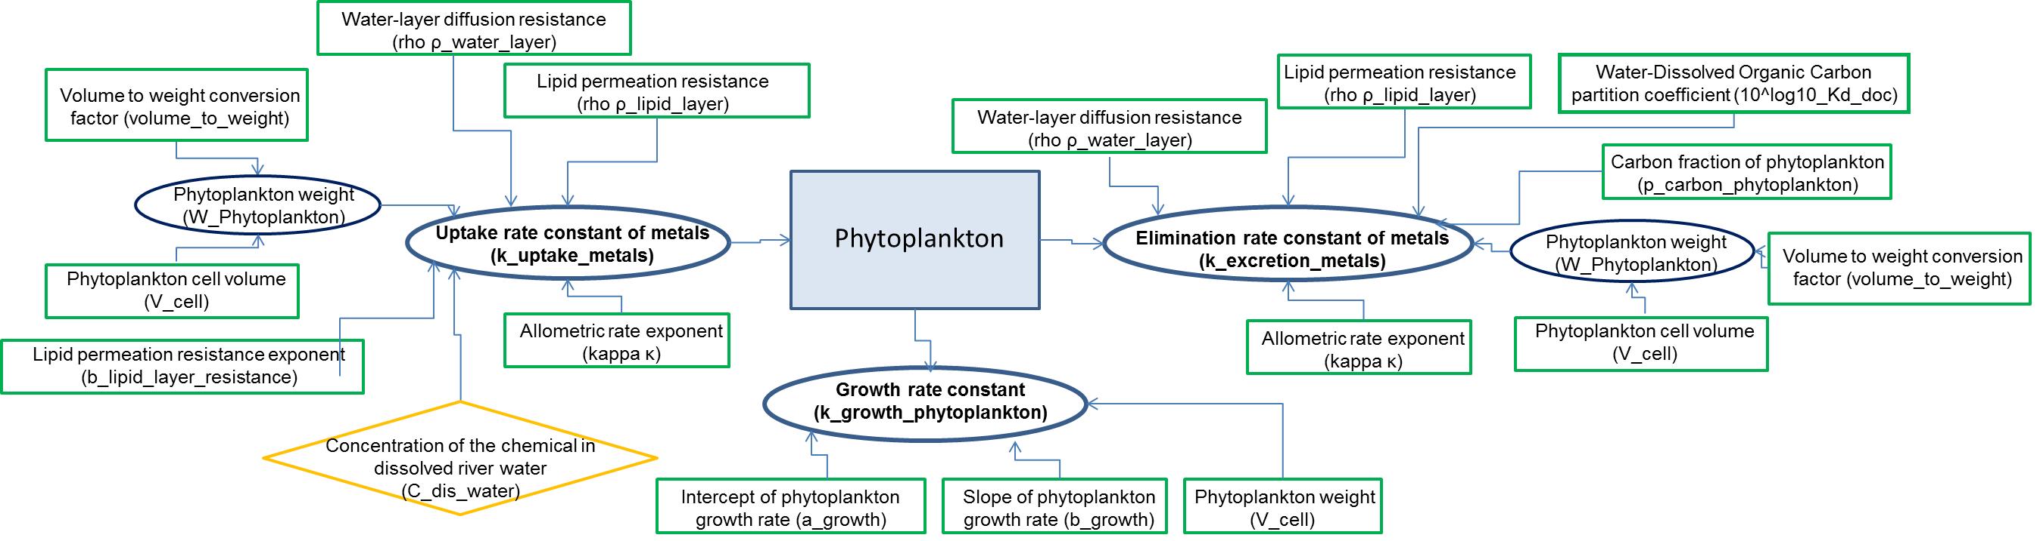
The following ‘regulatory state variables’ are calculated according to the flow charts presented in Figure 9 and Figure 10

SV n° | Name | Abbreviation and unit
8° | Concentration of the chemical in phytoplankton | C_phytoplankton (mg.kg⁻¹)

End of Level 1 documentation (basic end-user)

Level 2 documentation (background science)

Processes and assumptions

Process n°1: Uptake of chemicals (organics)
Motivation
Plankton is an important pathway of bioaccumulation and biomagnification in food webs. Phytoplankton accounts for the largest fractions of both the organic carbon and the surface area in the food web (Skoglund et al 1996). In aquatic environment organic compounds like PCBs may undergo partitioning between water, suspended particles and plankton. This process can be considered as a critical entry point for hydrophobic contaminants into aquatic food webs.
Biological membranes are selectively permeable membranes that help maintain homeostasis in the cell. Each cell membrane consist of a fluid bilayer composed of phospholipids in which a variety of proteins are embedded. One of the main functions of membrane proteins is to transport materials, such as ions and small polar molecules through cell membranes (Solomon 2011). In MERLIN-Expo, accumulation of contaminants in phytoplankton takes into account combination of detailed phase partitioning (lipid and water resistances) with organic carbon fraction (in addition to lipids) as an important medium in which bioaccumulation occurs (Arnot and Gobas 2004). The movement from water to lipids requires transport of the molecule across cell membranes made of lipid bilayers. Physical transport may be limited for larger, more hydrophobic molecules such that thermodynamic equilibrium cannot be reached (Swackhamer and Skoglund 1993). Uptake rate constants of hydrophobic compounds have been reported to depend on the size of the organism, that is, the larger organism, the smaller the uptake rate constant (Sijm et al 1998). Sijm et al 1998 reports that actual uptake rate constants of the different tested hydrophobic compounds in algae are high, and that they are relatively constants throughout an experiment (slight increase is observed with hydrophobicity of chemicals), fitting fairly well within existing allometric relationship.
Algae may have significant lipid content which affect both uptake and elimination of chemicals. Two-stage bioaccumulation mechanism for hydrophobic compounds may take place. During first step chemicals undergo rapid sorption on the surface within 24 hours and then small, steady increase with transfer to interior lipids for the duration of the exposure (Swackhamer and Skoglund 1993).
Bioaccumulation of PCBs in phytoplankton depends on solubility, hydrophobicity, molecular configuration of the compound, growth rate, surface area and type, content and type of lipid in the algae (Stange and Swackhamer 1994).
Selected model and assumptions
Equilibrium is often considered to apply between small planktonic organisms and dissolved water concentration. However, the most lipophilic PCBs do not appear to equilibrate between water and plankton (Campfens, Mackay 1997). We follow Hendriks’ approach for defining rate constants, that is, each rate constant can be correlated to species weight by allometric regression (Hendriks et al 2001).
In MERLIN-Expo uptake rate constant is considered inversely proportional to resistances in water and lipid layers (ρ_water_layer, ρ_lipid_layer). Each resistance is correlated to species weight by allometric regression. These resistances occur while chemicals diffuse through water and lipid layers during exchange with water. Assumption here is made that the resistances are considered to be the same for different chemicals.
Model type
Empirical [] vs mechanistic [X]
Steady-state [ ] vs dynamic [X]
Analytical [X] vs numerical [ ]
Alternatives and limits
Although several studies suggest using cell surface sorption and desorption kinetics of chemicals (Skoglund et al 1996, Koelmans 2014), and in addition, sorption of hydrophobic organic chemicals to phytoplankton exudates that might significantly limit bioavailability of organics for uptake (Koelmans and Heugens 1998, Sijm et al 1998), we do not account for those processes due to data scarcity and to avoid additional complexity of the model.
As an alternative to kinetic-based modelling of bioaccumulation the thermodynamic equilibrium based models can be applied. However, equilibrium is not achieved for more hydrophobic chemicals in actively growing phytoplankton (Swackhamer and Skoglund 1993).
Current understanding of bioconcentration of chemicals in phytoplankton supports two-step uptake mechanism using two compartment first-order approach i.e. accumulation to cell surface and cell matrix components (Skoglund et al 1996). Experiments show significant contribution from fast surface sorption that occurs in minutes (Koelmans 2014).
Regression data analysis indicates that estimated surface adsorption portioning coefficients is independent of chemical and species parameters (Skoglund et al 1996). In the study by Skoglund et al (1996) surface area-to-volume ratio is indicated as a factor controlling surface sorption. As phytoplankton cell size decreases and area/volume ratio increases, the role of surface sorption becomes more important in accumulation of chemical. Phytoplankton surface adsorption portioning coefficients were calculated from PCB data after short time exposure. Calculations were based on the hypothesis that accumulation during short exposure times is mainly due to surface adsorption. Experimental datasets agree with this hypothesis (Skoglund et al 1996). Independent laboratory and field data suggest initial rapid sorption (surface) followed by slower accumulation process, characterized by high capacity. Rapid sorption during initial time was chosen as the best estimate of the adsorption of PCBs to phytoplankton’s surface.

Process n°2: Uptake of chemicals (metals)
Motivation
Some of the heavy metals, such as copper, nickel, and zinc, are essential for life. However, at higher concentrations these metal ions are toxic to most prokaryotic and eukaryotic organisms. Other heavy metals such as cadmium, lead, and mercury are non-essential and can cause damage in organisms even at very low concentrations. Metal speciation is a key factor in determining metals solubility, mobility, availability, and toxicity (Kaplan et al 2013).
Metal uptake by phytoplankton can be described as biphasic process, where rapid sorption to the cell surface, is followed by slower diffusion across the cell membrane and subsequent binding within the cell. Transport of the metal into the cell interior can come about as carrier-mediated transport by membrane protein, or passive diffusion of lipid-soluble (non-polar) metal forms (McGeer et al 2004).
It has been observed that metal exposure concentration in medium correlates well with metal uptake rate. Laboratory experiments shows linear increase with exposure concentration up to dissolved concentrations that are at least an order of magnitude higher than those seen in nature (Luoma et al 2005). While field experiments agree that the concentration in exposed organism and in medium display similar patterns, they also underline significance of environmental and ecological parameters such as dissolved and particulate organic matter, aquatic species, and total metal fraction in the water on metal uptake process (Faburé et al 2015, Veltman et al 2008).

Selected model and assumptions
MERLIN-Expo incorporates Phytoplankton model based on bioaccumulation model for metals (OMEGA) proposed by Hendriks et al (2001, inorganics). The uptake model has been adapted to satisfy uptake process of metals, which may be limited by the protein carriers in the membrane, by including lipid layer resistance as a function of exposure concentration with exponent b_lipid_layer_resistance. The rationale for this approach is that empirical uptake rate constants of various species and metals showed that influx of metals through membranes exhibits saturable uptake kinetics, analogous to Freundlich kinetic for sorption (Veltman et al 2008, Hendriks et al 2001).
Model type
Empirical [ ] vs mechanistic [X]
Steady-state [ ] vs dynamic [X]
Analytical [X] vs numerical [ ]
Alternatives and limits
Metal uptake rate can be described by the saturation equation (the Langmuir isotherm) where metal uptake rate is expressed by concentration of the free metal ion and its affinity for the binding to the transport site, through the use of affinity constant. This approach is additionally based on maximum uptake rate, which occurs when transport sites are saturated with metal, and is equal to total moles of transporter sites per unit of biomass and rate constant for the transport of metal across the cell membrane (Sunda et al 1998). This approach would require extra parameterization (affinity constant, maximum uptake rate, amount of transporters, and transport rate constant across membrane) comparing to approach by Hendriks 2001, therefore saturation model has not been included.

Another approach that can be considered for estimating uptake rate is to relate metal absorption rate constants to a metal speciﬁc physicochemical property, the covalent index, and a species characteristic, the ventilation rate, in the form of quantitative structure-activity relationship (Veltman et al 2008). This approach has been excluded for the sake of consistency between models.

The free ion activity model (FIAM) and the biotic ligand model (BLM) may provide sound evaluations of metal biouptake, since they include metal speciation in solution and can differentiate between the fraction of metals absorbed at cell surface and intracellular fraction of the organism. However, the equilibrium-based BLM ignores the dynamic proccesses at the cell interface which control metal biouptake (Rotureau et al 2015).

Process n°3: Elimination of chemicals through excretion (organics)
Motivation
Elimination rate constant (k_depuration) of hydrophobic compounds have been reported to depend on the size and lipid content of the organism (i.e., the larger and fattier the organism, the smaller the elimination rate constant) and the hydrophobicity of chemicals. For algae (phytoplankton) elimination can be further affected by growth and exudation (Sijm et al 1998). However, Skoglund et al. (1996) assumes that elimination by algae is predominantly dependent on physicochemical elimination, calculated from uptake rate constant (k_uptake). Phytoplankton actively excrete 10 to 40% of carbon fixed by primary production, thus exudate may represent a substantial loss mechanism for organic chemicals from phytoplankton because of their high affinity for dissolved carbon (Swackhamer et al 1993, Koelmans 2014).
Selected model and assumptions
Phytoplankton elimination rate constant in MERLIN-Expo is reflected as a release of chemicals from carbon pool of the cell compartment (p_carbon_content∙ K_oc)⁻¹ (Hendriks et al 2001, Arnot and Gobas 2004).
Model type
Empirical [ ] vs mechanistic [X]
Steady-state [ ] vs dynamic [X]
Analytical [X] vs numerical [ ]
Alternatives and limits
Thermodynamic equilibrium based model. Additional alternative to our solution is to use additionally desorption rate constant in algal bioconcentration dynamics. If this constant is low relative to the growth rate then algal cells will not achieve thermodynamic equilibrium. Usage of desorption constant is limited however due to lacking direct measurements.

Process n°4: Elimination of chemicals through excretion (metals)
Motivation
Metals can be ejected from cell through exocytosis, and may be sequestered in vacuoles or granules (Solomon 2011). Cells often possess efflux systems for toxic metals, as observed for Cd in diatoms. For at least one species, Thalassiosira weissflogi, this system involves the export of Cd-phytochelatin chelates. Efflux systems are induced by high intracellular metal concentrations, and decrease toxicity by minimizing metal accumulation (Sunda et al 1998). Alternative mechanism for exudation could be passive permeation through the cell membrane.
Selected model and assumptions
Rate constant for metal excretion is a function of accumulation ratio (p_carbon_content∙log10^Kd_doc)⁻¹, and water and lipid layer resistances. While water resistance is considered to be the same for metal uptake and excretion, lipid layer resistance in excretion term is being considered independent from water concentration, what is contrary to uptake rate, because depuration rate has been reported to be not affected by exposure concentration (Hendriks et al 2001). On the basis that as much as 50% of the total carbon ﬁxed by photoautotrophs may be released into seawater as organic matter (exudates) in the form of products of metabolism, through active processes for waste removal, substrate acquisition, defence, or communication (Becker et al 2014, Sharp 1977), and also that dissolved organic matter (DOM) is often characterised by estimating DOC concentration (Hestir et al 2015), we assume that description of excretion of trace metals by phytoplankton can be supported by use of metal partition coefficient to dissolved organic carbon (Kd_doc) (Paquet et al 2015, Baken et al 2011, Allison et al 2005, Weng et al 2002). The amount of extracellular DOM released and its composition depend on the organism and its physiological state as well as additional factors including: temperature, light, growth phase, availability of inorganic nutrients, and the presence of other organisms. However, assessment of phytoplankton-derived DOM has not been conducted at the molecular level and it is not yet clear how much chemical variation exists in DOM produced by different marine phytoplankton types (Becker et al 2014).
Model type
Empirical [ ] vs mechanistic [X]
Steady-state [ ] vs dynamic [X]
Analytical [X] vs numerical [ ]

Process n°5: Elimination of chemicals through growth (organics)
Motivation
Calculating bioaccumulation factor should account for phytoplankton growth, because algae are fast-growing organisms with a doubling time in the order of days (Sijm et al 1998). Phytoplankton may double and triple in one day and the turnover may be so rapid that organic contaminants will not reach equilibrium (Hill and Napolitano 1997). High growth rates can limit internal contaminant concentrations. Thus it is suggested to use growth kinetic to model contaminants accumulation in primary trophic chain to avoid overestimating accumulated contaminants at higher trophic levels (Swackhamer and Skoglund 1993).
Growth dilution by plankton can result in lower bioaccumulation factor of highly halogenated compounds. It is reported that due to higher equilibration times, growth of planktonic organisms significantly dilutes cell concentrations of absorbed POPs (Frouin et al 2013). Increased metabolism during phytoplankton growth accounts for increased elimination rate constant due to increased excretion of extracellular products, resulting in deviating from equilibrium between chemicals in dissolved water and in phytoplankton. Swackhamer et al (1993) shows that after 30 days of exposure, relationship between PCBs congeners with logK_{OW} > 5.5 and logBAF (lipid normalized) is not consistent for actively growing phytoplankton. Under fast growth conditions, kinetics of PCB uptake rate are of the same order of magnitude as phytoplankton growth kinetics, leading to constant dilution of PCB concentration in the phytoplankton compartment. On the other hand, under low growth conditions, predictions of the kinetic models and equilibrium are similar. However, data collected during periods of active growth show that equilibrium predictions significantly deviate from kinetic predictions. Therefore kinetic based models, better than equilibrium-based, reflect observed concentrations in phytoplankton.
In case of metals interrelation exists between cellular metal concentration and growth rate since changes in either parameters affect one another. Thus, the concentration of accumulated metal is in balance with metal uptake rate and specific growth rate (Sunda et al 1998). Sunda also reports that for algal cells this relationship may not apply due to day/night cycles, when growth occurs during daytime (carbon fixation), resulting in metal biodilution during the day.
Selected model and assumptions
Phytoplankton model uses growth kinetics, estimated from allometric scaling to cell volume (Kagami et al 2001). It has been reported that relationship between cell size and growth follow unimodal pattern for wide cell size and phylogenetic ranges (Marañón et al 2013). Due to data availability on phytoplankton sizes and biovolumes (Olenina et al 2006) in MERLIN-Expo we apply the phytoplankton cell biovolume in calculating maximum growth and weight of phytoplankton.
Model type
Empirical [ ] vs mechanistic [X]
Steady-state [ ] vs dynamic [X]
Analytical [X] vs numerical [ ]
Alternatives and limits
The growth rate of a phytoplankton can be calculated from Droop model. It proposes originally the cell-quota model as an empirical description of the observed relationship between growth rate and cellular content, or cell quota, deﬁned as the weight of internal nutrient per unit biomass. The average cell quota of the whole algae population can be measured and the obtained model ﬁts well the experimental data. The Droop model suggests that growth might depend upon some stored intra-cellular pool of nutrient, instead of the extra-cellular available nutrient as in for example in the Monod model. However, the problem with Droop’s cell quota is that it has no clear biological interpretation: it accounts not only for the internal nutrient pool but also for the internal metabolized nutrient (Lemesle et al 2008, Pahlow et al 2013). Additionally, it predicts the population-average speciﬁc growth or cell division rate, based on the population-average nutrient cell quota (Hellweger et al2007), while in MERLIN-Expo individual algal cells are considered.
Another approach that can be considered for deriving growth kinetics is a light-dependent growth of phytoplankton where growth is a function of irradiance. In general, growth increases with irradiance due to an increase in the rate of light-limited photosynthesis, growth saturates at irradiances where photosynthesis is no longer light-limited, and growth may decline at higher irradiances due to photodamage from excess light and/or the costs of photoprotection. Application of this approach is limited by lack of a comprehensive view of how light utilization traits vary across genotypes and species, and how this variation is structured by cell size, taxonomy, and environmental gradients (Edwards et al 2015).
End of Level 2 documentation (end-user with expertise in process)

Level 3 documentation (numerical information)

Numerical default values (deterministic and/or probabilistic)

Initialization of concentrations in Media
The ‘regulatory state variables’, i.e. the concentrations of the chemical in the Phytoplankton compartment (i.e. C_Phytoplankton (mg.kg⁻¹)) must be initialized (i.e. value for time=0). By default, no contamination is assumed at the beginning of the simulation, i.e. all the concentrations are put at zero, but end-user must adapt these values according to their specific case studies (e.g. initial contamination in phytoplankton).

Default parameter values

Phytoplankton physiological parameters

Phytoplankton cell volume (V_cell) (µm³)
Physical/chemical/biological/empirical meaning
Phytoplankton biomass refers to the total weight of all living phytoplankton organisms present in a unit area at a given time. There are several ways to present the quantity of algal biomass either by number of cells or through determination of volume, optical density, chlorophyll a or weight. Phytoplankton biomass can be measured as total wet weight or biovolume, since the volume-to-weight ratio is close to one for phytoplankton (Strickland 1960). Estimation of biovolume per cell facilitates the calculation of total biomass and the biomass of the various groups and species of phytoplankton. Cell volumes can be calculated from cell-size and shape by use of appropriate geometric formulas.
Factors influencing parameter value
Size and hence biovolume of a given taxon varies due to several factors. The variability and instability in size is dependent on environmental influence, e.g. light and nutrient availability, but also seasonality may have influence on the mode of the life cycle of different phytoplankton groups (Olenina et al 2006). Large species of the phytoplankton group such as diatoms may have a very high biovolume. This has been observed, for example, in coastal areas of the Kattegat and Skagerrak (Skjevik et al. 2011). Much of the diatom cell volume is a vacuole that contains very little organic substance, meaning that the total biovolume data may give a skewed biomass value when large diatoms are present. In this case, measures other than biovolume (e.g., carbon content) should be evaluated. On the other hand small Cryptophyceae and Prymnesiophyceae can be abundant but, due to small biovolumes, may constitute little of the total biovolume (Höglander et al 2013).
Role in the model
Cell biovolume is used in determining phytoplankton weight and growth rate.
Database used for parameter estimation
Based on HELCOM Biovolumes and size-classes of phytoplankton in the Baltic Sea database. Authors assumed the goal, to find shapes, which require as few measurements as possible, but which at the same time reflect the shape of the organism as far as possible. The study generated information on taxonomic order, species/genera name (Latin name), author(s), size-classes (size-range), geometric shape of the cell, geometric equation, and measurements needed for biovolume calculation. A total of 694 taxa were analysed. Data from the different laboratories were compared, clustered into cell-sizes, and grouped into size-classes. In general, the arithmetic mean of each size-class was used as a standardised biovolume. Phytoplankton taxa used in building HELCOM database follow the Checklist of Baltic Sea Phytoplankton Species (Hällfors 2004). For each taxon the best fitting geometric shape and matching equation was used. The survey of phytoplankton species present in the Baltic Sea resulted in 16 basic geometric shapes to be used for the determination of the biovolume of cells. Authors underline however, that it is not possible to classify each shape of all phytoplankton species into the few basic geometric shapes being used. Biovolumes were calculated for single cells and sometimes colonies of 4, 8, 16, 20, 50, 100, or 200 cells. Species list covers a wide range of marine and freshwater species.

Here we present extract from HELCOM database. It should be used as recommendation for finding and estimating phytoplankton biomass based on cell size and biovolume. Table 1 presents volume of several classes of phytoplankton together with several reported species.

Taxonomy of selected phytoplankton species | Geometric shape |  | Cell size range (μm) | Cell Volume  (μm³ cell⁻¹)
- Class Chlorophyceae  (86 species) |  |  |  | Min= 0.8  Max= 2010.0
Actinastrum hantzschii  (Order CHLOROCOCCALES)  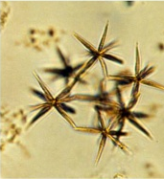 | 2 cones |  | 2-3 x 10 -25  (d x h) | 20-37
- Class Chrysophyceae  (20 species) |  |  |  | Min=6.28  Max=523.30
Apedinella radians  (Order PEDINELLALES)  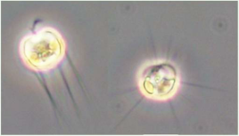 | sphere |  | 7-8  (d) | 221
- Class Cryptophyceae  (25 species) |  |  |  | Min=4.19  Max=2227.00
Hemiselmis sp.  (Order CRYPTOMONADALES)  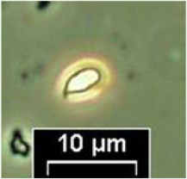 | sone + half sphere |  | 3 x 4-6  (d x h) | 15
- Class Cyanophyceae  (84 species) |  |  |  | Min=0.07  Max=344.60
Merismopedia anguine  (Order CHROOCOCCALES)  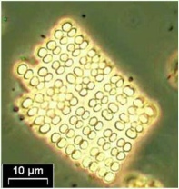 | sphere |  | 2.5-3.6  (d) | 14
- Class Diatomophyceae  (290 species) |  |  |  | Min=13  Max=4847000
Atteya decora  (Order EUPODISCALES)  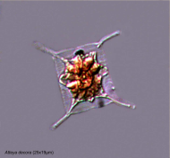 | Oval cylinder | 14 x 18  (d x h) |  | 791
- Class Dictyochophyceae  (3 species) |  |  |  | Min=220.78  Max=2093.33
Dictyocha fibula  (Order DICTYOCHALES)  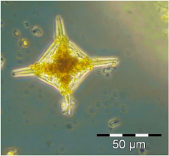 | half sphere |  | 16 | 1072
- Class Dinophyceae  (162 species) |  |  |  | Min=44.9  Max= 1047000.0
Akashiwo anguine  (Order GYMNODINIALES)  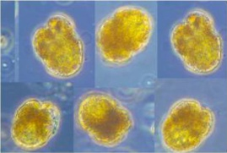 | flattened ellipsoid |  | 60 x 40  (d1 x d2) | 33661
- Class Euglenophyceae  (20 species) |  |  |  | Min=130.8  Max= 16160.0
Eutreptiella sp.  (Order EUGLENALES)  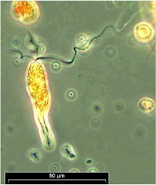 | rotational ellipsoid |  | 5-7 x 10-15  (d x h) | 236
- Class Prasinophyceae  (15 species) |  |  |  | Min=1.1  Max= 523300.0
Cymbomonas tetramitiformis  (Order CHLORODENDRALES)  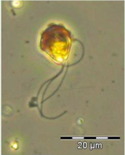 | rotational ellipsoid |  | 12-16 x 13-17  (h x d) | 1539
- Class Prymnesiophyceae  (16 species) |  |  |  | Min=14.13  Max= 763.00
Emiliania huxleyi  (Order PRYMNESIALES)  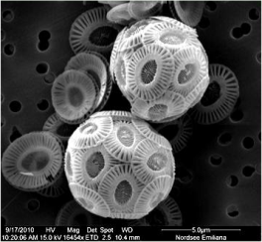 | sphere |  | 2-4  (d) | 14
- Class Raphidophyceae  (4 species) |  |  |  | Min=523.3  Max= 4187.0
Heterosigma akashiwo  (Order CHATTONELLALES)  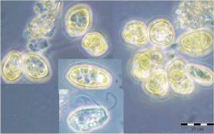 | sphere |  | 15-25  (d)
- INCERTAE SEDIS  (13 species) |  |  |  | Min=37.68  Max= 502.40
Telonema sp.  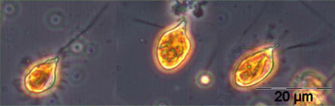 | cone + half sphere |  | 6-7 x 12  (d x h) | 169
Table 1. Geometric shapes, cell sizes, and calculated cell volumes of several phytoplankton species representing 11 classes (Explanation of symbols : (d) diameter, (d1) large diameter, (d2) small diameter, (h) height, (l) length). (Olenina et al 2006, Leibniz Institute for Baltic Sea Research Warnemünde, The IOW-Image Gallery of Microalgae, National Marine Fisheries Research Institute Gdynia, Southern Baltic Sea and the Gulf of Gdańsk Phytoplankton images)
Parameter estimation type
Statistical analysis of large database [X]
Calibration [ ]
Extrapolation [ ]
Expert elicitation [ ]
Bayesian approach [ ], eventually
QSAR or read-across [ ]
Mechanistic model [ ]
Perfect information [ ] to be informed by the end user case by case
Parameter estimation description
For each taxon the best fitting geometric shape and matching equation was used (Olenina et al 2006). The survey of phytoplankton species, present in the Baltic Sea, resulted in 16 basic geometric shapes to be used for the determination of the biovolume of cells. However, it is not possible to classify each shape of all phytoplankton species into the few basic geometric shapes being used. Volumes are given for single cells. Classes were given range of volumes, i.e. maximum and minimum reported value based on measurements of phytoplankton species single cells. Sizes and volumes of phytoplankton colonies and coenobia are not included.

Volume calculations performed through size measurements on live cells yielded coefficient of variation (CV) in cell volume ranging from 22% to 56% (Menden-Deuer et al 2000). Authors suggest that high variation in cell volumes is intrinsic to planktonic species cultures due to differences in life cycle and growth status of individual cells.
Available HELCOM data on phytoplankton cell volumes (2469 entries) were analysed. Cell volumes were log10 transformed to plot histogram (with overlaid Normal PDF) and Normal Probability Plot to summarise distribution of the data set. It seems reasonable to assume that the cell volume data are from approximately a normal distribution.
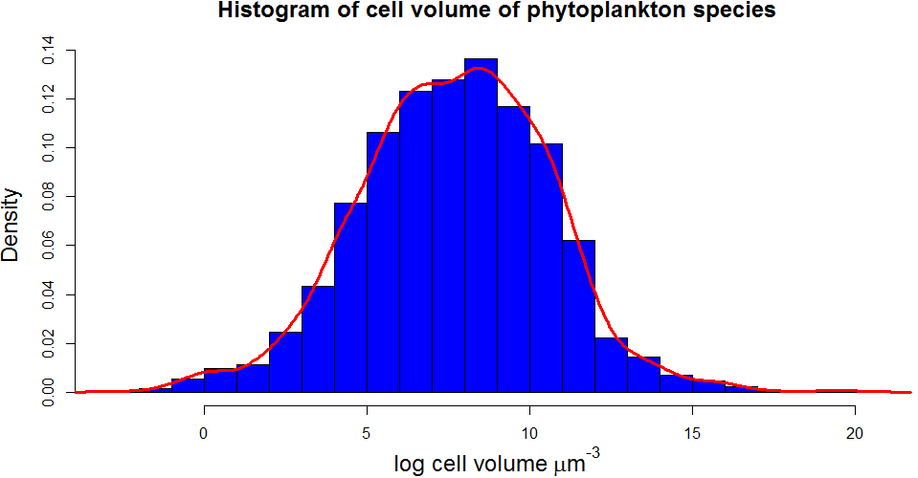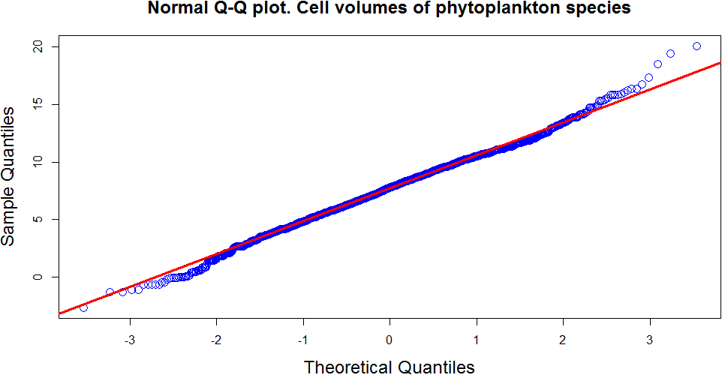
Figure 11. Histogram and norml q-q plot of data on phytoplankton cell volumes (Olenina et al 2006)
Parameter default value and PDF
Best estimate (V_cell) = 7.68 (µm³ cell⁻¹)
PDF (V_cell) = LN (perc 5 = 2.90 – perc 95 = 12.04)

Volume to weight conversion factor (volume_to_weight) (µg. µm⁻³)
Physical/chemical/biological/empirical meaning
Two kind of wet weights can be recognized, the true wet weight of the cells themselves with no extraneous water and the experimental wet weight obtained after draining the cells. The first weight is obtained from measuring algal cell volumes, and a specific gravity value may be taken as unity. The experimental wet weight will vary considerably according to the technique employed and will rarely be less than twice the true algal weight, due to the presence of interstitial water (Strickland 1960).
Role in the model
volume_to_weight conversion factor is used in transforming cell biovolume to weight of cell.
Parameter estimation type
Statistical analysis of large database [ ]
Calibration [ ]
Extrapolation [ ]
Expert elicitation [X]
Bayesian approach [ ], eventually
QSAR or read-across [ ]
Mechanistic model [ ]
Perfect information [ ] to be informed by the end user case by case
Parameter estimation description
Assuming phytoplankton cells have specific gravity of unity, 10⁹ mm³ of phytoplankton weigh 1 mg (Strickland 1960).
Parameter default value and PDF
Best estimate (volume_to_weight) = 1,00 (unitless)
PDF (volume_to_weight) = N (µ=1,00 ; SD=0,03)

Intercept of phytoplankton growth rate (a_growth)
and

Slope of phytoplankton growth rate (b_growth)
Physical/chemical/biological/empirical meaning
Coefficients describe relationship between cell size and growth rate in the size scaling model of phytoplankton growth applied in the MERLIN-Expo.
Factors influencing parameter value
The size scaling of phytoplankton growth is reported to be independent of taxonomic affiliation (Marañón et al 2013). The decrease in growth rate was observed in both diatoms and dinoflagellates, while increase in cyanobacteria, chlorophytes, and other flagellate species. Growth rate of small species may be more constrained, relative to that of intermediate-size cells, by their maximum nutrient uptake rate. Decrease in carbon-to-nitrogen ratio due to decrease in carbon-rich components such as lipids and carbohydrates, and relative increase in nitrogen-containing molecules such as nucleic acids and membrane proteins. On the other hand, in largest species geometric constraints imposed by resource transportation networks may have resulted in a progressively slower supply rate of nutrients as phytoplankton cells become larger, which would explain the decrease in growth rate observed in the largest cells.
Role in the model
Used to calculate cell volume and related growth rate of phytoplankton.
Database used for parameter estimation
Determined experimentally volumes and growth rates of 22 species of marine phytoplankton from 5 phyla, ranging from 0.1 to 10⁶ µm³ in cell volume, have been used to estimate coefficients intercept (a_growth) and slope (b_growth). Authors report growth rate peak at intermediate cell size (Marañón et al 2013). Therefore, two sets of intercept and slope coefficients are defined for two allometric relationships, describing both increase in growth rate with increase in cell volume (up to ca. 50-100 µm³), and subsequent decrease in growth rate for larger species.
Parameter estimation type
Statistical analysis of large database [ ]
Calibration [ ]
Extrapolation [ ]
Expert elicitation [X]
Bayesian approach [ ], eventually
QSAR or read-across [ ]
Mechanistic model [ ]
Perfect information [ ] to be informed by the end user case by case
Parameter estimation description
Linear regression was used to determine the size-scaling parameters for phytoplankton growth relationship between log 10-transformed cell volumes. Bootstrapping method was applied to compute standard errors and 95% confidence intervals for the regression estimates. All regressions were highly signiﬁcant (P < 0.01) (Marañón et al 2013).
Parameter default value and PDF

Species with V_cell > 40 μm3 (used as default in MERLIN-Expo Phytoplankton model)
Best estimate (a_growth) = 0.22 (unitless)
PDF (a_growth) = LN (perc 5 =0.13 – perc 95 = 0.34)

Best estimate (b_growth) = 0.15 (unitless)
PDF (b_growth) = LN (perc 5 = 0.12 – perc 95 = 0.19)

Species with V_cell < 300 μm3
Best estimate (a_growth) = 0.43 (unitless)
PDF (a_growth) = LN (perc 5 = 0.40 – perc 95 = 0.50)

Best estimate (b_growth) = 0.19 (unitless)
PDF (b_growth) = LN (perc 5 =0.16 – perc 95 = 0.23)

Allometric rate exponent (kappa) κ
Physical/chemical/biological/empirical meaning
Allometric relationships provide body-size specific parameters instead of values that are arbitrary or taken from a well-known species. Allometry, or the biology of scaling, is the study of size and its consequences. It has become a useful tool for comparative physiology. There are several empirical allometric equations that relate body size to many parameters, including ingestion rate, lifespan, inhalation rate, mortality, age at maturity, maximum density, territory size, rate constants, etc. Even if these relationships were originally derived from empirical observations, there is a growing body of evidence that these relationships have their origins in the dynamics of energy transport mechanisms. From a meta-analysis based on 230 relationships, slopes of allometric regressions were shown to be mutually consistent with rate constants, and generally decrease with organism mass at a constant exponent (Hendriks 2007).
Factors influencing parameter value
Differences in allometric regressions can be observed according to temperature, trophic position and evolutionary history (for example between plants, invertebrates, cold-blooded vertebrates and warm-blooded vertebrates). Cold-blooded species have generally lower rate constants but reach higher ages and densities than equally sized warm-blooded organisms. Intercepts of body size distributions tend to decrease with trophic position (Hendriks 2007).
Role in the model
Slope of allometric regression κ (kappa) is a component of each rate constant used in Phytoplankton bioaccumulation model. Moreover, allometric rate exponent affects the values and uncertainties of the coefficients γ (gamma), because it is used in the allometric relations from which the coefficients are derived.
Database used for parameter estimation
Hendriks et al (2007) conducted a meta-analysis on 230 allometric regressions derived from over 100 publications. The relationships were shown to be consistent and rate constants generally decrease with organism mass at an exponent of -0,25.
The range of the slope of allometric regression is derived from reviews of empirical studies that have shown that the exponent is usually within the range of 0,25 to 0,33, theoretically explained by food-web networks and surface-volume relationships (Hendriks, 2001).
Parameter estimation type
Statistical analysis of large database [X]
Calibration [ ]
Extrapolation [ ]
Expert elicitation [ ]
Bayesian approach [ ], eventually
QSAR or read-across [ ]
Mechanistic model [ ]
Perfect information [ ] to be informed by the end user case by case
Parameter estimation description
The parameter estimation was based on the range observed by Hendriks et al (2007) in their meta-analysis, and reported by Hauck et al (2011).
Parameter default value and PDF
Best estimate (κ) = 0,25 (unitless)
PDF (κ) = N (µ=0,25 ; SD=0,11)

Parameters related to partition between phases

Carbon fraction of phytoplankton (p_carbon_phytoplankton)
Physical/chemical/biological/empirical meaning
Phytoplankton incorporates CO₂ into organic molecules by photosynthesis. The phytoplankton carbon biomass (ash-free dry matter) is defined by cell carbon content in proteins, polysaccharides, lipids, and nucleic acids Laws (1991). Carbon is the principal structural component of both heterotrophic and phototrophic organisms, although phototrophic species are more carbon dense than heterotrophs due to the presence of chloroplasts (Menden-Deuer et al 2000). Estimates of carbon biomass of planktonic organisms are usually made by converting microscopic size measurements to cell volumes, which are often then converted to carbon biomass using empirically or theoretically derived carbon to volume ratios. One of the key parameters in modelling bioaccumulation in phytoplankton is the choice of the matrix in which accumulation occurs. The studies by Swackhamer and Skoglund (1993, 1999) lead to observation that the lipid fraction may be an inappropriate normalization factor and that organic carbon pools other than lipids may play a role in accumulation of contaminants. Study by Skoglund et al 1999 shows that optimum sorbing fraction correlates better with organic carbon than lipid fractions. Therefore organic carbon is the most appropriate measure of the sorbing matrix fraction for kinetic modelling of PCB bioaccumulation in phytoplankton. Authors propose explanation, that membranes may be important site of accumulation in phytoplankton, and that absorption to membranes plays a greater role in the accumulation process in phytoplankton than in higher trophic level organisms. These membranes consist of 40% - 50% of proteins what is a part of organic carbon pool but not the lipid pool, and proteins represent 40 – 70% of total carbon (Moal et al 1987).
Factors influencing parameter value
Site and species specific factors may influence fraction of carbon content, and account for its large variability. Some planktonic species (Dinoflagellates) with large vacuoles result in reduction of carbon to volume ratio.
Role in the model
Carbon fraction represents phytoplankton cell carbon pool, where accumulation of chemicals may take place.
Database used for parameter estimation
Two databases have been considered. First, phytoplankton carbon obtained from observation of Skoglund and Swackhamer 1999, and second dataset on carbon content provided in HELCOM Biovolumes and Size-Classes of Phytoplankton Species in the Baltic Sea database (Olenina et al 2006). For the sake of consistency between MERLIN-Expo models we use unitless carbon fraction not carbon content in pgC/cell, therefore first database providing more general values is preferred to be used in MERLIN-Expo. However, information in HELCOM database may be used for gaining detailed information on carbon content in phytoplankton species.

Sample ID | Data-station-depth-duplicate | organic carbon fraction | lipid fraction
1-1 | 0489-10-5-A | 0.36 | 0.02
1-2 | 0489-10-5-B | 0.42 | 0.03
1-3 | 0489-14-5-B | 0.26 | 0.03
1-4 | 0489-18-5-A | 0.41 | 0.04
1-5 | 0489-24-5-A | 0.21 | 0.03
2-1 | 0689-54-2-A | 0.11 | 0.01
2-2 | 0689-14-5-A | 0.30 | 0.04
3-1 | 0789-54-2-A | 0.23 | 0.03
3-2 | 0789-04-2-A | 0.24 | 0.02
3-3 | 0789-10-5-A | 0.16 | 0.02
3-4 | 0789-14-5-A | 0.29 | 0.02
3-5 | 0789-14-5-B | 0.29 | 0.03
3-8 | 0789-21-25-A | 0.28 | 0.01
4-1 | 0989-04-2-A | 0.22 | 0.01
4-2 | 0989-10-5-A | 0.20 | 0.01
4-3 | 0989-14-5-A | 0.27 | 0.03
4-4 | 0989-18-5-A | 0.35 | 0.02
4-5 | 0989-21-5-A | 0.46 | 0.02
4-6 | 0989-24-5-A | 0.40 | 0.02
5-1 | 1089-10-5-A | 0.29 | 0.01
5-2 | 1089-14-5-A | 0.28 | 0.05
6-1 | 0290-04-2-A | 0.38 | 0.01
 |  | Min=0.11  Max=0.46  Mean=0.29  SD=0.09 | Min=0.01  Max=0.05  Mean=0.02  SD=0.01
Table 2. Measured organic carbon and lipid fractions (Skoglund et al 1999).
As an alternative to proposed values, HELCOM database (Olenina et al 2006) is recommended for users looking for specie specific carbon biomasses. HELCOM Biovolume database is aimed for calculating biomass in monitoring of Baltic Sea phytoplankton. It contains extensive information on carbon content in phytoplankton cells, where carbon:volume relationships were used, according to conclusions of Menden-Deuer & Lessard (2000). Menden-Deuer reports Carbon to volume relationships for several planktonic groups: Diatoms (pgC cell⁻¹=0.288 × volume^{0.811}), all other groups – Protists (pgC cell⁻¹=0.216 × volume^{0.939}). Available HELCOM data on phytoplankton single cell carbon (2469 entries) were analysed. Carbon content were log10 transformed to plot histogram (with overlaid Normal PDF) and Normal Probability Plot to summarise distribution of the data set. It seems reasonable to assume that the cell volume data are from approximately a normal distribution. Based on our analysis, best estimate of pgC cell⁻¹ = 5.34, and PDF, LN (perc 5 =1.17 – perc 95 = 9.23), have been derived.

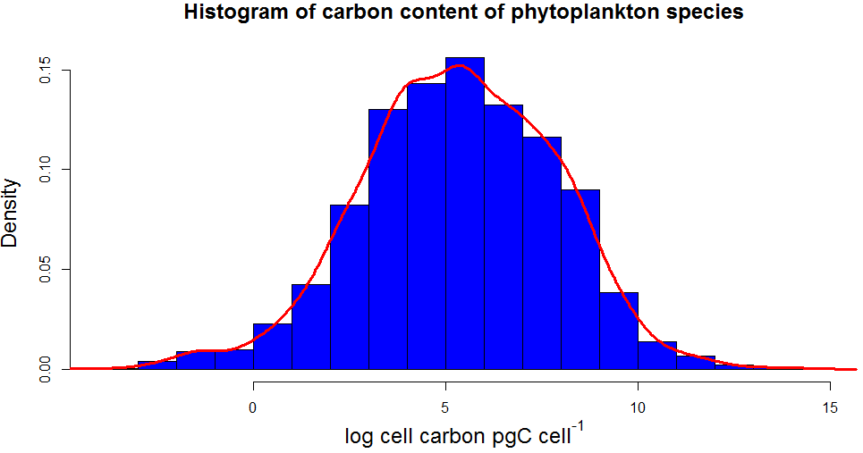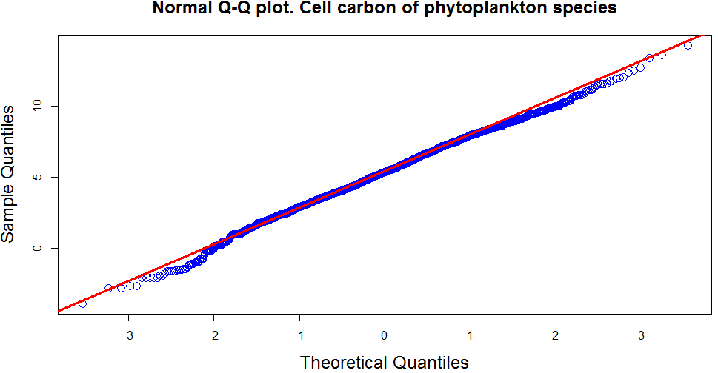
Figure 12. Histogram and norml q-q plot of data on phytoplankton cell carbon (Olenina et al 2006)
Parameter estimation type
Statistical analysis of large database [X]
Calibration [ ]
Extrapolation [ ]
Expert elicitation [ ]
Bayesian approach [ ]
QSAR or read-across [ ]
Mechanistic model [ ]
Perfect information [ ] to be informed by the end user case by case
Parameter estimation description
Skoglund et al 1999 estimated optimum sorbing matrix fraction by calculating the least-squares sum residuals method for each sample. Then the most appropriate sorbing matrix was determined by comparing the dry weight, organic carbon fraction, and lipid fraction to the optimum sorbing matrix fraction.
Parameter default value and PDF

Best estimate (p_carbon_phytoplankton) = 0,29 (unitless)
PDF (p_carbon_phytoplankton) = U (min=0,11 ; max=0,46)

Lipid layer permeation resistance (ρ_lipid_layer) (d·kg)
and

Water layer diffusion resistance for uptake of chemicals from water (ρ_water_layer) (d·kg)
Physical/chemical/biological/empirical meaning
Uptake and elimination rate constants of chemicals are expressed in terms of parameters that are separately specific to the phytoplankton and to the chemical. Resistances we use in model are specific to phytoplankton species, and are believed to vary with phytoplankton size. Water/lipid resistances can be viewed as the time (d) required to achieve a certain degree of chemical transfer, hence long resistance time means slow transfer of contaminant (Clark et al, 1990).
Factors influencing parameter value
It is assumed that water and lipid resistances apply to all chemicals involved in passive diffusion across membranes, and that the water layer diffusion resistances for contaminant uptake through water are the same for different xenobiotics. Additionally, the lipid layers permeation changes with K_ow of chemical.
Role in the model
Partial resistance in water and lipid layers are used in calculating the uptake rate constants k_uptake. ρ_lipid_layer and ρ_water_layer expressed as a reciprocal sum of water and lipid resistances.
ρ_lipid_layer used in for in metal model is considered to be a power a function of the concentration in water with coefficient b_lipid_layer_resistance.
Database used for parameter estimation
Water resistance parameters, as well as Lipid resistance parameter, were obtained by Hendriks et al (2001) and Hauck et al (2011) by fitting rate constants on data collected from literature. Published measured data related to chemical rate constants for intake from water were collected. Data are related to substances with K_ow values between 10³ and 10⁹ and to algae, invertebrates, and fish. These values were compared to calculated values for the rate constants of chemical intake from water to estimate the most likely values for the resistances. Resistances were calibrated simultaneously. The calibration of resistances was performed using constant values (best estimates) for allometric rate constant and lipid fractions. The total uncertainty of resistances was then calculated by taking into account the variance in resistance due to the uncertainty in other parameters and in resistance itself. The approach summarized above is described in more detail in Hauck et al 2011.
Parameter estimation type
Statistical analysis of large database [ ]
Calibration [X]
Extrapolation [ ]
Expert elicitation [ ]
Bayesian approach [ ], eventually
QSAR or read-across [ ]
Mechanistic model [ ]
Perfect information [ ] to be informed by the end user case by case
Parameter estimation description
Measured and estimated chemical rate constants for intake from water were compared to calculate the most likely values for the partial resistances (ρ_lipid_layer, ρ_water_layer) (Hauck et al, 2011).
Parameter default value and PDF
Best estimates were derived based on maximum likelihood estimation.

Best estimate (ρ_lipid_layer) = 97 (kg∙d∙kg⁻¹)
PDF (ρ_lipid_layer) = LN (perc 5 = 32 – perc 95 = 298)

Best estimate (ρ_water_layer) = 6,8∙10⁻³ (kg∙d∙kg⁻¹)
PDF (ρ_water_layer) = LN (perc 5 = 3,7∙10⁻³ – perc 95=1,3∙10⁻²)

Lipid layer resistance exponent (b_lipid_layer_resistance) (only for metals)
Physical/chemical/biological/empirical meaning
Hendriks et al (2001) model for metal uptake is analogous with Freundlich empirical relationship sorbet:solute, allowing explanation of exponent b_lipid_layer_rsistance. Sorption of heavy metals on natural materials can be described by Freundlich isotherm.
$$C_{sorbate}=K_{F}×C_{solute}^{n}$$
n exponent is a measure of nonlinearity of the relation between concentration of sorbate (C_{sorbate}) and concentration of chemical in the solution (C_{solute}), with Freundlich constant or capacity factor (K_{F}). Schwarzenbach (2003) further details definition of n exponent; the exponent is an index of the diversity of free energies associated with the sorption of the solute by multiple components of heterogeneous sorbent according to Freundlich sorption isotherm. It assumes that there are multiple types of sorption sites acting in parallel, with each site type exhibiting a different sorption free energy and total site abundance. Exponent n is usually smaller than 1, meaning that further sorption increases with more sorbet present in the sorbent. When exponent n equals 1 Freundlich isotherm becomes linear and constant sorption occurs at all sorbate concentrations (Schwarzenbach 2003).
Factors influencing parameter value
b_lipid_layer_resistance coefficient is influenced by exposure concentration of metals.
Role in the model
Hendriks et al (2001) describes different outcomes of the model with changing exponent b_lipid_layer_resistance and exposure concentration of metals.
- If the exponent b_lipid_layer_resistance equals 0, inﬂux and efﬂux rate constants are both independent of the external concentration, indicating that the organism does not control the internal concentration,
- The same situation occurs when the coefficient b_lipid_layer_resistance equals 1 and exposure concentration is low,
- If the exponent equals 1 and exposure concentration level is high uptake rate constant decreases linearly with exposure concentration,
- If the exponent is between 0 and 1 and exposure is high internal concentration is partially controlled. The equation can be considered to reflect competition between metals with accumulation as a function of the available metal fraction for membrane receptors.
Database used for parameter estimation
Lipid resistance parameters for calculating uptake rate were calibrated on measured rate constants (Hendriks 1999, Hendriks et al 2001).
Parameter estimation type
Statistical analysis of large database [ ]
Calibration [X]
Extrapolation [ ]
Expert elicitation [ ]
Bayesian approach [ ], eventually
QSAR or read-across [ ]
Mechanistic model [ ]
Perfect information [ ] to be informed by the end user case by case
Parameter estimation description
Lipid resistance parameters for calculating uptake rate were calibrated on measured rate constants (Hendriks et al 2001). In analysis of allometric relationships conducted by Hendriks (1999), it was assumed to be appropriate to select a single exponent for all allometric rate parameters. The selected value is close to the average observed and predicted slopes.
Parameter default value and PDF

Best estimate (b_lipid_layer_resistance) = 0,41 (unitless)
PDF (b_lipid_layer_resistance) = N (µ=0,28 ; SD=0,53)

Water-organic carbon partition coefficient (log10_K_oc) (for organics only)
Physical/chemical/biological/empirical meaning
Partition coefficient between plankton and water can be derived from lipid contents of the plankton and octanol-water partition coefficient Kow, or from organic carbon content of the plankton and organic carbon-water partition coefficient Koc. It has been reported that the equilibrium partition coefficient in phytoplankton is better characterized by an organic carbon-water partition coefficient (Swackhamer et al 1993). The plankton-water partitioning is best assessed by recognizing the sorptive capacities of both lipid and organic matter other than lipid (Gobas et al 2003).
Factors influencing parameter value
Variability in Koc results from complex and variable nature of organic matter.
Role in the model
It is used in calculating partition of organic contaminants between water and organic content of phytoplankton.
Database used for parameter estimation
See Paragraph Parameter estimation description
Parameter estimation type
Statistical analysis of large database [ ]
Calibration [ ]
Extrapolation [ ]
Expert elicitation [ ]
Bayesian approach [ ]
QSAR or read-across [X]
Mechanistic model [ ]
Perfect information [ ]
Parameter estimation description
Because experimental K_oc data are not available for all chemicals in use, numerous correlations have been developed relating K_oc to molecular descriptors like the Octanol-Water partition coefficient K_ow. Such correlations (called QSAR models) tend to be developed for specific groups or classes of chemicals and can therefore be adapted for some classes of chemicals only. We present here some of the QSAR models that can be used for estimating K_oc values for a given chemical ( Table 1).
- A classical hydrophobic approach based on Kow and on a decision tree was proposed by Sablić et al (1995; 1996). Log K_oc is estimated by a hierarchical decision tree, offering 20 different equations in total. The first equation applies the topological index 1χ, while the other 19 equations correlate log Koc to log Kow. For non-polar compounds, the more precise but also restricted model is the one with 1χ, if it cannot be applied, a more general, less precise equation is used.
- Schüürmann et al (2006) developed another model for non-ionic organic compounds. Literature data of logKoc for 571 organic chemicals (subdivided in 457 for training set and 114 for predictive set) were fitted to 29 parameters. The general form of the model is:
with 3 variable P_{i} (molecular weight, bond connectivity, molecular E-state), 21 fragment correction factors F_{j}, 4 structural indicator variables I_{k}. The data set compounds are neutral organics (except for partial ionization of acids and bases at soil pH) that include the following atom types: C, H, N, O, P, S, F, Cl, and Br. Because the training set contained no organoiodine compounds, I is not included, but it is likely that a simple extension (see below) will provide reasonable estimates for compounds with iodine attached to aliphatic or aromatic carbon. The range confidence is checked for the molecular correction factors by comparing the frequency of these substructures in the molecule to the training set. The compound will be checked versus the original training set compounds by means of 2nd order ACFs (Atom Centered Fragments). The applicability domain is then classified as: (i) In: All ACFs are matching including the number of occurrences; (ii) Borderline in: Either the frequency of at least one substructure of the compound exceeds the range of occurrences in the training set, or one substructure is not in the training set at all; (iii) Borderline out: More than one substructure is not in the training set at all, but all 1st order ACFs are matching; (iv) Out: There is mismatch even with 1st order ACFs.
- Tao et al (1999) developed another model based on logKoc data for 592 organic chemicals (subdivided in 430 for training set and 162 for predictive set) and on 98 parameters (74 fragment constants and 24 structural factors).
- Huuskonen (1999) developed a model based on atom-type electrotopological state indices, involving 12 parameters (connectivity index 1χ, 11 atom-type E-state indices). It was tested on logKoc data for 201 organic pesticides (subdivided in 143 for training set and 58 for predictive set). The general form of the model is:
where S_{i} are the atom-type E-state values..
- Poole and Poole (1999) developed a solvatation-based model to predict logK_oc. After removal of the outliers, the model is under the form:
Where V is the McGowan’s characteristic volume, E is the excess molar refraction, A and B(O) are the solute’s effective hydrogen-bond acidity and hydrogen-bond basicity.
- Franco et al (2008, 2009) developed a QSAR model for ionizable compounds (monovalent organic acids and bases). The classical Kow model is applied here, but the Kow value accounts for the distribution of the chemical between neutral and ionic forms. The neutral and ionic fractions are calculated from the substance pKa and the surrounding pH, according to the Henderson-Hasselbalch relationship:
for acids;
for bases.
Thus, supplying of a valid pKa and a pH is required for running the model. The models do not work for neutral compounds without specification of pKa.

The QSAR models that are indicated above are based on linear regressions fitted by ordinary least squares. Assuming identical, independent and normally distributed errors, the uncertainty in a QSAR prediction Log Koc,p can be defined as the predictive distribution by the predictive mean and standard error of predictions :
Where is the student t-distribution with n-k-1 degrees of freedom, n is the number of data in the training set, k is the number of descriptors in the model (and k+1 is the intercept plus the number of descriptors).
The QSAR models that are indicated above generally provide an estimation of the standard error of predictions by the Mean Squared error MSE. Since MSE is an expectation value, it is subject to estimation error that could be taken into account. The uncertainty on MSE can be calculated from a Bayesian point of view, assuming that the uncertainty of MSE has a scaled inverse Chi distribution. A re-analysis of raw data used in the training set would however be necessary to calculate this posterior distribution. Therefore, in the present model, the MSE uncertainty is not included and the standard error of predictions is assumed to be equal to the MSE value provided in each QSAR model description.
Source | Descriptors | N. of data in the training set | MSE | Applicability domain | - 5th-95th percentile
Sablić et al (1995; 1996) | 1: topological index 1χ | 81 | 0.264 | Predominantly hydrophobics - 3 to 22  atoms of carbon or halogenes with 1<logKoc<6,5 | 0.44
 | 1: octanol-water partition coefficient K_{ow} | 81 | 0.451 | Predominantly hydrophobics | 0.75
 |  | 390 | 0.557 | Nonhydrophobics with -2<logKow<8 | 0.92
 |  | 54 | 0.401 | Phenols, Anilines, Benzonitriles, Nitrobenzenes with 1<logKow<5 | 0.67
 |  | 216 | 0.425 | Acetanilides, Carbamates, Esters, Phenylureas, Phosphates, Triazines, Triazoles, Uracils with -1<logKow<8 | 0.70
 |  | 36 | 0.388 | Alcohols, Organic acids with -1<logKow<5 | 0.66
 |  | 21 | 0.339 | Acetanilides | 0.59
 |  | 13 | 0.397 | Alcohols | 0.71
 |  | 28 | 0.491 | Amides | 0.84
 |  | 20 | 0.341 | Anilines | 0.59
 |  | 43 | 0.408 | Carbamates | 0.69
 |  | 20 | 0.242 | Dinitroanilines | 0.42
 |  | 25 | 0.463 | Esters | 0.79
 |  | 10 | 0.583 | Nitrobenzenes | 1.08
 |  | 23 | 0.336 | Organic acids | 0.58
 |  | 24 | 0.373 | Phenols, Benzonitriles | 0.64
 |  | 52 | 0.335 | Phenylureas | 0.56
 |  | 41 | 0.452 | Phosphates | 0.76
 |  | 16 | 0.379 | Triazines | 0.67
 |  | 15 | 0.482 | Triazoles | 0.85
Schüürmann et al, 2006 | 29 descriptors : molecular weight, bond connectivity, molecular E-state, 24 fragment corrections representing polar groups, one indicator for nonpolar and weakly polar compounds | 457 (and 114 compounds used in the prediction set) | 0.467 | Neutral organics (except for partial ionization of acids and bases at soil pH) with atom types C, H, N, O, P, S, F, Cl, Br | 0.77
Tao et al, 1999 | 98 descriptors (74 fragment constants and 24 structural factors) | 430 (and 162 compounds used in the prediction set) | 0.366 | Organics with K_oc over 7.65 log-units | 0.60
Huuskonen, 2003 | 12 structural parameters (connectivity index 1χ, 11 atom-type E-state indices) | 143 (and 58 compounds used in the prediction set) | 0.40 | Organic pesticides (with logKoc ranging from 0.42 to 5.31) | 0.66
Poole et al, 1999 | 4 descriptors | 131 | 0.248 |  | 0.41
Franco et al, 2008, 2009 | 3 descriptors or conditions (octanol-water partition coefficient K_{ow}, pKa, pH) | 44 (10 acids, 12 bases, different pH) | 0.32 | Ionizable monovalent organic acids and bases | 0.54
Table 3 - QSAR available for calculating logK_oc

Parameter default value and PDF
According to the approach described above, the default best estimate and PDF for the LogK_oc parameter are given for several key substances in Table 4 - LogKoc of selected substances. All the calculation were computed on the ChemProp software that is freely available on request (http://www.ufz.de/index.php?en=6738). When the Schüürmann’s approach indicates ‘In’ for the applicability domain, it was the preferred approach because it explicitly checks the validity domain. Instead, the Sablic approach was considered. For pesticides, the Huuskonen’s approach was considered because it was specifically developed for this class of chemicals. The grey lines indicate the methods that are proposed by default in the 4FUN tool. However, end-users are encouraged to run the ChemProp software with alternative methods (that are not reported comprehensively here) to check the concordance between several approaches and to evaluate the plausibility of estimations.

Chemical class | Substance | Model | Applicability domain | Best estimate | 5th-95th percentile
PAH | Anthracene | Sablić – Equ. 1 |  | 4.3 | 3.86-4.74
 |  | Schüürmann | In | 4.08 | 3,31-4,85
 | Benzo(a)pyrene | Sablić – Equ. 1 |  | 5.86 | 5,42-6,3
 |  | Schüürmann | In | 5.7 | 4,93-6,47
 | Benzo(b)fluoranthene | Sablić – Equ. 1 |  | 5.86 | 5,42-6,3
 |  | Schüürmann | In | 5.18 | 4,41-5,95
 | Benzo(k)fluoranthene | Sablić – Equ. 1 |  | 5.86 | 5,42-6,3
 |  | Schüürmann | In | 5.18 | 4,41-5,95
 | Fluoranthene | Sablić – Equ. 1 |  | 4.83 | 4,39-5,27
 |  | Schüürmann | In | 4.23 | 3,46-5
 | Naphtalene | Sablić – Equ. 1 |  | 3.28 | 2,84-3,72
 |  | Schüürmann | In | 3.12 | 2,35-3,89
PCB | PCB28 | Sablić – Equ. 1 |  | 4.43 | 3,99-4,87
 |  | Schüürmann | In | 4.26 | 3,49-5,03
 | PCB 52 | Sablić – Equ. 1 |  | 4.64 | 4,2-5,08
 |  | Schüürmann | In | 4.63 | 3,86-5,4
 | PCB101 | Sablić – Equ. 1 |  | 4.85 | 4,41-5,29
 |  | Schüürmann | In | 5.00 | 4,23-5,77
 | PCB118 | Sablić – Equ. 1 |  | 4.85 | 4,41-5,29
 |  | Tao |  | 6.12 | 5,52-6,72
 |  | Poole |  | 5.61 | 5,2-6,02
 | PCB138 | Sablić – Equ. 1 |  | 5.08 | 4,64-5,52
 |  | Schüürmann | In | 5.36 | 4,59-6,13
 | PCB153 | Sablić – Equ. 1 |  | 5.07 | 4,63-5,51
 |  | Schüürmann | Border In | 5.37 | 4,6-6,14
 |  | Tao |  | 6.63 | 6,03-7,23
 |  | Poole |  | 5.88 | 5,47-6,29
 | PCB180 | Sablić – Equ. 1 |  | 5.29 | 4,85-5,73
 |  | Schüürmann | Border In | 5.73 | 4,96-6,5
 |  | Tao |  | 7.14 | 6,54-7,74
 |  | Poole |  | 6.26 | 5,85-6,67
Pesticides | Alachlor | Huuskonen |  | 2.83 | 2,17-3,49
 | Atrazine |  |  | 2.44 | 1,78-3,1
 | Chlordane |  |  | 5.15 | 4,49-5,81
 | Chlorpyrifos |  |  | 3.6 | 2,94-4,26
 | DDT |  |  | 4.72 | 4,06-5,38
 | Dieldrin |  |  | 4.49 | 3,83-5,15
 | Diuron |  |  | 2.29 | 1,63-2,95
 | Endosulfan |  |  | 4.04 | 3,38-4,7
 | Hexachlorocyclohexane (lindane) |  |  | 3.7 | 3,04-4,36
 | Isopruturon |  |  | 2.05 | 1,39-2,71
 | Malathion |  |  | 2.4 | 1,74-3,06
 | Parathion |  |  | 2.82 | 2,16-3,48
 | Pentachlorophenol |  |  | 3.46 | 2,8-4,12
Brominated flame retardants | Pentabromo diphenylether | Sablić – Equ. 3 |  | 4.74 | 3.82-5,66
 |  | Schüürmann | Border Out | 5.34 | 4,57-6,11
 | Hexabromobiphenyl | Sablić – Equ. 1 |  | 5.08 | 4,64-5,52
 |  | Schüürmann | Border Out | 6.32 | 5,55-7,09
VOCs | Benzene | Sablić – Equ. 1 |  | 2.26 | 1,82-2,7
 |  | Schüürmann | In | 2.18 | 1,41-2,95
 | 1,2-Dichloroethane | Sablić – Equ. 1 |  | 1.70 | 1,26-2,14
 |  | Schüürmann | In | 1.85 | 1,08-2,62
 | Dichloromethane | Sablić – Equ. 1 |  | 1.44 | 1-1,88
 | Hexachlorobenzene (HCB) | Sablić – Equ. 1 |  | 3.54 | 3,1-3,98
 |  | Schüürmann | Border In | 4.37 | 3,6-5,14
 | Hexachlorobutadiene | Sablić – Equ. 1 |  | 3.02 | 2,58-3,46
 | Pentachlorobenzene | Sablić – Equ. 1 |  | 3.32 | 2,88-3,76
 |  | Schüürmann | In | 4.01 | 3,24-4,78
 | Trichlorobenzene | Sablić – Equ. 1 |  | 2.89 | 2,45-3,33
 |  | Schüürmann | In | 3.28 | 2,51-4,05
 | Trichloromethane (chloroform) | Sablić – Equ. 1 |  | 1.6 | 1,16-2,04
Phthalate | Dibutylphthalate (DBP) | Sablić – Equ. 1 | Chemical domain mismatch : at least one substructure not represented | 3.03 | 2,59-3,47
 | Di(2-ethylhexyl)phthalate (DEHP) | Sablić – Equ. 1 |  | 4.54 | 4,1-4,98
 |  | Schüürmann | In | 4.15 | 3,38-4,92
Dioxins | 2,3,7,8-TCDD | Sablić – Equ. 1 |  | 3.91 | 3,47-4,35
 |  | Schüürmann | In | 4.62 | 3,85-5,39
 | 1,2,3,7,8-PeCDD | Sablić – Equ. 1 |  | 4.26 | 3,82-4,7
 |  | Schüürmann | Border Out | 4.98 | 4,21-5,75
 | 1,2,3,6,8-HxCDD | Sablić – Equ. 3 |  | 4.62 | 3,7-5,54
Phenols - Alkylphenols | 2,4,6-tri-tert-butylphenol | Sablić – Equ. 3 | Chemical domain borderline approached : at least one substructure occurrence outside thresholds | 4.35 | 3,43-5,27
 | Nonylphenol | Sablić – Equ. 3 |  | 3.82 | 2,9-4,74
 |  | Schüürmann | Border Out | 3.62 | 2,85-4,39
 | 2-Octylphenol | Sablić – Equ. 3 |  | 3.58 | 2,66-4,5
 |  | Schüürmann | Border Out | 3.46 | 2,69-4,23
Table 4 - LogKoc of selected substances

Octanol-water partition coefficient (log10_K_ow) (for organics only)
Physical/chemical/biological/empirical meaning
n-octanol water partition coefficient is used as a measure of hydrophobicity of the compound in aqueous solution. K_ow is defined as the distribution ratio of concentration of compound in the two phases (n-octanol/water), and that it is constant in the range of small concentrations of the solute in each solution. For organic compounds K_ow values typically range from 10⁻⁴ to 10⁸ covering 12 orders of magnitude. Hydrophobicity is often expresses as log K_ow.
K_ow is often used to estimate the sorption of neutral organic compounds into organic matter in soil (K_oc), and aquatic organisms (BCF). A further application of K_ow is to predict minimum toxicity of organic compounds to aquatic species when considering acute exposure regimes.
Experimental methods used for determining K_ow inlcude shake-flask method or reversed-phase chromatography (RP-HPLC). Another way to calculate K_ow values are prediction methods based on molecular structure or compound-related information.
Factors influencing parameter value
In accordance with Nernst’s law K_ow is independent from compound absolute concentration in n-octanol and water. K_ow is usually weakly dependent on temperature, and experiments to measure K_ow values are set to standard conditions i.e. 25°C and 1 atm. Literature value with log K_ow > 6 may contain significant error and thus should be carefully checked. Application of K_ow implies that the solute under consideration has identical speciation in both phases. Processes such complex formation, dissociation and protonation in at least one of the two phases lead to more complex distribution phenomena.
Role in the model
Hydrophobicity of chemicals moderate resistance they encounter while passing through organic membranes i.e. the resistance
Database used for parameter estimation
Several prediction methods exist for estimating K_ow:
(i) Fragment based model KOWWIN (http://www.epa.gov/opptintr/exposure/pubs/episuite.htm). Widely used KOWWIN models is available as the EPI (Estimation Programs Interface) Suite, a Windows-based suite of physical/chemical property and environmental fate estimation programs developed by the EPA’s Office of Pollution Prevention Toxics and Syracuse Research Corporation. EPI Suite is a screening-level tool and should not be used if acceptable measured values are available,
(ii) ALOGPS non-linear neural network model, developed with log K_ow data for 12908 compounds from the Physprop database, and is publicly available for online application (Tetko et al 2001, 2002).
We provide list of log K_ow values used by US EPA for developing KOWWIN, where applicable, reference to experimental work is given together with residuals.
Parameter estimation type
Statistical analysis of large database [ ]
Calibration [ ]
Extrapolation [ ]
Expert elicitation [ ]
Bayesian approach [ ], eventually
QSAR or read-across [X]
Mechanistic model [ ]
Perfect information [ ] to be informed by the end user case by case
Parameter estimation description
The KOWWIN is a multivariate linear regression model for log K_ow, it implements the Atom/Fragment Contribution (AFC) method. Analysis of applicability domain of KOWWIN model by N. Nikolova & J. Jaworska (2005) based on training set of 2 434 (r² = 0,981 and rms = 0,22) compounds revealed 186 different fragments and 322 different correction factors, resulting in a 508-dimensional descriptor space. The validation set consisted of 10 910 substances, in which the log K_ow values vary between -4,99 and 11,71.

Assuming identical, independent and normally distributed errors, the uncertainty in a QSAR prediction log K_ow can be defined as the predictive distribution by the predictive mean log K_ow and standard error of predictions$\overline{K_ow}$:

${log K_ow}_{p}\sim \overline{log {K_ow}_{p}}+t_{n-k-1}.SE ({\overline{log K_ow}}_{p})$

Where is the student t-distribution with n-k-1 degrees of freedom, n is the number of data in the training set, k is the number of descriptors in the model (and k+1 is the intercept plus the number of descriptors).
The QSAR model used here provides an estimation of the standard error of predictions $SE ({\overline{log K_ow}}_{p})$ by the Mean Squared error (MSE).
Parameter default value and PDF

Chemical class | Substance | Log Kow experimental estimate (ref in appendix 1) | Log Kow KOWWIN estimate | Residual | 5th-95th percentile  (KOWWIN)
PAH | Anthracene | 4,45 | 4,35 | -0,10 | 3,99 - 4,71
PAH | Benzo(a)pyrene | 6,13 | 6,11 | -0,02 | 5,75 - 6,47
PAH | Benzo(b)fluoranthene | 5,78 | 6,11 | 0,33 | 5,75 - 6,47
PAH | Benzo(k)fluoranthene | 6,11 | 6,11 | 0,00 | 5,75 - 6,47
PAH | Fluoranthene | 5,16 | 4,93 | -0,23 | 4,57 - 5,29
PAH | Naphthalene | 3,30 | 3,17 | -0,13 | 2,81 - 3,53
PCB | PCB28 | 5,62 | 5,69 | 0,07 | 5,33 - 6,05
PCB | PCB 52 | 6,09 | 6,34 | 0,25 | 5,98 - 6,70
PCB | PCB101 | 6,80 | 6,98 | 0,18 | 6,62 - 7,34
PCB | PCB118 | 7,12 | 6,98 | -0,14 | 6,62 - 7,34
PCB | PCB138 | 7,44 | 7,62 | 0,18 | 7,26 - 7,98
PCB | PCB153 | 7,75 | 7,62 | -0,13 | 7,26 - 7,98
PCB | PCB180 | - | 8,27 | - | -
Pesticides | Alachlor | 3,37 | 3,52 | -0,15 | 3,01 - 3,73
Pesticides | Atrazine | 2,61 | 2,82 | 0,21 | 2,46 - 3,18
Pesticides | Chlordane | 6,16 | 6,26 | 0,10 | 5,90 - 6,62
Pesticides | Chlorpyrifos | 4,96 | 4,66 | -0,30 | 4,30 - 5,02
Pesticides | DDT | 6,91 | 6,79 | -0,12 | 6,43 - 7,15
Pesticides | Dieldrin | 5,40 | 5,45 | 0,05 | 5,09 - 5,81
Pesticides | Diuron | 2,68 | 2,67 | -0,01 | 2,31 - 3,03
Pesticides | Endosulfan | 3,83 | 3,50 | -0,33 | 3,14 - 3,86
Pesticides | Hexachlorocyclohexane (lindane) | 3,72 | 4,26 | 0,54 | 3,90 - 4,62
Pesticides | Isoproturon | 2,87 | 2,84 | -0,03 | 2,48 - 3,20
Pesticides | Malathion | 2,36 | 2,29 | -0,07 | 1,93 - 2,65
Pesticides | Parathion | 3,83 | 3,73 | -0,10 | 3,37 - 4,09
Pesticides | Pentachlorophenol | 5,12 | 4,74 | -0,38 | 4,38 - 5,10
Brominated flame retardants | Pentabromo diphenylether | - | 7.66 | - | -
Brominated flame retardants | Hexabromobiphenyl | - | 9.10 | - | -
VOCs | Benzene | 2,13 | 1,99 | -0,14 | 1,63 - 2,35
VOCs | 1,2-Dichloroethane | 1,48 | 1,83 | 0,35 | 1,47 - 2,19
VOCs | Dichloromethane | 1,25 | 1,34 | 0,09 | 0,98 - 1,70
VOCs | Hexachlorobenzene (HCB) | 5,73 | 5,86 | 0,13 | 5,50 -6,22
VOCs | Hexachlorobutadiene | 4,78 | 4,72 | -0,06 | 4,36 - 5,08
VOCs | Pentachlorobenzene | 5,17 | 5,22 | 0,05 | 4,86 - 5,58
VOCs | Trichlorobenzene | 4,05 | 3,93 | -0,12 | 3,57 - 4,29
VOCs | Trichloromethane (chloroform) | 1,97 | 1,52 | -0,45 | 1,16 - 1,88
Phthalate | Dibutylphthalate (DBP) | 5,53 | 4,61 | -0,92 | 4,25 - 4,97
Phthalate | Di(2-ethylhexyl)phthalate (DEHP) | 7,60 | 8,39 | 0,79 | 8,03 - 8,75
Dioxins | 2,3,7,8-TCDD | 6,80 | 6,92 | 0,12 | 6,56 - 7,28
Dioxins | 1,2,3,7,8-PeCDD | 6,64 | 7,56 | 0,92 | 7,20 - 7,92
Dioxins | 1,2,3,6,8-HxCDD | 7,80 | 8,21 | 0,41 | 7,85 - 8,57
Phenols - Alkylphenols | 2,4,6-tri-tert-butylphenol | 6,06 | 6,39 | 0,33 | 6,03 - 6,75
Phenols - Alkylphenols | Nonylphenol | 5,76 | 5,99 | 0,23 | 5,63 - 6,35
Phenols - Alkylphenols | 2-Octylphenol | - | 5,50 | - | -
Table 5 -Log K_ow values for selected substances. For the full list of chemicals and their log K_ow values see APPENDIX 1: KOWWIN log K_ow values

Water-Dissolved Organic Carbon partition coefficient (log10_Kd_doc) (for metals only)
Physical/chemical/biological/empirical meaning
Elements can sorb to both living and non-living particles such as phytoplankton and suspended particulate matter, respectively. Sorption can come about through active or passive mechanism, and its pathway is dependent on element of interest. In general the metal partition coefficient Kd, or sorption distribution coefficient is the ratio of sorbed metal concentration to the dissolved metal concentration at equilibrium.
Factors influencing parameter value
Different factors can influence Kd_doc, such as inorganic and organic complexation, pH, and dilution by varying amounts of inorganic and non-living particles. Metal partitioning also varies through time as phytoplankton communities undergo species succession and changes in dominant species.
Role in the model
Log10_Kd_doc is used to calculate metal excretion from phytoplankton cell.
Database used for parameter estimation
An extended literature review was conducted by Allison and Allison (2005) to obtain partition coefficients to describe the partitioning of metals between dissolved organic carbon and the dissolved inorganic phase in natural waters Kd_doc. Authors have reviewed approximately 245 articles and reports. A total of 1170 individual Kd_doc values were obtained from these sources, either directly or calculated from reported media concentrations. Review aimed to select experimental values from the literature was carried out according to several filtering criteria: (i) data from studies using pure mineral phases were rejected and only data obtained on “whole” natural media were accepted; (ii) only data obtained at low total metal concentrations (i.e. at usual natural concentrations) were accepted; (iv) partition coefficient corresponding to the conditions most closely approximating natural conditions (e.g. pH, no organic chelates in the extractant, etc) were preferred.

When reviewed and gathered Kd_doc values by Allison and Allison (2005) were insufficient to set up a reasonable range and median values statistical analysis, modelling, and expert judgment were used. To establish probability density function authors first evaluated degree to which the literature data sample is representative. Then, for each metal statistical tests were performed to determine shape of the frequency distribution of the partition coefficient, the Shapiro-Wilk test and the Kolmogorov-Smirnov test were applied to test the samples for normality. When it seemed reasonable sample data were log transformed to fit normal distribution.
Parameter estimation type
Statistical analysis of large database [ ]
Calibration [ ]
Extrapolation [ ]
Expert elicitation [X]
Bayesian approach [ ], eventually
QSAR or read-across [ ]
Mechanistic model [X]
Perfect information [ ] to be informed by the end user case by case
Parameter estimation description
Kd_doc estimation was based on two-stage method. First phase involved literature survey to determine the range of statistical distribution of Kd_doc values. In case of lack information on metals species, Kd_doc estimation was extended of the second phase where statistical methods and expert judgment were used to provide reasonable estimates.
Authors noted that data on metal partitioning to DOC are not often described by partition coefficients (Kd_doc), therefore speciation models are employed to estimate it. Such models require consideration of several additional factors such as pH, major ion composition of the solution, and ionic strength. In the review by Allison et al 2005, Kd_doc values were derived by MINTEQA2 Guassian distribution submodel. In this model dissolved organic carbon is represented as a mixture of binding sites, described by metal-DOC binding formation constant log K. Where probability for occurring DOC-metal binding is given by normal probability function defined by mean log K and standard deviation of log K. The fact that MINTEQA2 model requires specification of metal-DOC reactions, which are very scarce for some metal ions, authors found it necessary to estimate metal-DOC binding constant log K for following elements: Ag, Co, Hg(II), Sn(II), Tl(I), Hg(II). To accomplish this they created regression relationship between mean log K values and the estimated from other sources binding constants (log K) specific to humic and fulvic acids. Whereas for other species Cd, Cu, Ba, Be, Cr(III), Ni, Pb, and Zn log K values are available in the model. When neither the regression equations nor MINTEQA2 could reasonably be used to estimate a needed mean Kd_doc, the mean value was estimated subjectively using expert judgement based on literature study.

Relative confidence level (CL) has been assigned to each of the final values presented by Allison et al 2005. The CL values range from 1 to 4, with the highest confidence corresponding to a value of 1 and the lowest to a value of 4. In general, estimates based on literature survey for a well-studied metal with a large literature sample was deemed to merit a CL of 1. Data for a metal not represented in the literature for which the final values were estimated by MINTEQA2 were assigned a CL of 4. Many CL values were determined between these extremes in situations such as range was given in the literature, a value was available from a previous compilation, or literature findings combined with estimates from modelling, these case were given values 2 and 3.
Parameter default value and PDF
Chemical | Parameter estimation method | Number of data | PDF | Best estimate | Confidence level
Ag (I) | µ calculated from MINTEQA2; other parameters from expert judgement | - | LN(µ=2.5 ; SD=1.0) | 2.5 | 3
As | Values from expert judgement | - | LN(µ=2.0 ; SD=1.0) | 2.0 | 4
Ba (II) | µ calculated from MINTEQA2; other parameters from expert judgement | - | LN(µ=3.6 ; SD=1.0) | 3.6 | 3
Be (II) | All parameters estimated from  MINTEQA2 | - | LN(µ=2.1 ; SD=1.0) | 2.1 | 3
Cd (II) | µ calculated from MINTEQA2; other parameters from expert judgement | - | LN(µ=3.8 ; SD=0.9) | 3.8 | 3
Co (II) | µ calculated from MINTEQA2; other parameters from expert judgement | - | LN(µ=3.8 ; SD=0.9) | 3.8 | 3
Cr (III) | µ calculated from MINTEQA2; other parameters from expert judgement |  | LN(µ=1.1 ; SD=1.6) | 1.1 | 4
Cr (VI) | Values from expert judgement | - | LN(µ=2.0 ; SD=1.0) | 2.0 | 4
Cu (II) | From literature data | 17 | LN(µ=5.4 ; SD=1.1) | 5.4 | 2
Hg (II) | µ from literature data other; parameters from expert judgement | 3 | LN(µ=5.4 ; SD=1.2) | 5.4 | 4
MeHg | µ estimated based on relative Kd of Hg(II) and MeHg for suspended matter and Hg(II) Kd with DOC | - | LN(µ=5.0 ; SD=1.1) | 5.0 | 4
Mo (VI) | Values from expert judgement | - | LN(µ=2.0 ; SD=1.0) | 2.0 | 4
Ni (II) | µ calculated from MINTEQA2; other parameters from expert judgement | - | LN(µ=3.7 ; SD=0.9) | 3.7 | 3
Pb (II) | From literature data | 9 | LN(µ=4.9 ; SD=0.5) | 4.9 | 2
Sb | Values from expert judgement | - | LN(µ=2.0 ; SD=1.0) | 2.0 | 4
Se (IV) | Values from expert judgement | - | LN(µ=2.0 ; SD=1.0) | 2.0 | 4
Se (VI) | Values from expert judgement | - | LN(µ=2.0 ; SD=1.0) | 2.0 | 4
Sn (II) | Values from expert judgement | - | LN(µ=2.0 ; SD=1.0) | 2.0 | 4
Ti (I) | µ calculated from MINTEQA2; other parameters from expert judgement |  | LN(µ=1.6 ; SD=1.0) | 1.6 | 4
V (V) | Values from expert judgement | - | LN(µ=2.0 ; SD=1.0) | 2.0 | 4
Zn | From literature data | 9 | LN(µ=5.1 ; SD=0.7) | 5.1 | 3
Table 6 – Kd_doc best estimates and PDFs (Allison and Allison 2005).
End of Level 3 documentation (end-user with expertise in parameterization)

Level 4 documentation (mathematical information)

Mathematical models for State variables
The objective of Chapter 6 is to present the mathematical models used for calculating each of the State variables conceptually listed in 3.8. The understanding of these models is a prerequisite for understanding the mass balance equations presented in Chapter 7. In the following tables, the following symbols were adopted:

Phytoplankton weight
The data process for calculating the State variable W_Phytoplankton is reminded here:
The ‘W_Phytoplankton’ State variable is calculated as follows:
1) $W_Phytoplankton=V_cell ×volume_to_weight$

Uptake rate constant of organics (k_uptake_organics)
The data process for calculating the State variable k_uptake_organics is reminded here:
The ‘k_uptake_organics’ State variable is calculated as follows:

2) $k_uptake_organics=\frac{W_Phytoplankton^-к}{ρ_water_layer+ \frac{ρ_lipid_layer}{10^log10_K_ow }}$

Uptake rate constant of metals (k_uptake_metals)
The data process for calculating the State variable k_uptake_metals is reminded here:

The ‘k_uptake_metals’ State variable is calculated as follows:

3) $k_uptake_metals=\frac{W_Phytoplankton^-к}{ρ_water_layer+ ρ_lipid_layer×C_dis_water^b_lipid_layer_resistance}$

Elimination rate constant of organics (k_excretion_organics)
The data process for calculating the State variable k_excretion_organics is reminded here:

The ‘k_excretion_organics’ State variable is calculated as follows:

4) $k_excretion_organics=\frac{1}{p_carbon_phytoplankton×10^log10_K_oc}×\frac{W_Phytoplankton^-κ}{ρ_water_layer+ \frac{ρ_lipid_layer}{10^log10_K_ow }}$

Elimination rate constant of metals (k_excretion_metals)
The data process for calculating the State variable k_excretion_metals is reminded here:

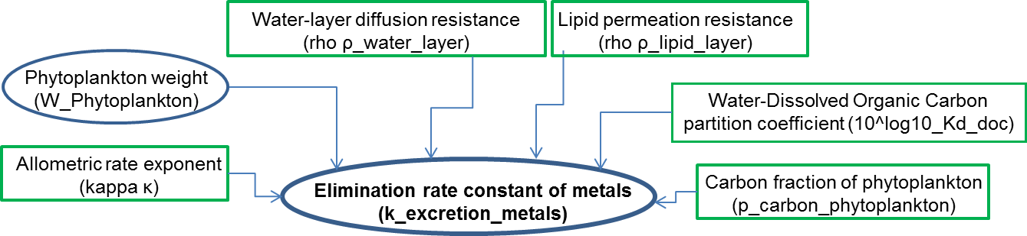

The ‘k_excretion_metals’ State variable is calculated as follows:

5) $k_excretion_metals=\frac{1}{p_carbon_phytoplankton×10^log10_Kd_doc}×\frac{W_Phytoplankton^-κ}{ρ_water_layer+ρ_lipid_layer}$

Growth rate constant (k_growth_phytoplankton)
The data process for calculating the State variable k_growth_phytoplankton is reminded here:

The ‘k_growth_phytoplankton’ State variable is calculated as follows:

Species with V_cell > 40 μm3 (used as default in MERLIN-Expo Phytoplankton model)
6a) $k_growth_phytoplankton =a_growth∙{V_cell}^{-b_growth}$

Species with V_cell < 300 μm3
6b) $k_growth_phytoplankton =-a_growth∙{V_cell}^{b_growth}$

Mass balance equation for organic chemicals accumulation in the cell matrix
7)
$$\frac{dQ_Phytoplankton_organics}{dt}=W_Phytoplankton∙\left(k_uptake_organics∙C_diss_water \right)-\left(k_ecretion_organics+k_growth_phytoplankton\right)∙Q_Phytoplankton_organics$$

Mass balance equation for metals accumulation in the cell matrix
8)
$$\frac{dQ_Phytoplankton_metals}{dt}=W_Phytoplankton∙(k_uptake_metals∙C_diss_water )-(k_ecretion_metals+k_growth_phytoplankton)∙Q_Phytoplankton_metals$$

Concentration of chemicals organics/metals in phytoplankton
9) $C_Phytoplankton_organics=Q_Phytoplankton_organics/(W_Phytoplankton$/1000)

10) $C_Phytoplankton_metals=Q_Phytoplankton_metals/(W_Phytoplankton$/1000)

References:
Edwards, K.F., Thomas, M.K., Klausmeier, C.A., Litchman, E., 2012. Allometric scaling and taxonomic variation in nutrient utilization traits and maximum growth rate of phytoplankton. Limnology and Oceanography 57, 554–566. doi:10.4319/lo.2012.57.2.0554

Marañón, E., Cermeño, P., López-Sandoval, D.C., Rodríguez-Ramos, T., Sobrino, C., Huete-Ortega, M., Blanco, J.M., Rodríguez, J., 2013. Unimodal size scaling of phytoplankton growth and the size dependence of nutrient uptake and use. Ecology Letters 16, 371–379. doi:10.1111/ele.12052

Edwards, K.F., Thomas, M.K., Klausmeier, C.A., Litchman, E., 2015. Light and growth in marine phytoplankton: allometric, taxonomic, and environmental variation: Light and growth in marine phytoplankton. Limnology and Oceanography 60, 540–552. doi:10.1002/lno.10033

Edwards, K.F., Thomas, M.K., Klausmeier, C.A., Litchman, E., 2015. Light and growth in marine phytoplankton: allometric, taxonomic, and environmental variation: Light and growth in marine phytoplankton. Limnology and Oceanography 60, 540–552. Doi:10.1002/lno.10033anguine

Pahlow, M., Oschlies, A., 2013. Optimal allocation backs Droop’s cell-quota model. Marine Ecology Progress Series 473, 1–5. Doi:10.3354/meps10181

Lemesle, V., Mailleret, L., 2008. A Mechanistic Investigation of the Algae Growth “Droop” Model. Acta Biotheoretica 56, 87–102. Doi:10.1007/s10441-008-9031-3

Hellweger, F.L., Kianirad, E., 2007. Individual-based modeling of phytoplankton: Evaluating approaches for applying the cell quota model. Journal of Theoretical Biology 249, 554–565. Doi:10.1016/j.jtbi.2007.08.020

Strickland, J.D.H., 1960. Measuring the Production of Marine Phytoplankton, Fisheries Research Board of Canada. Bulletin.

Solomon, E.P., Berg, L.R., Martin, D.W., 2011. Biology, 9th ed. ed. Brooks/Cole, Belmont, CA.
Baken, S., Degryse, F., Verheyen, L., Merckx, R., Smolders, E., 2011. Metal Complexation Properties of Freshwater Dissolved Organic Matter Are Explained by Its Aromaticity and by Anthropogenic Ligands. Environmental Science & Technology 45, 2584–2590. doi:10.1021/es103532a

Sharp, J.H., 1977. Excretion of organic matter by marine phytoplankton: Do healthy cells do it? 1. Limnology and Oceanography 22, 381–399.

Hestir, E.L., Brando, V., Campbell, G., Dekker, A., Malthus, T., 2015. The relationship between dissolved organic matter absorption and dissolved organic carbon in reservoirs along a temperate to tropical gradient. Remote Sensing of Environment 156, 395–402. doi:10.1016/j.rse.2014.09.022

Paquet, N.; Lavoie, M.; Maloney, F.; Duval, J. F. L.; Campbell, P. G. C.; Fortin, C. Cadmium accumulation and toxicity in the unicellular alga Pseudokirchneriella subcapitata: In ﬂ uence of metal-binding exudates and exposure time. Environ. Toxicol. Chem. 2015. In press (DOI:10.1002/etc.2927)
Becker, J.W., Berube, P.M., Follett, C.L., Waterbury, J.B., Chisholm, S.W., DeLong, E.F., Repeta, D.J., 2014. Closely related phytoplankton species produce similar suites of dissolved organic matter. Frontiers in Microbiology 5. doi:10.3389/fmicb.2014.00111

Allison, J.D., Allison, T.L., 2005. Partition coefficients for metals in surface water, soil, and waste. Rep. EPA/600/R-05 74.

Weng, L., Temminghoff, E.J.M., Lofts, S., Tipping, E., Van Riemsdijk, W.H., 2002. Complexation with Dissolved Organic Matter and Solubility Control of Heavy Metals in a Sandy Soil. Environmental Science & Technology 36, 4804–4810. doi:10.1021/es0200084

Olenina, I., Hajdu, S., Edler, L., Andersson, A., Wasmund, N., Busch, S., Göbel, J., Gromisz, S., Huseby, S., Huttunen, M., Jaanus, A., Kokkonen, P., Ledaine, I. and Niemkiewicz, E. 2006 Biovolumes and size-classes of phytoplankton in the Baltic Sea, HELCOM Balt.Sea Environ. Proc. No. 106, 144pp.

Kagami, M., Urabe, J., 2001. Phytoplankton growth rate as a function of cell size: an experimental test in Lake Biwa. Limnology 2, 111–117

Sunda, W.G., Huntsman, S.A., 1998. Processes regulating cellular metal accumulation and physiological effects: phytoplankton as model systems. Science of the Total Environment 219, 165–181.

Veltman, K., Huijbregts, M.A., Kolck, M. van, Wang, W.-X., Hendriks, A.J., 2008. Metal bioaccumulation in aquatic species: quantification of uptake and elimination rate constants using physicochemical properties of metals and physiological characteristics of species. Environmental science & technology 42, 852–858.

Veltman, K., Huijbregts, M.A.J., Hendriks, A.J., 2008. Cadmium bioaccumulation factors for terrestrial species: Application of the mechanistic bioaccumulation model OMEGA to explain field data. Science of The Total Environment 406, 413–418. doi:10.1016/j.scitotenv.2008.05.049

Faburé, J., Dufour, M., Autret, A., Uher, E., Fechner, L.C., 2015. Impact of an urban multi-metal contamination gradient: Metal bioaccumulation and tolerance of river biofilms collected in different seasons. Aquatic Toxicology 159, 276–289. doi:10.1016/j.aquatox.2014.12.014

Kaplan, D., Richmond, A., Hu, Q., 2013. Absorption and adsorption of heavy metals by microalgae. Handbook of Microalgal Culture: Applied Phycology and Biotechnology, second ed., John Wiley & Sons, Oxford.

McGeer, J.C., G. Henningsen, R. Lanno, N. Fisher, K. Sappington, and J. Drexler. 2004. Issue paper on the bioavailability and bioaccumulation of metals. US Environmental Protection Agency Risk Assessment Forum. 126 pgs.
http://cfpub2.epa.gov/ncea/raf/recordisplay.cfm?deid=86119

Luoma, S.N., Rainbow, P.S., 2005. Why Is Metal Bioaccumulation So Variable? Biodynamics as a Unifying Concept. Environmental Science & Technology 39, 1921–1931. doi:10.1021/es048947e

Arnot J.A. and Gobas F.A.P.C., A food web bioaccumulation model for organic chemicals in aquatic ecosystems, Environ. Toxicol. Chem. 23, 2004

Bjørrisen, P.K., 1988. Phytoplankton exudation of organic matter: Why do healthy cells do it? 1. Limnology and oceanography 33, 151–154.

Campfens J, MacKay D., Fugacity-based model of PCB bioaccumulation in complex aquatic food webs, Environ Sci Technol 31, 1997

Ciavatta S., Lovato T., Ratto M., Pastres R., Global uncertainty and sensitivity analysis of a food-web bioaccumulation model, Environ. Toxicol. Chem. 28, 2009

Clark K.E., Gobas F.A.P.C., MacKay D., Model of organic chemical uptake and clearance by fish from food and water, Environ. Sci. Technol. 24, 1990

EPI-Suite, US EPA. 2012. Estimation Programs Interface Suite™ for Microsoft® Windows,
v4.11. United States Environmental Protection Agency, Washington, DC, USA

Frouin, H., Dangerfield, N., Macdonald, R.W., Galbraith, M., Crewe, N., Shaw, P., Mackas, D., Ross, P.S., 2013. Partitioning and bioaccumulation of PCBs and PBDEs in marine plankton from the Strait of Georgia, British Columbia, Canada. Progress in Oceanography 115, 65–75. doi:10.1016/j.pocean.2013.05.023

Hendriks AJ. 1999. Allometric scaling of rate, age and density parameters in ecological models. Oikos 86:293–310.
Hauck M., Hendriks H.W.M., Huijbregts M.A.J., Ragas A.M.J., Van de Meent D.,
Hendriks A.J., Parameter uncertainty in modeling bioaccumulation factors of fish, Environ. Toxicol. Chem. 30, 2011

Hendriks A.J., Parameter uncertainty in modeling bioaccumulation factors of fish, Environ. Toxicol. Chem. 30, 2011

Hendriks A.J., The power of size: A meta-analysis reveals consistency of allometric regressions, ecological modeling 205, 2007

Hendriks A. J., Van der Linde A., Cornelissen G., Sijm D.T.H.M., The power of size. 1. rate constants and equilibrium ratios for accumulation of organic substances related to octanol–water partition ratio and species weight, Environ. Toxicol. Chem. 20, 2001

Hill, W.R., and Napolitano, G.E. 1997. PCB Congener Accumulation by Periphyton, Herbivores,
and Omnivores. Archives Environmental Contamination Toxicology, 32:449-455.

Koelmans, A.A., 2014. Limited Reversibility of Bioconcentration of Hydrophobic Organic Chemicals in Phytoplankton. Environmental Science & Technology 48, 7341–7348. doi:10.1021/es5003549

Koelmans, A.A., and E.H.W. Heugens. 1998. Binding Constants of Chlorobenzenes and
Polychlorobiphenyls for Algal Exudates. Water Science Technology, 37(3):67-73.

Levasseur, M., Thompson, P. A. and Harrison, P. J. (1993), PHYSIOLOGICAL ACCLIMATION OF MARINE PHYTOPLANKTON TO DIFFERENT NITROGEN SOURCES. Journal of Phycology, 29: 587–595. doi: 10.1111/j.0022-3646.1993.00587.x

Nikolova-Jeliazkova N., Jaworska J., An Approach to Determining Applicability Domains for
QSAR Group Contribution Models: An Analysis of SRC KOWWIN, ATLA 33, 2005

Puddu, A., Zoppini, A., Fazi, S., Rosati, M., Amalfitano, S. and Magaletti, E. (2003), Bacterial uptake of DOM released from P-limited phytoplankton. FEMS Microbiology Ecology, 46: 257–268. doi: 10.1016/S0168-6496(03)00197-1

Seth, R., Mackay, D., Muncke, J., 1999. Estimating the organic carbon partition coefficient and its variability for hydrophobic chemicals. Environmental Science & Technology 33, 2390–2394.

Sijm, D.T., Broersen, K.W., de Roode, D.F., Mayer, P., 1998. Bioconcentration kinetics of hydrophobic chemicals in different densities of Chlorella pyrenoidosa. Environmental toxicology and chemistry 17, 1695–1704.

Skoglund, R.S., Stange, K., Swackhamer, D.L., 1996. A kinetics model for predicting the accumulation of PCBs in phytoplankton. Environmental science & technology 30, 2113–2120.

Swackhamer, D.L., Skoglund, R.S., 1993. Bioaccumulation of PCBs by algae: kinetics versus equilibrium. Environmental Toxicology and Chemistry 12, 831–838.

Tetko, I. V., Tanchuk, V. Y., Application of associative neural networks for prediction of lipophilicity in ALOGPS 2.1 program, J. Chem. Inf. Comput. Sci. 42, 2002

Tetko, I. V., Tanchuk, V. Y., Kasheva, T. N., Villa, A. E., Internet software for the calculation of the lipophilicity and aqueous solubility of chemical compounds, J. Chem. Inf. Comput. Sci. 41, 2001

http://www.epa.gov/opptintr/exposure/pubs/episuite.htm
http://www.fao.org/docrep/003/w3732e/w3732e06.htm

APPENDIX 1 KOWWIN references to experimental log K_ow values. SMILES, and CAS number provided for identification of MERLIN substances
Substance | CAS number | SMILES | Reference (KOW experimental)
Anthracene | 120-12-7 | C1=CC=C2C=C3C=CC=CC3=CC2=C1 | Hansch,C et al. (1995)
Benzo(a)pyrene | 192-97-2 | C1=CC=C2C3=C4C(=CC2=C1)C=CC5=C4C(=CC=C5)C=C3 | De Voogt,P et al. (1990)
Benzo(b)fluoranthene | 205-99-2 | C1=CC=C2C3=C4C(=CC=C3)C5=CC=CC=C5C4=CC2=C1 | Wang,L et al. (1986)
Benzo(k)fluoranthene | 207-08-9 | C1=CC=C2C=C3C4=CC=CC5=C4C(=CC=C5)C3=CC2=C1 | De Maagd,PG et al. (1998)
Fluoranthene | 206-44-0 | C1=CC=C2C(=C1)C3=CC=CC4=C3C2=CC=C4 | Hansch,C et al. (1995)
Naphthalene | 91-20-3 | C1=CC=C2C=CC=CC2=C1 | Hansch,C et al. (1995)
PCB28 | 7012-37-5 | C1=CC(=CC=C1C2=C(C=C(C=C2)Cl)Cl)Cl | Hansch,C & Leo,A (1985)
PCB 52 | 35693-99-3 | C1=CC(=C(C=C1Cl)C2=C(C=CC(=C2)Cl)Cl)Cl | Hansch,C et al. (1995)
PCB101 | 37680-73-2 | C1=CC(=C(C=C1Cl)C2=CC(=C(C=C2Cl)Cl)Cl)Cl | Hansch,C et al. (1995)
PCB118 | 31508-00-6 | C1=CC(=C(C=C1C2=CC(=C(C=C2Cl)Cl)Cl)Cl)Cl | Hansch,C et al. (1995)
PCB138 | 35065-28-2 | C1=CC(=C(C(=C1C2=CC(=C(C=C2Cl)Cl)Cl)Cl)Cl)Cl | Rapaport,RA & Eisenreich,SJ (1984)
PCB153 | 35065-27-1 | C1=C(C(=CC(=C1Cl)Cl)Cl)C2=CC(=C(C=C2Cl)Cl)Cl | Hansch,C et al. (1995)
PCB180 | 35065-29-3 | C1=C(C(=CC(=C1Cl)Cl)Cl)C2=CC(=C(C(=C2Cl)Cl)Cl)Cl | -
Alachlor | 15972-60-8 | CCC1=C(C(=CC=C1)CC)N(COC)C(=O)CCl | Hansch,C et al. (1995)
Atrazine | 1912-24-9 | CCNC1=NC(=NC(=N1)Cl)NC(C)C | Hansch,C et al. (1995)
Chlordane | 57-74-9 | C1C2C(C(C1Cl)Cl)C3(C(=C(C2(C3(Cl)Cl)Cl)Cl)Cl)Cl | Simpson,CD et al. (1995)
Chlorpyrifos | 2921-88-2 | CCOP(=S)(OCC)OC1=NC(=C(C=C1Cl)Cl)Cl | Sangster (1994)
DDT | 50-29-3 | C1=CC(=CC=C1C(C2=CC=C(C=C2)Cl)C(Cl)(Cl)Cl)Cl | Hansch,C et al. (1995)
Dieldrin | 60-57-1 | C1[C@@H]2[C@H]3[C@@H]([C@H]1[C@H]4[C@@H]2O4)[C@]5(C(=C([C@@]3(C5(Cl)Cl)Cl)Cl)Cl)Cl | DeBruijn,J et al. (1989)
Diuron | 330-54-1 | CN(C)C(=O)NC1=CC(=C(C=C1)Cl)Cl | Hansch,C et al. (1995)
Endosulfan | 959-98-8 | C1C2C(COS(=O)O1)C3(C(=C(C2(C3(Cl)Cl)Cl)Cl)Cl)Cl | Hansch,C et al. (1995)
Hexachlorocyclohexane (lindane) | 58-89-9 | [C@@H]1([C@@H]([C@@H]([C@H]([C@@H]([C@@H]1Cl)Cl)Cl)Cl)Cl)Cl | Hansch,C et al. (1995)
Isoproturon | 34123-59-6 | CC(C)C1=CC=C(C=C1)NC(=O)N(C)C | Hansch,C et al. (1995)
Malathion | 121-75-5 | CCOC(=O)CC(C(=O)OCC)SP(=S)(OC)OC | Hansch,C et al. (1995)
Parathion | 56-38-2 | CCOP(=S)(OCC)OC1=CC=C(C=C1)[N+](=O)[O-] | Hansch,C et al. (1995)
Pentachlorophenol | 87-86-5 | C1(=C(C(=C(C(=C1Cl)Cl)Cl)Cl)Cl)O | Hansch,C et al. (1995)
Pentabromo diphenylether | 32534-81-9 | C1=CC(=C(C=C1Br)Br)OC2=CC(=C(C=C2Br)Br)Br | -
Hexabromobiphenyl | 36355-01-8 | Brc2ccc(c1ccc(Br)c(Br)c1Br)c(Br)c2Br | -
Benzene | 71-43-2 | C1=CC=CC=C1 | Hansch,C et al. (1995)
1,2-Dichloroethane | 107-06-2 | C(CCl)Cl | Hansch,C et al. (1995)
Dichloromethane | 75-09-02 | C(Cl)Cl | Hansch,C et al. (1995)
Hexachlorobenzene (HCB) | 118-74-1 | C1(=C(C(=C(C(=C1Cl)Cl)Cl)Cl)Cl)Cl | DeBruijn,J et al. (1989)
Hexachlorobutadiene | 87-68-3 | C(=C(Cl)Cl)(C(=C(Cl)Cl)Cl)Cl | Hansch,C et al. (1995)
Pentachlorobenzene | 608-93-5 | C1=C(C(=C(C(=C1Cl)Cl)Cl)Cl)Cl | Hansch,C et al. (1995)
Trichlorobenzene | 87-61-6 | C1=CC(=C(C(=C1)Cl)Cl)Cl | Sangster (1994)
Trichloromethane (chloroform) | 67-66-3 | C(Cl)(Cl)Cl | Hansch,C et al. (1995)
Dibutylphthalate (DBP) | 1962-75-0 | [O-]C(=O)c1ccc(CCCC)c(CCCC)c1C([O-])=O | Hansch,C et al. (1995)
Di(2-ethylhexyl)phthalate (DEHP) | 117-81-7 | CCCCC(CC)COC(=O)C1=CC=CC=C1C(=O)OCC(CC)CCCC | DeBruijn,J et al. (1989)
2,3,7,8-TCDD | 1746-01-6 | C1=C2C(=CC(=C1Cl)Cl)OC3=CC(=C(C=C3O2)Cl)Cl | Shiu,WY et al. (1988)
1,2,3,7,8-PeCDD | 40321-76-4 | C1=C2C(=CC(=C1Cl)Cl)OC3=C(C(=C(C=C3O2)Cl)Cl)Cl | BioByte (1995)
1,2,3,6,8-HxCDD | 39227-28-6 | C1=C2C(=C(C(=C1Cl)Cl)Cl)OC3=CC(=C(C(=C3O2)Cl)Cl)Cl | Shiu,WY et al. (1988)
2,4,6-tri-tert-butylphenol | 732-26-3 | CC(C)(C)C1=CC(=C(C(=C1)C(C)(C)C)O)C(C)(C)C | Chem Inspect Test Inst (1992)
Nonylphenol | 104-40-5 | CCCCCCCCCC1=CC=CC=C1O | Itokawa,H et al. (1989)
2-Octylphenol | 27193-28-8 | CCCCCCCCC1=CC=CC=C1O | -

Exudation has been explicitly interpreted as the active release of excess of photosynthates that accumulate when carbon fixation exceeds incorporation into new cell material (Bjoernsen 1988 after Fogg 1983). From culture studies, carbohydrates are reported as the major components of phytoplankton exudates but their molecular composition is highly variable, depending on species and nutrient status (Puddu et al 2003).
Sabljic A, Güsten H, Verhaar H, Hermens J 1995. QSAR modelling of soil sorption. Improvements and systematics of log KOC vs. log KOW correlations. Chemosphere. 31: 4489- 4514, Corrigendum: Vol. 33 (1996), p. 2577.
The topological index was introduced by Kier et Hall (1990, 1999) following the suggestions of Randic (1975). nχ is a n-order topological index where n represents the number of atoms (except H) linked to each atom (except H) belonging to the molecule.
Schüürmann G, Ebert R-U, Kühne R 2006. Prediction of the sorption of organic compounds into soil organic matter from molecular structure. Environ. Sci. Technol. 40: 7005-7011
Kühne R, Ebert R-U, Schüürmann G 2009. Chemical domain of QSAR models from atom-centered fragments. J. Chem. Inf. Model. 96: 2660-2669
Tao S, Piao H, Dawson R, Lu X, Hu H 1999. Estimation of organic carbon normalized sorption coefficient (Koc) for soils using the fragment constant method. Environ. Sci. Technol. 33: 2719-2725
Huuskonen J 2003. Prediction of soil sorption coefficient of organic pesticides from the atom-type electrotopological state indices. Environ. Toxicol. Chem. 22: 816-820
Franco A, Fu W, Trapp S 2009. Influence of soil pH on the sorption of ionizable chemicals: Modeling advances. Environ. Toxicol. Chem. 28: 458-464. Franco A, Trapp S 2008. Estimation of the soil-water partition coefficient normalized to organic carbon for ionizable organic chemicals. Environ. Toxicol. Chem. 27: 1995-2004
Defined as molecules containing only C, H and halogen (F, Cl, Br, I)
Defined as all the molecules that contains other atoms than C, H and halogen (F, Cl, Br, I). Does not imply anything about their lipophilicity.
Schüürmann G, Ebert R-U, Kühne R 2006. Prediction of the sorption of organic compounds into soil organic matter from molecular structure. Environ. Sci. Technol. 40: 7005-7011

